
EXECUTIVE HEADTEACHER

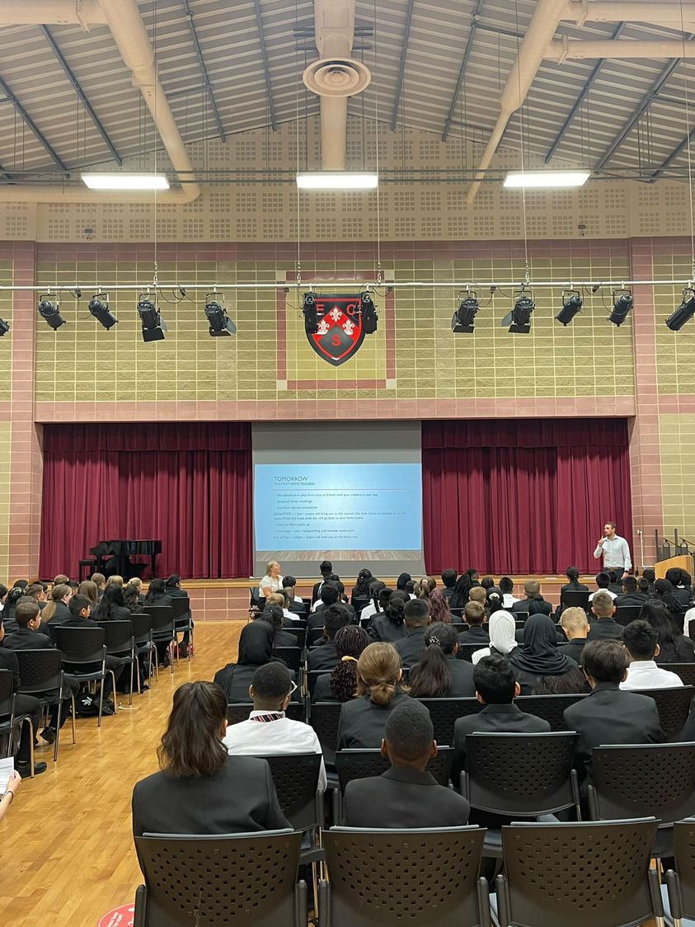

Contents
Chair of Governors Welcome. 4
The Recruitment Process. 5
Advertisement. 8
School information . 11
Job Description/Criterion 13
Our Ethos and Strategic Direction. 21

LETTER FROM CHAIR OF GOVERNORS

Thank you for your interest in applying for this post.
This vacancy has arisen following the forthcoming retirement of Sharon Gladman, who has worked with staff, pupils, Governors and the wider community at the school for 23 years, leading it to its current success and reputation.
I hope that the information in the Application Pack, and a visit to the school, will give you a strong sense of Eastbury Community School. I particularly urge you to visit our website: www.eastbury.bardaglea.org.uk. It will give you a very clear picture of the breadth of the school’s work and the approach it takes to fulfil our mission statement:
“A school where opportunities are created, so that potential is realised.”
Details of how to apply for this post are included in the pack.
Governors are seeking to appoint an exceptional individual with a strong track record in leadership and management in schools, who will be able to command the respect of Eastbury and the wider community. Moreover, they will demonstrate the values and ethos that have ensured our success, and through involving the widest range of stakeholders, will lead the school forward in its future development.
In addition, we are looking for someone with the resilience, strategic vision and moral purpose to steer the school through the challenging times that education currently faces — including pressures on funding, changing pupil demographics and the increasing complexity of pupils’ needs. The successful candidate will be able to balance compassion with rigour, ensuring that Eastbury continues to provide an inclusive, ambitious and high-quality education for every learner.
The appointed person will benefit from a fantastic legacy, including: a dedicated staff committed to collaborative working and professional learning; a highly experienced and fully engaged governing body; exciting new and refurbished buildings; and strong links with the local and wider community. At the heart of all of this, of course, are the pupils — young people who are used to, and expect, a range of creative, sporting and challenging opportunities being integral to their educational experience.
This post offers tremendous potential, with the opportunity to build on the strong foundations evidenced in the school’s current success. It will provide the successful candidate with a great opportunity to further a career that will already have included significant experience of school leadership and a proven ability to meet the specific and varied needs of all pupils.
If you would like to have an informal discussion about the role, or the information provided in this pack, please get in touch with Karen Dunnell (kdunnell@eastbury.bardaglea.org.uk) to arrange a discussion with the current Executive Headteacher, Sharon Gladman.
If you believe you have the qualities we are looking for and would like the opportunity to lead Eastbury Community School on the next stage of its journey, we would be delighted to receive your application. Please do note the requirements for completing your application.

On behalf of the Governors of Eastbury Community School, I wish you well in your application and look forward to hearing from you.
Yours sincerely,


Anthony Ramsay
Chair of Governors
Eastbury Community School

The Recruitment Process

We are proud of our school, the staff and pupils and warmly welcome prospective applicants to visit us prior to application to learn more about the role and view the school in action.

Key Dates

Closing date for applications 9.00 am on Friday 28 November 2025
Shortlisting 1 December 2025
Assessment and Interviews 8 and 11 December 2025 Start date 1 September 2026
Please note all dates are subject to change.
School visits: Potential applicants are invited to visit the school Monday to Thursday 11 – 27 November 10am – 2.30pm

To arrange an appointment please email: kdunnell@eastbury.bardaglea.org.uk

Completing your application

Please complete all aspects of the application form fully (CVs will not be accepted).

Include your full work history with no unexplained gaps since leaving school education.
Include all the relevant training you have completed in recent years which have helped prepare you for this
Headship.

Person Specification and Personal Statement
When writing your response, it is important that you read the Job Description and address each of the requirements in the Personal Specification. Ensure that you evidence additional aspects, e.g., training, and qualifications together with your background and experience in your Personal Statement, which should not exceed 500 words.

Additional Task
Please explain why you have specifically applied for ECS at this point in your career and what in the past year has prepared you for the Executive Headship of Eastbury Community in no more than 500 words.

References
Referees will be asked to provide a reference for all short-listed candidates. There will be a swift turn-around for this process. Preferred referees are your last two employers and you should provide their official organisation e-mail address for us to contact. One referee must be either your last Headteacher or Chair of Governors.

Completed applications should be sent to: kdunnell@eastbury.bardaglea.org.uk

Advertisement

Advertisement

Eastbury Community School
Hulse Avenue, Barking, Essex IG11 9UW

Required for September 2026

Executive Headteacher, Eastbury Community School (3-19)
Full Time - Permanent
Group 8: Inner London 37 – 43 (£135,141 to £153,490). Roll 2150)

An additional ‘recruitment & retention’ allowance may be available for existing headteachers seeking a second headship in a larger school.

Following the forthcoming retirement of our current Executive Headteacher, after many years of exceptional leadership, the Governors are seeking to appoint a strategic individual with excellent people management skills, together with a proven track record of success in raising standards. Most importantly, we are seeking someone with a passion for education and pupils’ learning, across both the primary and secondary phases.

This is a rewarding opportunity for an outstanding, aspirational and inspirational leader to join a successful, well-established mixed 3-19 school (2 form entry primary; 10 form entry secondary). ECS is a popular school within Barking and Dagenham, with easy access to the District Line and mainline C2C Fenchurch Street to Southend line. The school’s reputation is built on both pupil wellbeing and academic progress. ECS is robustly Good (OFSTED March 2024).

The new Executive Headteacher will lead by example, with the determination to make a positive difference to the life chances of all children. The successful candidate will motivate and empower our talented staff to continue to provide the best possible education and care for our pupils. Above all, they will command the respect of all within the school and wider community.

School visits: Potential applicants are invited to visit the school Monday to Thursday 11 – 27 November 10am – 14.30pm
To arrange an appointment please email: kdunnell@eastbury.bardaglea.org.uk

For full details of the post and an application form, please visit the school website https://www.eastbury.bardaglea.org.uk/Work-for-Us/ and return the application form to the Headteacher’s PA, Karen Dunnell kdunnell@eastbury.bardaglea.org.uk. The closing date for applications is 9am on 28 November 2025 and interviews will be held on 8 and 11 December 2025.
ECS is committed to safeguarding and promoting the welfare of children and is an Equal Opportunities Employer.
This post is exempt from the Rehabilitation of Offenders Act 1974 and a comprehensive screening process, including Disclosure check, will be undertaken on all successful applicants.






School Information

Job Description

Eastbury Community School

Eastbury Community School – Overview
1. Profile and Context

Eastbury Community School (ECS) is a large, mixed all-through community school for pupils aged 3 to 19, located in Barking, East London. It serves a richly diverse community and is proud of its inclusive ethos and commitment to social justice.
ECS provides education across Nursery, Primary, Secondary and Sixth Form, including a resourced provision for deaf learners. With over 2,100 pupils and more than 70 languages spoken, it reflects the vibrancy and diversity of Barking and Dagenham. The school serves one of the most economically disadvantaged boroughs in the country and works tirelessly to remove barriers to learning so that every pupil can thrive.

2. Vision, Ethos and Values

At Eastbury, the central belief is that pupils must feel safe, happy and valued in order to achieve their potential. The school’s ethos is underpinned by high expectations, mutual respect and inclusion. As a UNICEF Rights Respecting Gold School, ECS embeds children’s rights into every aspect of school life, fostering respect, empathy and global citizenship.
The mission statement captures this spirit:
“*A school where opportunities are created so that potential is realised.*”

3. Curriculum and Educational Offer

ECS offers a broad and balanced curriculum with a strong focus on literacy, numeracy, creativity and critical thinking. Teachers collaborate across phases to ensure smooth progression from early years to sixth form, while enrichment and community projects connect learning to the wider world.

4. Leadership and Improvement

The school was judged ‘Good’ by Ofsted in 2024 and continues to build on this through a relentless focus on teaching quality, staff development and pupil outcomes. Its leadership is known for strategic creativity—finding innovative, pragmatic solutions to challenges both within and beyond the school. Governance is strong and transparent, led by Chair of Governors Anthony Ramsay in partnership with Executive Headteacher Sharon Gladman.

5. Inclusion, Safeguarding and Community Engagement

Inclusion and safeguarding are at the heart of the school’s work, with robust systems that ensure every pupil is known, supported and challenged. ECS works closely with parents, local faith and community groups to sustain trust and shared purpose. The school empowers pupils through initiatives such as worry boxes, peer mentoring and the online ‘Confide’ reporting system.

6. Strengths and Areas for Growth

Strengths:
• All-through model providing continuity of care and learning from ages 3–19.
• Strong inclusive culture and deep commitment to equality and diversity.
• High-expectation ethos that drives both academic and personal success.
• Skilled leadership team with strategic creativity and resilience.
• Recognised Rights Respecting Gold status promoting respect and citizenship.
• Strong community engagement and safeguarding culture.
Areas for continued growth:
• Narrowing attainment gaps linked to deprivation and attendance.
• Sustaining improvement across all phases amidst national funding and recruitment challenges.
• Further strengthening consistency in teaching and learning through professional development and subject
collaboration.

7. Summary

Eastbury Community School is a thriving, inclusive and aspirational all-through school combining high expectations with compassion and creativity. Its leadership demonstrates strategic innovation and moral purpose, ensuring that every pupil has the opportunity to realise their potential.

Job Description

The Executive Headteacher (EHT) is the leading professional in the school. Accountable to the governing body, the Executive Headteacher provides vision, strategic leadership and direction for the school and ensures that it is managed and organised to meet its aims and targets. The Executive Headteacher, working with others, is responsible for evaluating the school’s performance to identify the priorities for continuous improvement and raising standards; ensuring equality of opportunity for all; developing policies and practices; ensuring that resources are efficiently and effectively used to achieve the school’s aims and objectives and acting as ‘key-holder’ for the day-to-day operational management, organisation, Health & Safety and administration of the school.
The Executive Headteacher, working with and through others, secures the commitment of the wider community to the school by developing and maintaining effective partnerships with, for example, schools, other services and agencies for children, the LA, higher education institutions and employers. Through such partnerships and other activities, headteachers play a key role in contributing to the development of the education system as a whole and collaborate with others to raise standards locally.
Drawing on the support provided by members of the school community, the Executive Headteacher is responsibility for creating a productive and safe learning environment, and culture, which is engaging and fulfilling for all pupils.

Responsibilities

Shaping the Future

- Ensures the vision for the school is clearly articulated, shared, understood and acted
upon effectively by all.
- Works within the school community to translate the vision into agreed objectives and operational plans which will promote and sustain school improvement.
- Demonstrates the vision and values in everyday work and practice.
- Motivates and works with others to create a shared culture and positive climate.
- Ensures creativity, innovation, and the use of appropriate new technologies to achieve excellence.
- Ensures that strategic planning takes account of the diversity, values and experience of
the school and community at large.

Leading Learning & Teaching

- Ensures a consistent and continuous school-wide focus on pupils’ achievement, using data and benchmarks to monitor progress in every child’s learning.
- Ensures that learning is at the centre of strategic planning and resource management.
- Establishes creative, responsive, and effective approaches to learning and teaching.
- Ensures a culture and ethos of challenge and support where all pupils can achieve success and become engaged in their own learning.
- Demonstrates and articulates high expectations and sets stretching targets for the whole school community.
- Implements strategies which secure high standards of behaviour and attendance.
- Determines, organises, and implements a diverse, flexible curriculum and implements an effective assessment framework.
- Takes a strategic role in the development of new and emerging technologies to enhance and extend the learning experience of pupils.

- Monitors, evaluates, and reviews classroom practice and promotes improvement strategies.
- Challenges underperformance at all levels and ensures effective corrective action and follow-up.

Developing Self and Working with Others
- Treats people fairly, equitably and with dignity and respect to create and maintain a positive school culture.
- Builds a collaborative learning culture within the school and actively engages with other
schools to build effective learning communities.
- Develops and maintains effective strategies and procedures for staff induction, professional development, and performance review.
- Ensures effective planning, allocation, support, and evaluation of work undertaken by teams and individuals, ensuring clear delegation of tasks and devolution of responsibilities.
- Acknowledges the responsibilities and celebrates the achievements of individuals and teams.
- Develops and maintains a culture of high expectations for self and for others and takes appropriate action when performance is unsatisfactory.
- Regularly reviews own practice, sets personal targets, and takes responsibility for own personal development.
- Manages own workload and that of others to allow an appropriate work-life balance.

Managing the Organisation
- Creates an organisational structure which reflects the school’s values, and enables the management systems, structures, and processes to work effectively in line with legal requirements.
- Produces and implements clear, evidence-based improvement plans and policies for the development of the school and its facilities.
- Ensures that, within an autonomous culture, policies and practices take account of national and local circumstances, policies and initiatives.
- Manages the school’s financial, buildings and human resources effectively and efficiently to achieve the school’s educational goals and priorities.
- Recruits, retains and deploys staff appropriately and manages their workload to achieve the vision and goals of the school.
- Implements successful performance management processes with all staff.
- Manages and organises the school environment efficiently and effectively to ensure that it meets the needs of the curriculum and health and safety regulations; promotes and develop a safer working practice culture to ensure that all staff and children/students are supported and safe.
- Ensures that the range, quality and use of all available resources is monitored, evaluated and reviewed to improve the quality of education for all pupils and provide value for money.

- Uses and integrates a range of technologies effectively and efficiently to manage the school.
- Promotes and safeguards the welfare of pupils and ensures that staff, governors, and others are clearly aware of and meet their responsibilities for safeguarding and child protection.

Securing Accountability

- Fulfils commitments arising from contractual accountability to the governing body.
- Develops a school ethos which enables everyone to work collaboratively, share knowledge and understanding, celebrate success and accept responsibility for outcomes.
- Ensures individual staff accountabilities are clearly defined, understood and agreed and are subject to rigorous review and evaluation.
- Works with the governing body (providing information, objective advice and support) to enable it to meet its responsibilities.
- Develops and presents a coherent, understandable, and accurate account of the school’s performance to a range of audiences including governors, parents and carers.
- Reflects on personal contribution to school achievements and takes account of feedback from others.

Strengthening Community

- Builds a school culture and curriculum which takes account of the richness and diversity of the school’s communities.
- Creates and promotes positive strategies for challenging racial and other prejudice and dealing with racial harassment.
- Ensures learning experiences for pupils are linked into and integrated with the wider community.
- Ensures a range of community-based learning experiences.
- Collaborates with other agencies in providing for the academic, spiritual, moral, social, emotional, and cultural well-being of pupils and their families.
- Creates and maintains an effective partnership with parents and carers to support and improve pupils’ achievement and personal development.
- Seeks opportunities to invite parents and carers, community figures, businesses, or other organisations into the school to enhance and enrich the school and its value to the wider community.
- Contributes to the development of the education system by, for example, sharing effective practice, working in partnership with other schools and promoting innovative initiatives.
- Co-operates and works with relevant agencies to protect children.

Criterion

Qualifications

Criterion |  | Information available from
 | E/D | Application | Interview | Other
A good honours degree. | E | √
Qualified Teacher Status (QTS). | E | √
Professional/management qualification relevant to the role or relevant higher degree and/or NPQH. | D | √
Evidence of continuing professional development in preparation for Executive leadership role. | D | √ | √
Safeguarding/Designated Person Training. | E | √ | √

Students and Staff

Criterion |  | Information available from
 | E/D | Application | Interview | Other
Outstanding classroom practitioner with an excellent understanding of how students learn and the core features of successful classroom practice. | E | √ | √
Evidence of effective leadership of student behaviour. | E | √ | √
Provides inspirational leadership which challenges, motivates and empowers students, staff and parents. | E | √ | √
Successful experience of curriculum development and assessment to maximise student outcomes in mainstream primary and secondary phases. | E | √ | √
A clear understanding of the implications of Government Education Policy for ECS. | E | √ | √
Appreciate the importance of a work life balance for all staff and self and of continuing professional development. | E | √ | √

Professional Qualities, Knowledge and Experience

Criterion |  | Information available from
 | E/D | Application | Interview | Other
Outstanding classroom practitioner with an excellent understanding of how students learn and the core features of successful classroom practice in a diverse urban school | E | √ | √
Strategic thinker able to put strategies in place for ensuring inclusion and diversity are addressed at all levels. | E | √ | √
Knowledge of what constitutes quality in educational provision in both the primary and secondary phases, strategies for raising standards and the achievement of all students. | E | √ | √
Ability to articulate and share a vision of education and evidence of having successfully translated vision into reality at whole school level. | E | √ | √
Evidence of expertise and success in raising pupil achievement and securing school improvement. | E | √ | √
Proven track record of successful staff recruitment, retention, induction and development. | E | √ | √
Knowledge and understanding of the key legal issues relating to the leadership of a maintained 3 – 19 school, including equal opportunities, race relations, disability, employment, health and safety and public relations. | E | √ | √
Knowledge and understanding of statutory requirements of experience of Child Protection, Safer Recruitment, safeguarding procedures and Prevent. | E | √ | √
Experience of leading collaborative partnerships outside of school with external partners. | D | √ | √
Experience of collaboration with teaching school alliance, business and employers. | D | √ | √
Strong financial, commercial and business acumen. | E | √ | √

Strategic Skills

Criterion |  | Information available from
 | E/D | Application | Interview | Other
Evidence of successful strategies for planning, implementing, monitoring and evaluating school improvement. | E | √ | √
Evidence of driving robust appraisal and performance management procedures which recognise excellence and tackle underperformance. | E | √ | √
Ability to analyse data, developing strategic plans and targets to raise standards; monitoring/evaluating progress towards these. | E | √ | √
Proven successful experience of systematic, rigorous school self-evaluation to inform school improvement planning and raise educational standards. | E | √ | √
Able to combine the outcomes of regular school self-review with external evaluations to develop the school further. | E |  | √
Experience of effective strategic financial and resource management, to achieve educational priorities and ensure efficiency and value for money. | E | √ | √
Astute financial leadership and budget oversight; able to generate economies of scale. | E |  | √
Understanding of the strategic role of the Governing Body and Local Authority, with evidence of successful collaboration. | E | √ | √
Able to advise the governors on the strategic development of ECS. | E | √ | √

Leadership Skills

Criterion |  | Information available from
 | E/D | Application | Interview | Other
Inspirational, visionary leader, able to embrace and promote ECS’s core values. | E | √ | √
Currently a serving Secondary or All-through headteacher. | D | √
A high level of integrity working to the Nolan 7 Principles of Public Life establishing successful relationships at all levels. | E |  | √
A prominent and visible leader. | E |  | √
Determined, with sound judgement and strong negotiation/advocacy skills. | E |  | √
Able to relate empathetically to parents/carers, students, staff, governors, Local Authority, stakeholders and the wider community. | E |  | √
Approachable, articulate communicator, across all media, appropriate to the audience. | E | √ | √
Able to build and maintain effective, respectful relationships and promote unity across ECS. | E |  | √
Able to cultivate a team ethos, knowing when to lead, coordinate and delegate. | E | √ | √
Excellent listening skills, consulting and valuing the contribution of others. | E |  | √
A reflective leader, aware of their own strengths and areas for growth. | E |  | √
Resilient, tenacious, able to remain positive and enthusiastic while working under pressure. | E | √ | √
Accepts the full accountability of being ultimately responsible for ECS. | E |  | √



Our Ethos and Strategic Direction

Our Ethos and Strategic Direction

