

About Seaton Valley Federation

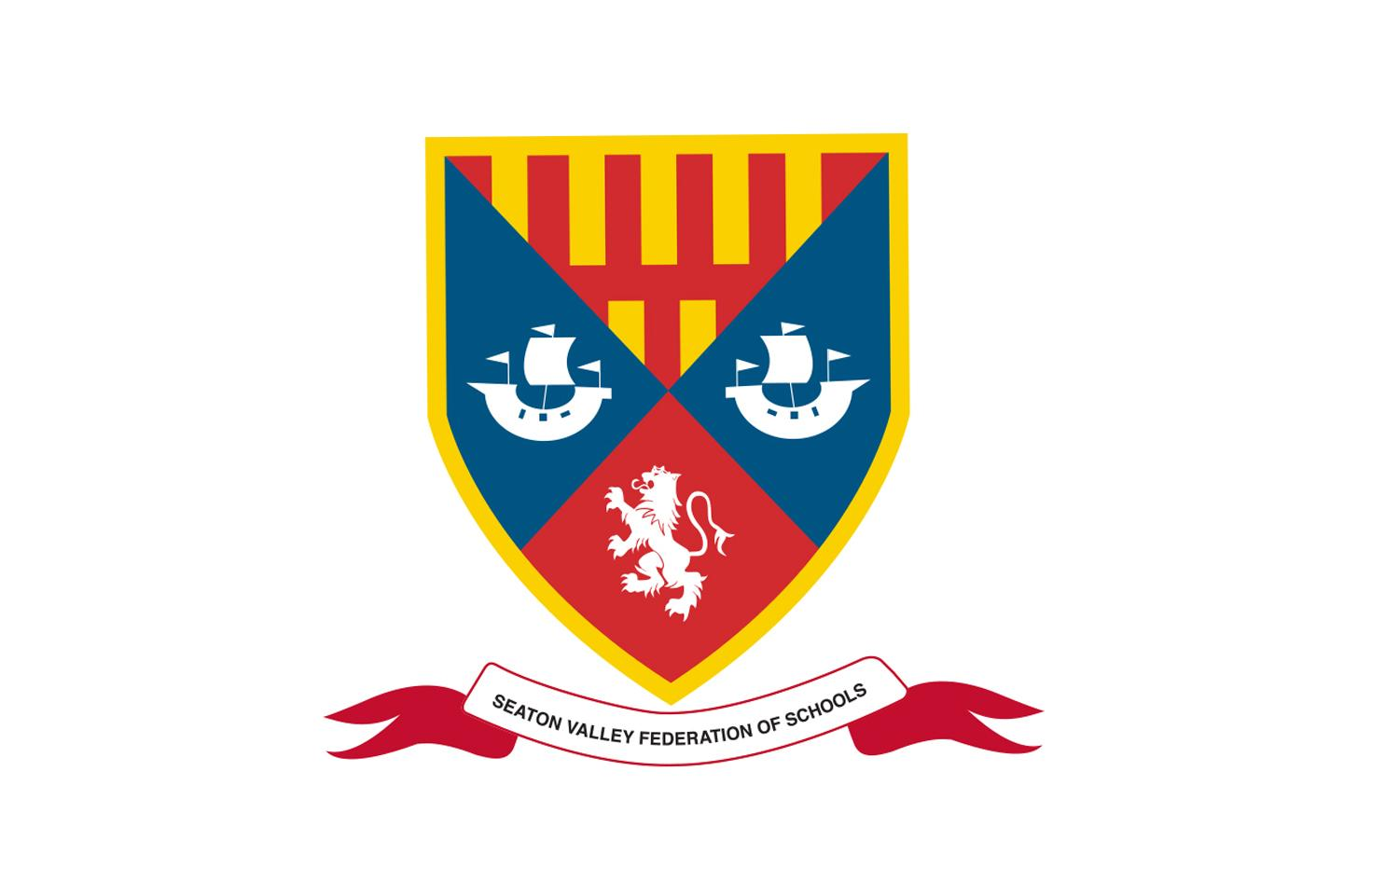

Small enough to care,
big enough to deliver a positive impact

Welcome
Thank you for your interest in the opportunity to lead Seaton Valley Federation at such a significant and exciting point in our development.

As Chair of Governors, I am delighted to invite applications for the role of Executive Headteacher, this is a rare opportunity to shape the future of a truly distinctive educational community.

The Seaton Valley Federation brings together Seaton Valley High School, Whytrig Middle School, and Seaton Sluice Middle School under one governing body, united by a shared vision and ethos. In September 2025, our federation entered a new chapter with the opening of a state-of-the-art, purpose-built facility on Prospect Avenue, creating an inspiring environment for both learning and collaboration.

We are seeking an exceptional and visionary leader, someone whose ambition is to provide a coherent, high-quality educational journey for every child from 9 to 18. You will bring the strategic expertise required to lead across multiple schools, while never losing sight of the importance of presence, visibility, and connection. Supported by a strong team of Heads of School and experienced senior leaders, you will also embrace the essential qualities of headship: being visible in our corridors and classrooms, building relationships, and setting the tone for a culture where every individual is known and valued.

Our federation is proud of its strong sense of community. We have built trusted relationships with our pupils, families, and the wider Seaton Valley area, and our dedication to excellence is reflected in our Ofsted reports. A distinct advantage is our relatively small school sizes; this allows us to truly know our students, responding to their individual needs and supporting them to thrive and achieve their full potential.

Equally, we are proud of our staff. Across the federation, colleagues demonstrate deep commitment, professionalism, and dedication to securing the best outcomes for every child. We have fostered a supportive and collaborative culture in which many staff choose to develop long and fulfilling careers.

As a governing body, we are deeply committed to investing in our people. Through strong partnerships across the North East and beyond, we provide rich opportunities for professional learning and leadership development. We recognise that great schools are built by
great teams, and we are dedicated to supporting you, as our Executive Headteacher, to flourish and to lead with confidence and impact.

If you are inspired by the opportunity to lead a values-driven federation, to build on strong foundations, and to make a lasting difference to the lives of young people and their communities, we would be delighted to hear from you.


Rebecca Bray
Chair of Governors

Our Ethos and Values

We have three main themes to our ethos:
- To know every child academically and pastorally as a complete young person.
- To treat everyone and everything with respect.
- To strive for everyone to be as good as they can be and to be proud of
doing well.

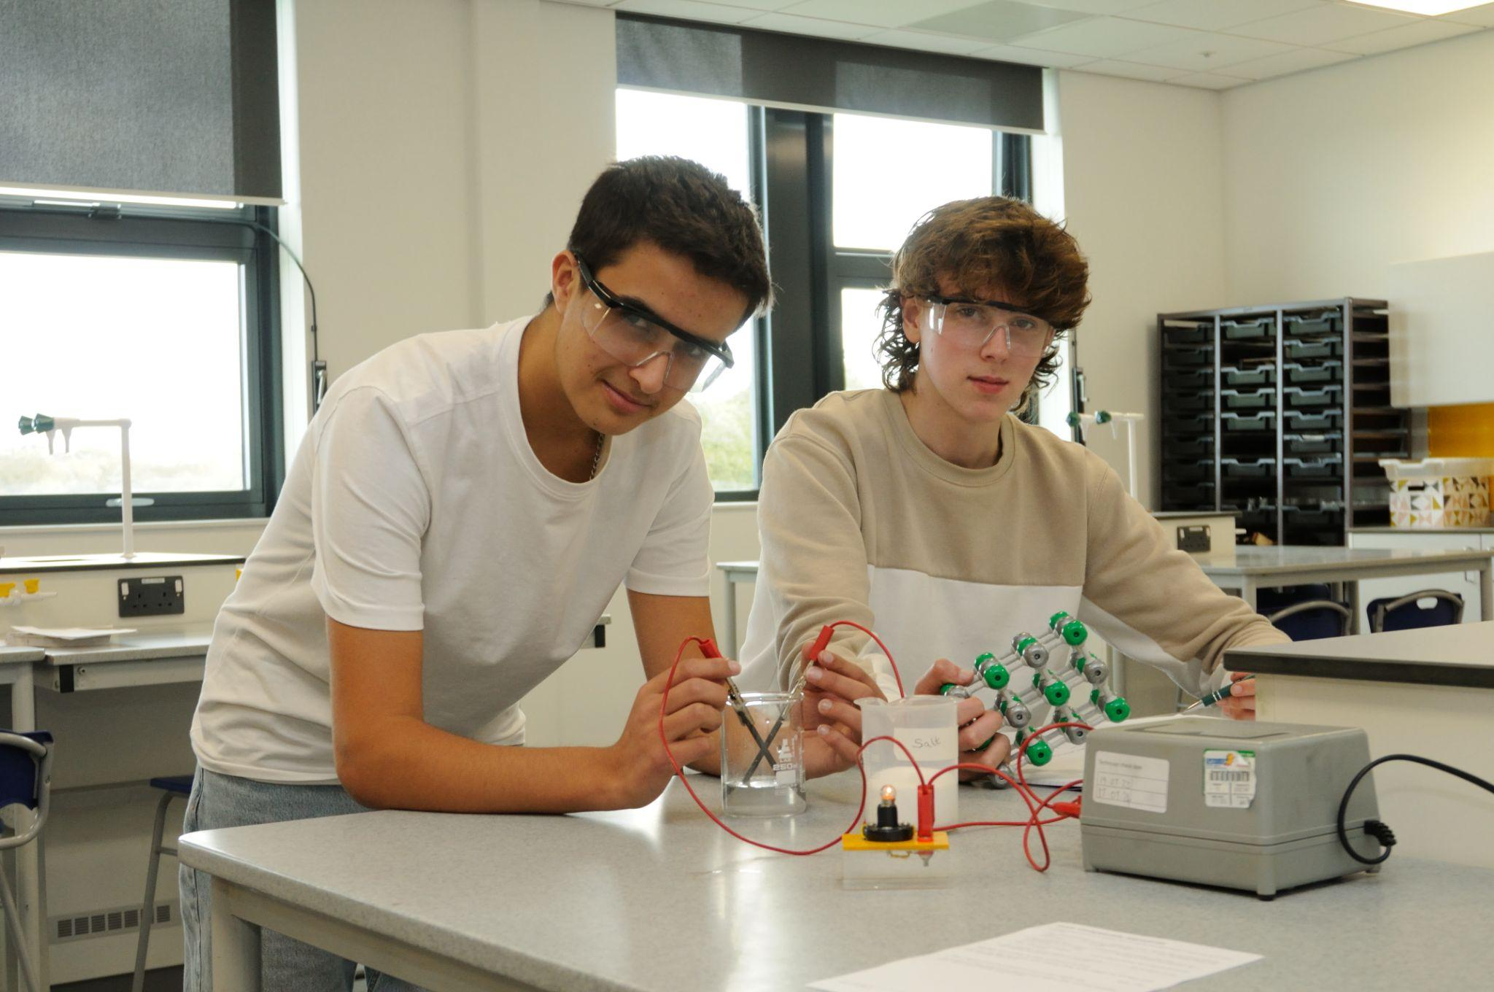
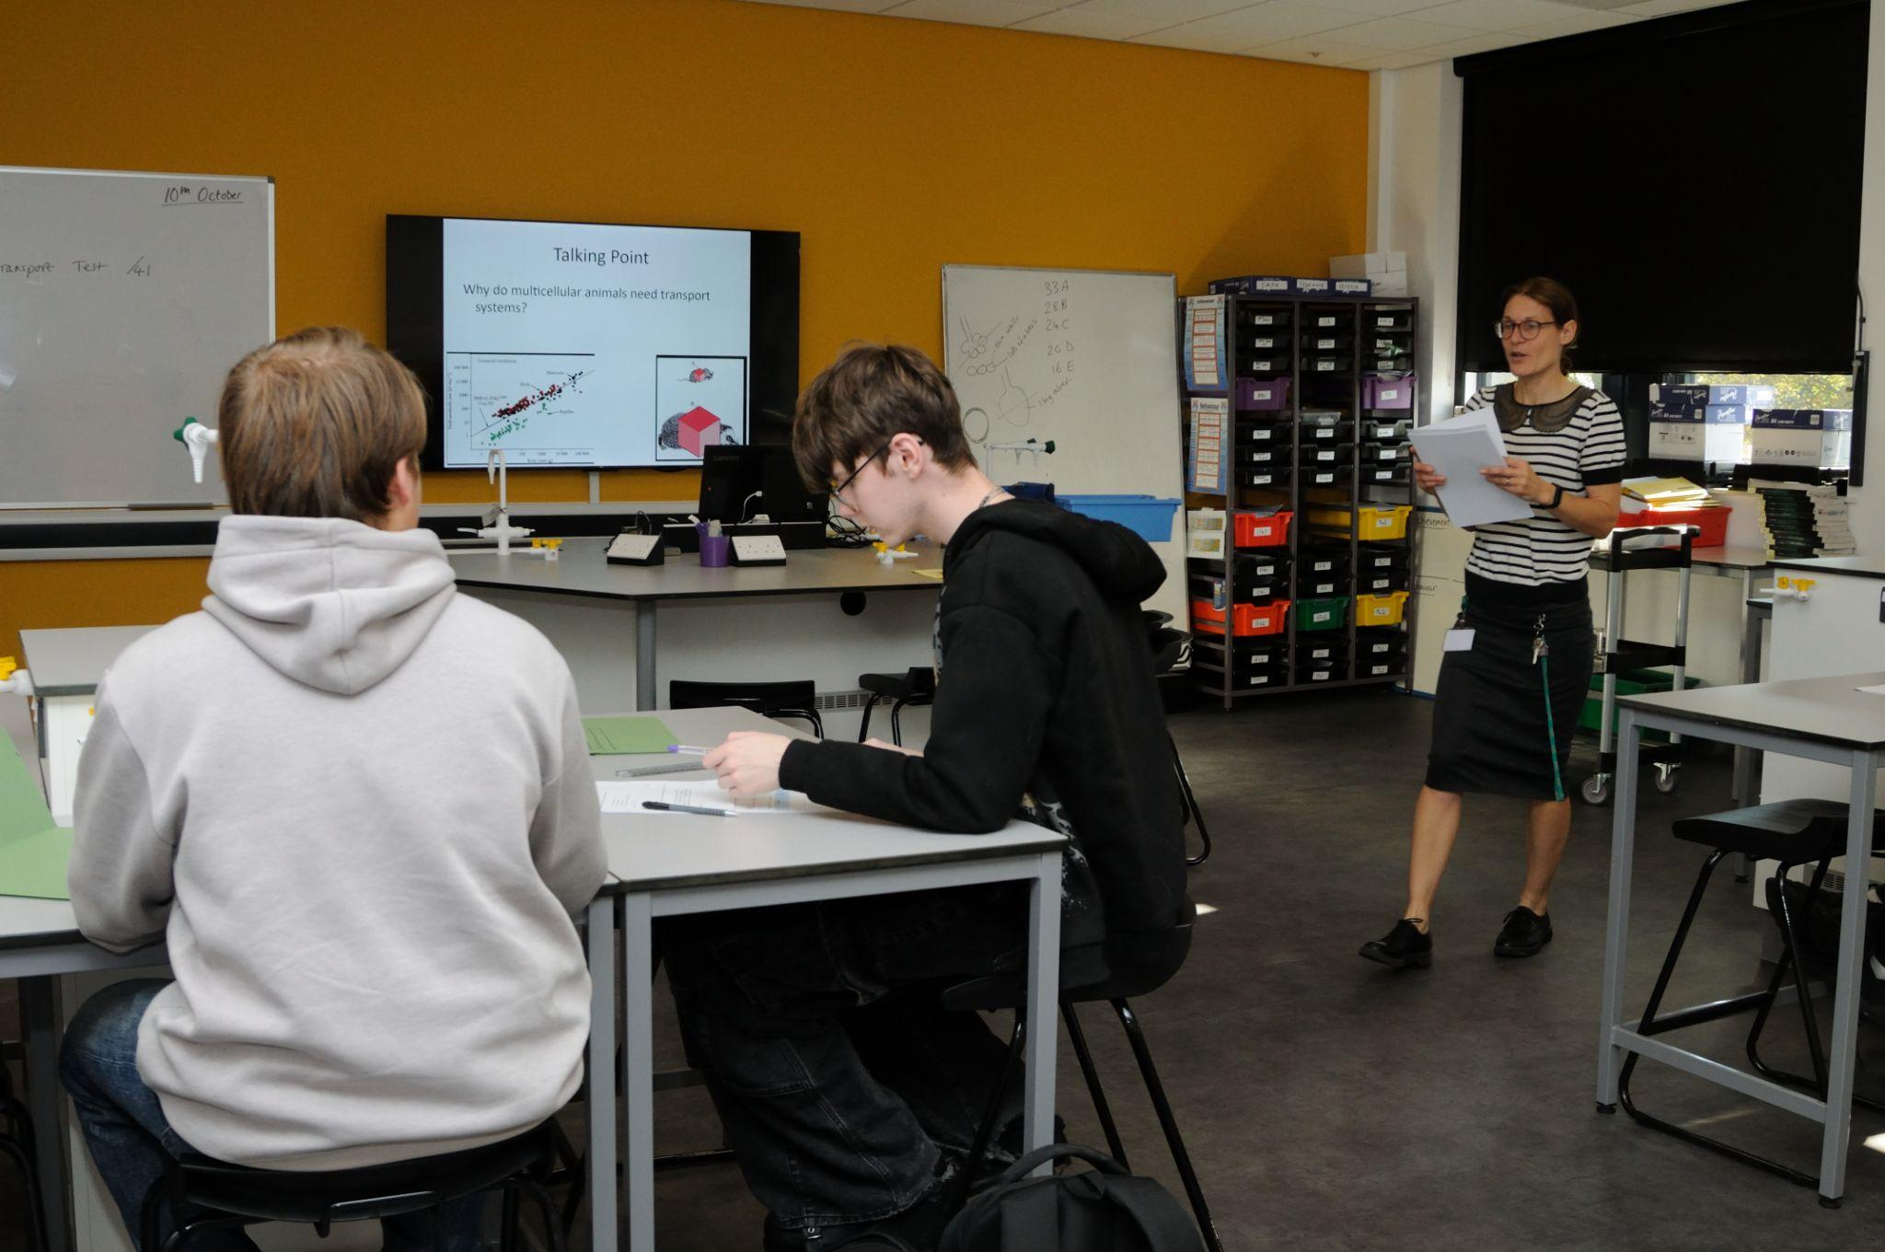
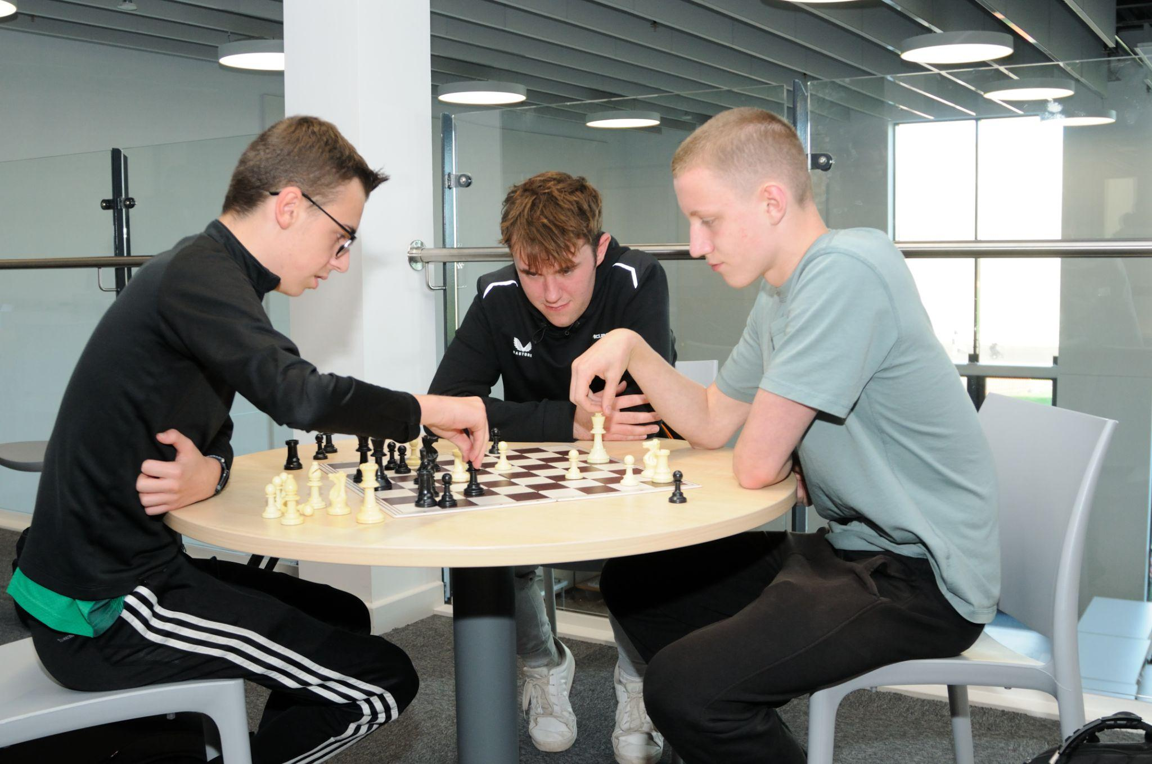

All three schools in the Seaton Valley Federation share a set of core values. We expect that all members of our school community will:
- develop their self-knowledge, self-esteem and self-confidence;
- respect the laws of England and will know right from wrong and ensure their
actions reflect this;
- accept responsibility for their behaviour;
- show initiative and contribute in a positive way to the school community, the
local community and society in general;
- show respect for each other and all other people;
- show tolerance and respect for different cultures and traditions and will never
act in such a way that these cultures or traditions are abused or attacked;
- show respect for the rule of democracy and respect for the democratic
principles of England.

Our New Building

September 2025 brought a new era for Seaton Valley High School and
Whytrig Middle School, as we moved into our new multi-million pound campus, featuring fantastic facilities for our students, staff and community, including fitness studio, swimming pool, 3G pitch. This has transformed the learning environment for students.

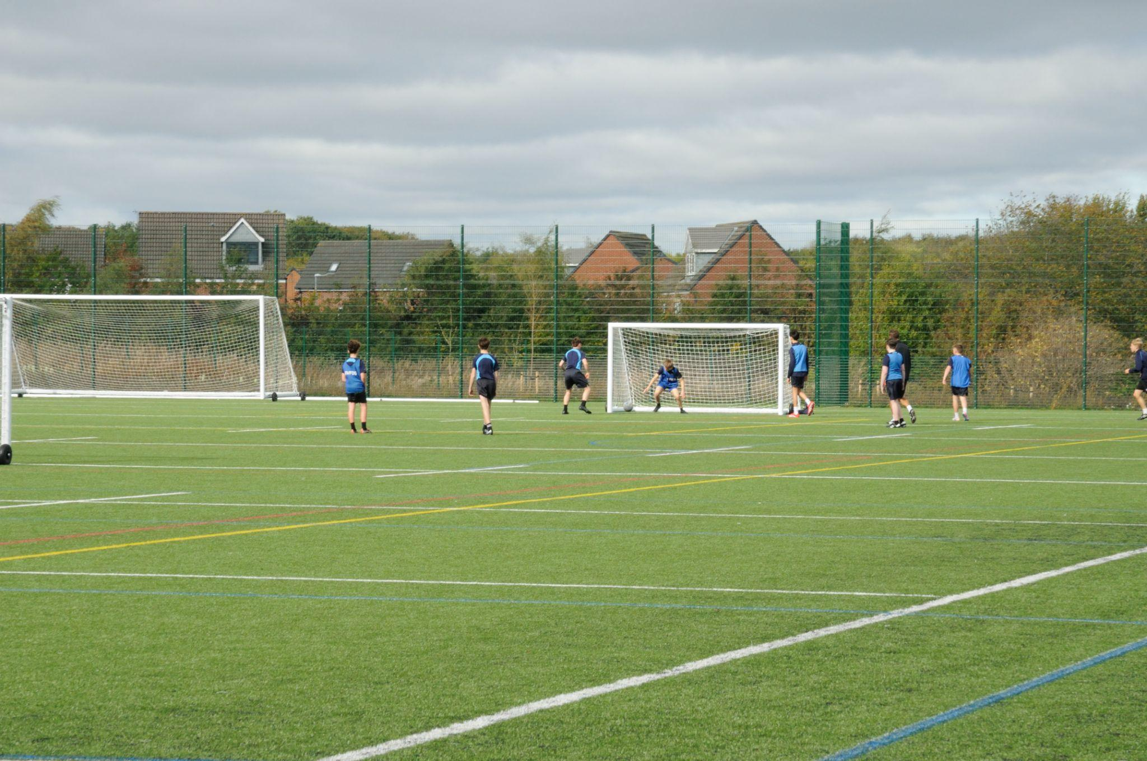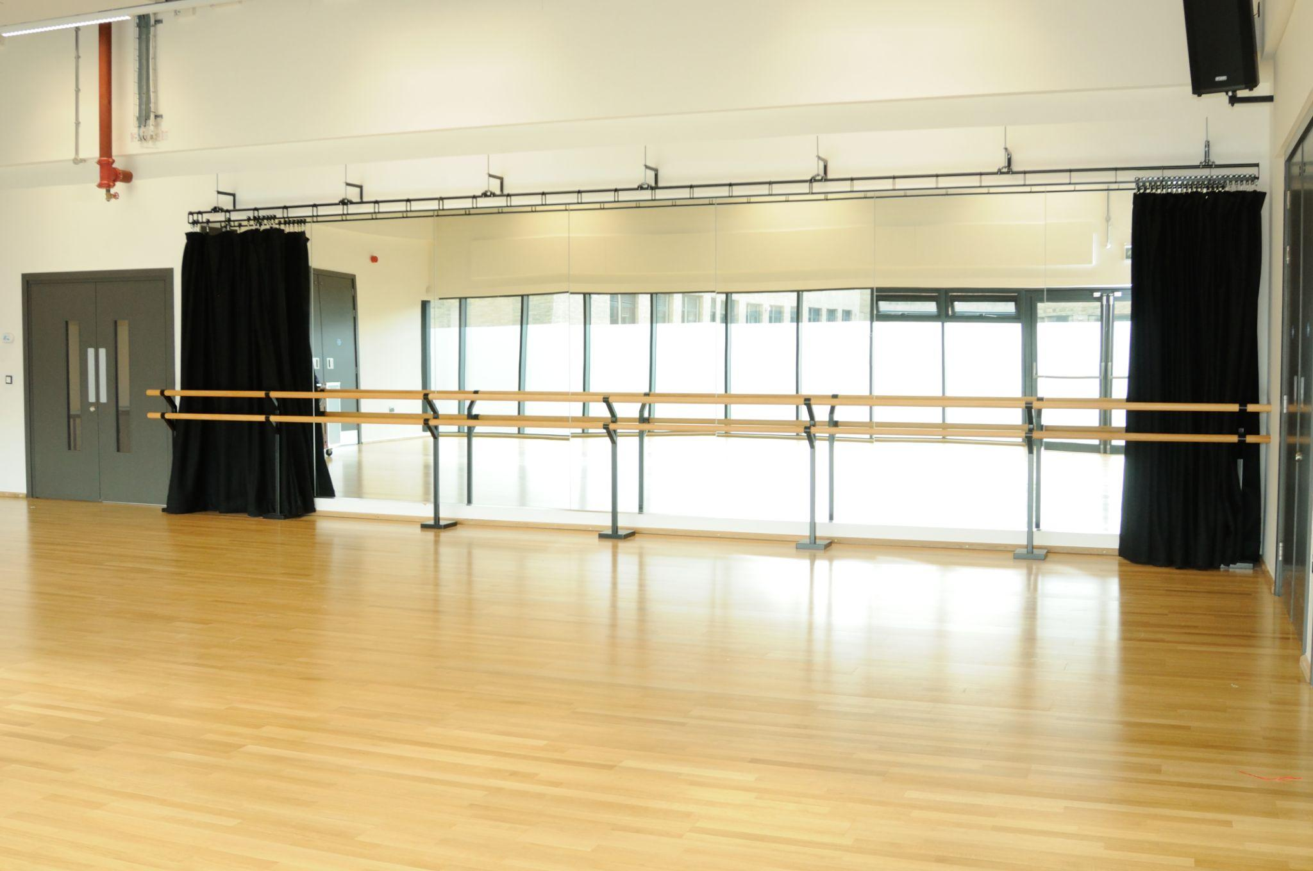
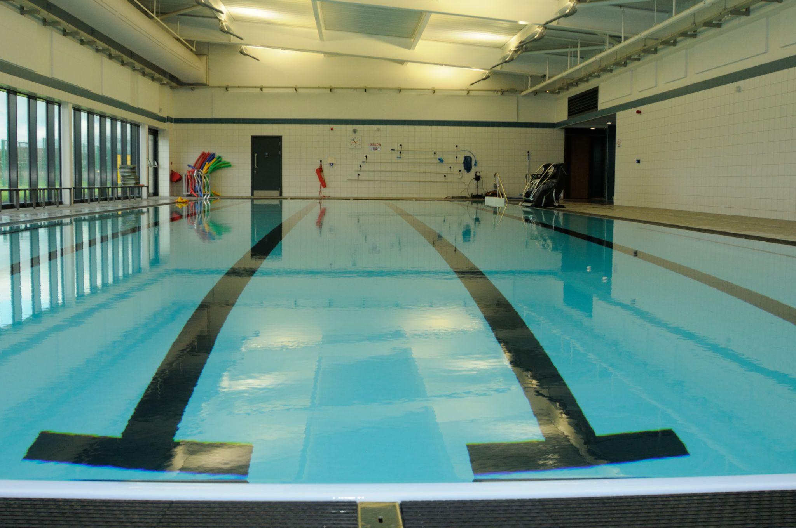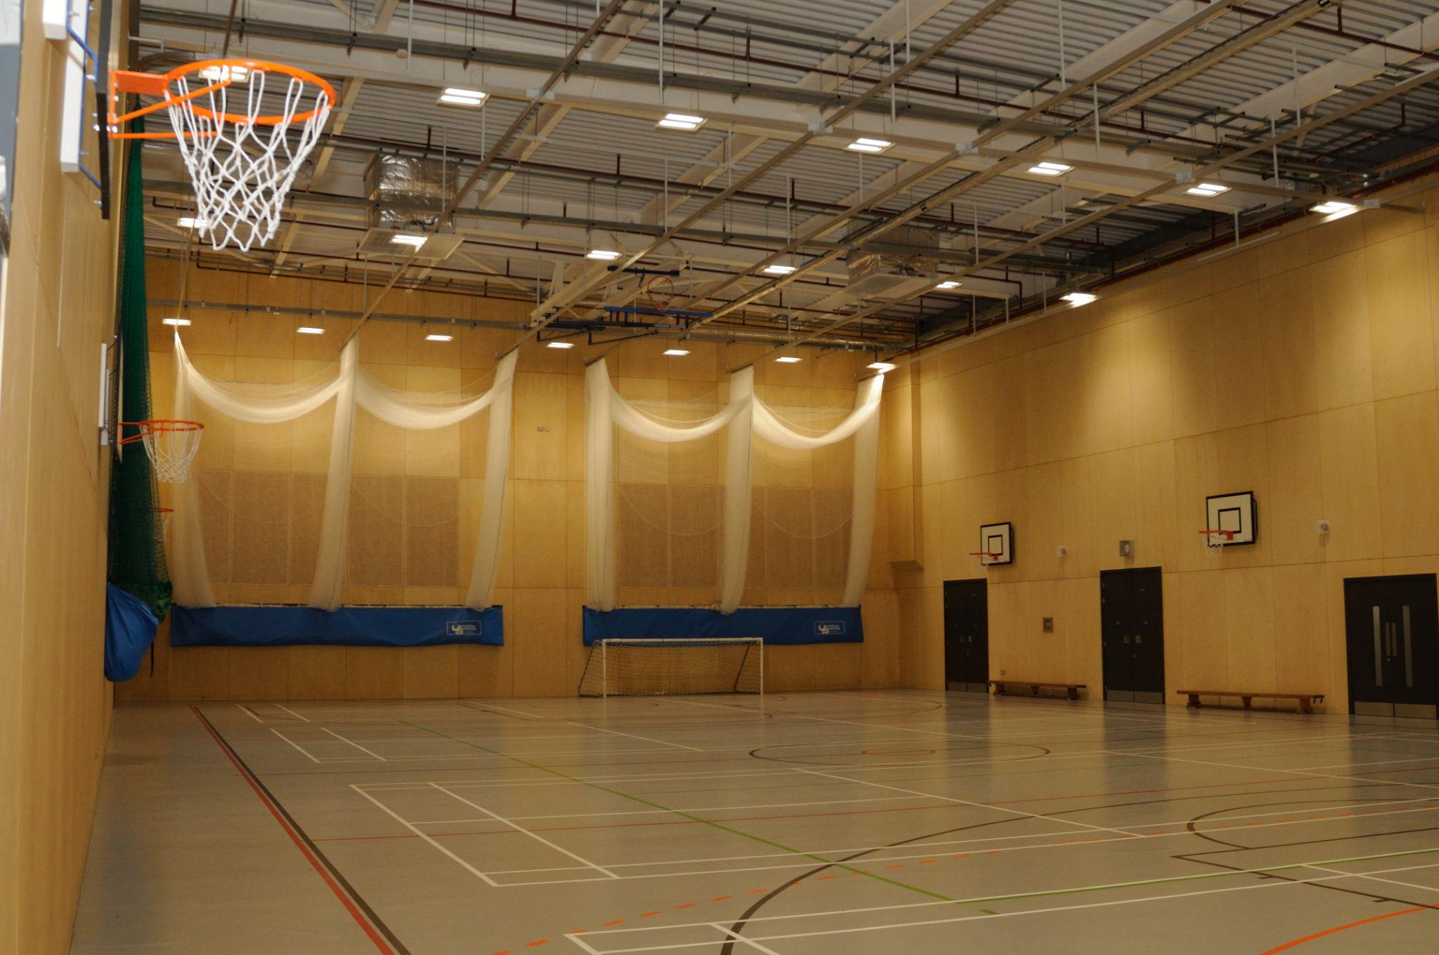
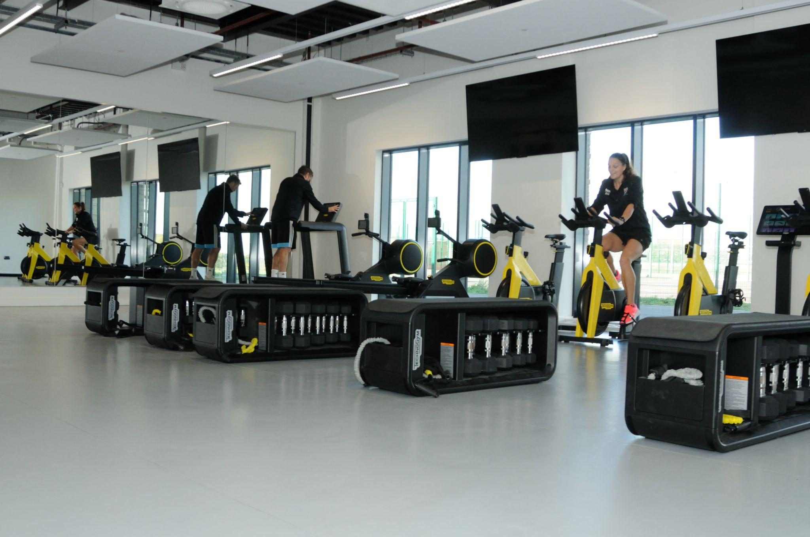

About our Schools

 | Age Range | Total Number of Pupils | Number in sixth Form
Seaton Valley High School | 13 to 18 years | 657 | 180
Seaton Sluice Middle School | 9 to 13 years | 314 | N/A
Whytrig Middle School | 9 to 13 years | 329 | N/A

Seaton Valley Federation attracts students from outside the Seaton Valley area
due to the inclusive nature of our school environment. Many students who have faced challenges elsewhere come to our schools and thrive. Our dedicated staff are both caring and nurturing, ensuring that every child is given the support and opportunities needed to succeed.

We focus on positive relationships between all members of the school community. We aim to help develop our students’ understanding of what positive relationships and behaviour look like and we strive to support those students who struggle with this, providing support for students wellbeing though our pastoral and counselling services.

We strive to support all students to achieve their full potential. This starts first through quality first teaching in each classroom – teachers knowing the students in front of them and adapting their teaching to suit the individual needs. Wraparound support is also put in place for those students who need it, especially from a pastoral and SEN perspective.

We also have a strong sixth form and we typically retain 75% of our Year 11 students for further study. This year we launched our Sports Academy in the sixth form, making the most of the fantastic new sporting facilities at Prospect Avenue.

About our Structure and Teams

The Senior Leadership team across our schools is led by the Executive
Headteacher, there is a Head of School in each school along with the Business
Director.

Executive Headteacher
VACANCY
Head of School  Seaton Valley  High School  Richard Goodman | Head of School  Whytrig  Middle School  Jon Souter | Head of School  Seaton Sluice  Middle School  Karen McSparron (retiring Summer 2026) | Business Director  Seaton Valley Federation  Ben Watson

In each school there is an individual Leadership Team, the SLT meet in their school base
but we often meet as a wider SLT to share practice across the federation.

Each member of the Senior Leadership Team line manages a faculty / department within their school, each faculty has a Head of Faculty. Our support staff team is headed up by
the Business Director, supported by Business Managers with responsibility for Data and Curriculum support, ICT and site, HR, Administration, partnerships, marketing and governance.

About our Performance and Ofsted

We are proud of our Ofsted reports, we are rated as Good schools
across the federation

 | Overall Effectiveness | Last Ofsted Inspection
Seaton Valley High School (formerly Astley Community High) | Good | December 2024
‘Astley Community High School is a close-knit community where pupils are safe and happy. Pupils are proud to attend the school and enjoy positive relationships with staff. The school has high expectations for pupils. Staff know pupils well. Pupils are regarded as individuals. Pastoral care is strong. Pupils conduct themselves well. They greet visitors warmly and demonstrate excellent manners. The school is calm and orderly. In lessons, pupils work hard and listen carefully to their teachers. At social times, pupils mix well together. Sixth-form students are positive role models for younger pupils.’

Seaton Sluice Middle School | Good | September 2023
‘Pupils at Seaton Sluice Middle School are proud of their school community. They say that everyone is welcome and that teachers will always help them do their best. Inspectors agree. Pupils are polite and confident when speaking to staff, visitors and each another. They are keen to make the most of their time at school.Bullying at the school is rare. If pupils are unkind in their words or actions, staff deal with this immediately. Pupils tell an adult if something is worrying them. The school counsellor provides additional support for vulnerable pupils. This helps pupils to become confident and resilient young adults. The school’s approach to promoting and supporting the mental health and well-being of pupils and staff is a strength of the school’

Whytrig Middle School | Good | December 2021
‘This school is an inclusive environment where pupils value each other. They respect and celebrate difference. There is a strong sense of community and pupils feel responsible for each other. Pupils spoken to would all challenge bullying if they saw it. Parents and carers and pupils agree that if bullying does occur, it is dealt with effectively by staff. Pupils feel safe and happy here. They are rightly proud of their school. Behaviour is exemplary. Pupils who have previously found school difficult thrive and flourish here.’

For full reports visit https://reports.ofsted.gov.uk

Our Commitment to Safeguarding

Keeping our children and young people safe and secure is crucially important.
We are committed to safeguarding and promoting the welfare of children and young people and we expect all staff and volunteers to share this commitment.

It is important during the recruitment process that we ensure candidates support this commitment. We will ask all applicants to tell us about any criminal convictions they have and the successful candidate will also need an enhanced certificate from the Disclosure and Barring Service (DBS). This does not mean that you cannot work here if you have a criminal conviction as we will take into account factors such as the age of the conviction, its relevance to the job and any mitigating factors before making a decision.

However we are aware that not everyone who is a risk to children will have a criminal conviction and therefore you should expect at interview that we will explore any gaps in your employment record, your motivations for working with children and young people and your ability to keep them safe from harm. We will also check this information in any references we receive, one of which must be from your current or last employer.

As part of our pre-employment checks, we will complete an online search of candidates.

How To Apply

All of our job vacancies are advertised on our website www.svf.org.uk/vacancies.

Please read through all of the information on the role and click on the link to apply, this will take you to mynewterm, our application portal, where you will be able to complete an application form online.

Please note that we do not accept CVs.

What We Offer and Staff Benefits

We offer staff benefits
Competitive Salary
Cycle To work Scheme
Onsite Parking
Onsite Gym at Seaton Valley and Whytrig
Teachers Pension Scheme
Local Government Pension Scheme for support staff
NHS Fleet solutions for support staff
Generous Annual Leave Allowance
Learning and Development
Salary Sacrifice
Occupational Health
Flu Jab
Mental Health support

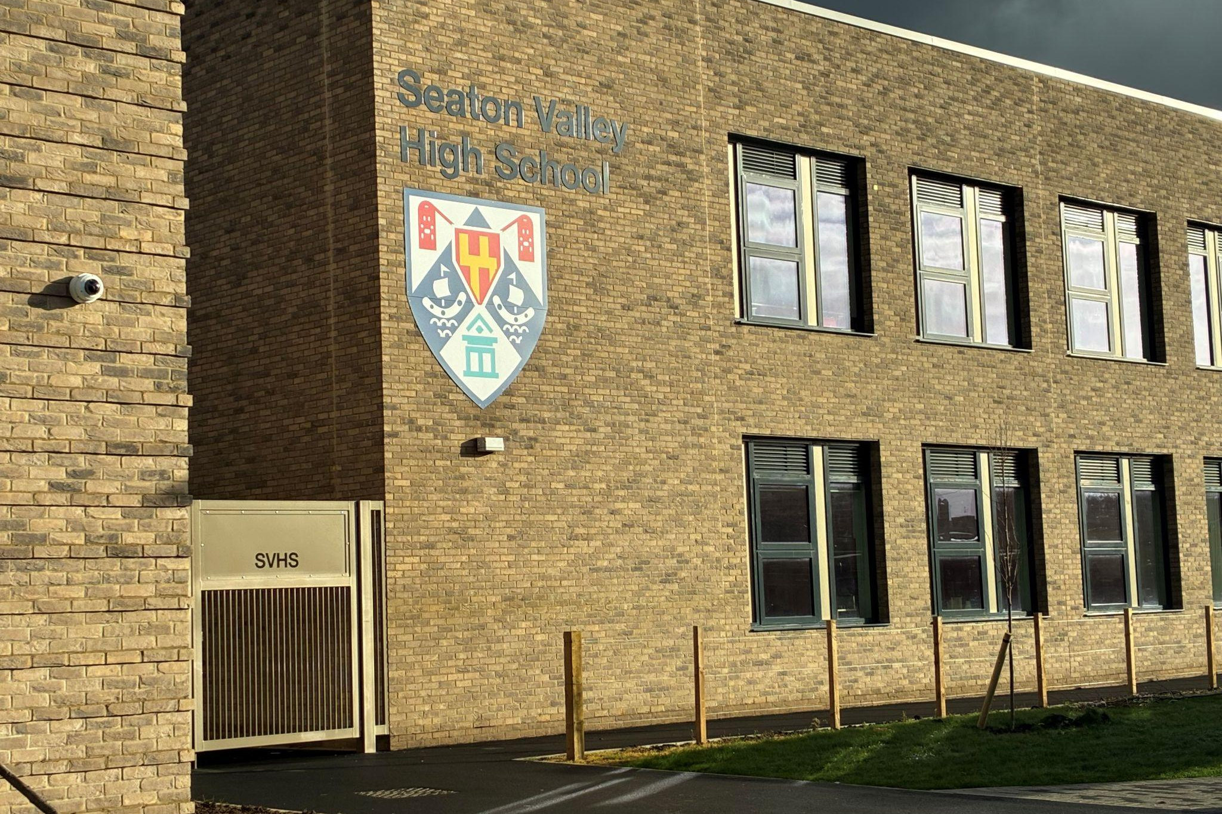

Contact Us
Seaton Valley Federation of Schools
Prospect Avenue
Seaton Delaval
NE25 0FW
0191 2371505
vacancies@svf.org.uk
www.svf.org.uk

