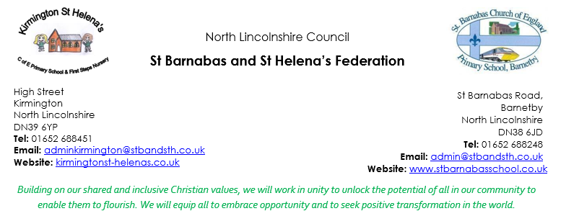
Dear Applicant
On behalf of the Governing Body, I would like to thank you for your interest in the position of Executive Headteacher of the St Barnabas and St Helena’s Federation.
We are a Federation of two small schools, who sit at the heart of their respective communities.
The Federation has been working closely over the past year with the St Lawrence Academies Trust which brings with it the necessary capacity for our small schools to develop and thrive. Governors intend that this collaboration continues and deepens over the forthcoming period.
This vacancy has arisen because our previous headteacher has resigned in order for him to pursue opportunities of further professional development.
Governors believe this post presents a unique opportunity for a skilled educator and leader to practise and develop those skills. We see “turning what could be into what is” as our ambition, and we see this translated at child-level, staff-level, school-level, federation-level and community level. Our new leader will be pivotal in helping us realise this ambition.
Governors are committed to building and maintaining a productive and supportive relationship with our Executive Headteacher to ensure that: our direction of travel accords with our vision; our strong Christian ethos pervades our thinking and doing; and every child and staff member is enabled to fulfil their potential.
We strongly encourage you to visit the schools. Our pupils are excellent ambassadors, and you will see first-hand our inclusive ethos and the great qualities of our pupils.
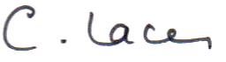
Everything we do is guided by our vision and rooted in the first verse of Psalm 133: You will see our Church school values being demonstrated across our whole school community through our daily Collective Worship and in all our interactions.

Christine Lacey
Chair of the Federation Governing Body

