

Welcome to the Cliff Federation

Willoughton Primary School
Northfield Lane, Willoughton
Gainsborough, lincolnshire,
DN21 5RT
enquiries@willoughton.lincs.sch.uk
www.willoughton.lincs.sch.uk




hemswell cliff primary school
capper avenue, hemswell cliff
gainsborough, lincolnshire
dn21 5xs
enquiries@hemswellcliff.lincs.sch.uk
www.hemswellcliff.lincs.sch.uk

Hemswell Cliff Primary School is a Group 1 school, NOR 35 pupils.
The school was graded ‘Good’ by Ofsted in November 2022.

Willoughton Primary School is a Group 1 school, NOR 45 pupils.

The school was graded as ‘Good’ by Ofsted in March 2024.



The Cliff Federation

Dear Applicant
Thank you for your interest in the post of Executive Head Teacher for the Cliff Federation. We enclose a pack of information about both our schools and the job description and specification. We hope this will provide you with an informed picture of our federation.
The vacancy for this post has come about due to our current Executive Head Teacher moving abroad with her family and leaves at the end of this academic year.
The combined pupils on roll for Willoughton and Hemswell Cliff totals 80 with children aged between 4 – 11 years. The 2 schools are located in a rural setting and are 3 miles apart, 14 miles north of Lincoln. They both play an important and vital role in the communities they serve and pride themselves on having a very caring and nurturing environment where pupils thrive and learn and families are well supported.
The Vision Strategy of the governing body gives focus and direction of the long-term development for both schools and we are looking for someone who shares the compassion, commitment, strategic direction and vision of the Governors, teachers and staff of both schools, to continue to develop and raise the standards even further.
The staff and governors at both schools are highly committed and enthusiastic to raising standards and are united behind a strong leadership team and would support the new Head Teacher in any way they can, to aid and foster excellent leadership within the school.
The staff and governors are really proud of our schools, and we would be delighted to welcome you to visit us prior to your application where either I or the School Business Manager will be happy to show you round.
Please contact the school office on: 01427 668381 (Willoughton) or 01427 668383 (Hemswell) where one of
our office staff will make an appointment for you.

Thank you, once again, for your interest and we look forward to hearing from you.

Sally Cowell
Chair of Governors



How to apply and key dates

- This is an Executive Headteacher position across our federation of two schools.

- The vacancy is for a Headteacher to commence in the Autumn Term in September 2026.

- The starting salary for this role will be within the Individual School Range of L 8 – 12.

- The closing date for applications is noon on Friday 8th May, 2026. Short listing will be complete by Wednesday 13th May, 2026.

- Successful candidates will be given more detail of the interview and recruitment process.

- Candidates are encouraged to book visits to our schools prior to submitting their application. Please email enquiries@hemswellcliff.lincs.sch.uk (01427 668383) or enquiries@willoughton.lincs.sch.uk (01427 668381).

- You are invited to submit an application form together with a covering letter. This letter should detail your ability to meet the key points within the Person Specification. Only the application form and covering letter will be considered by the Selection Panel; please do not forward any additional information at this stage.

- Completed application forms should be submitted to: Tina.dean@willoughton.lincs.sch.uk

- Interviews will take place on Wednesday 20th May, 2026.


Our staff and children look forward to meeting you.


Lincolnshire County Council
County Offices
Newland
Lincoln
LN1 1YL
Tel 01522 554590
Email: EducationTeam@lincolnshire.gov.uk

April 2026

MS/HO-S/CS

Dear Applicant,

Working in Lincolnshire

Thank you for your interest in the post of executive headteacher at The Cliff Federation, two Lincolnshire maintained primary schools.

Lincolnshire County Council is one of the largest employers in the county. We are an organisation that embraces diversity, innovation and progress. We value our people and want to ensure that we can support you in joining and growing with us. It is compassionate leadership, skills and commitment of our people that helps make us a high performing organisation which meets the ongoing needs of our residents, and especially our school communities.

Lincolnshire is a large rural county nestled in the heart of England and celebrates a unique blend of rich heritage and vibrant communities. Our towns offer affordable housing options, and a strong sense of community spirit. These factors make it a desirable place to live and work. With quaint villages, bustling market towns, and a historic city like Lincoln, from the Wolds to the Wash, here is a place here for everyone to call home.

Our schools are at the heart of our communities. Lincolnshire County Council wants the very best outcomes for our children and young people and their families. We are committed to our schools and our Education team are highly skilled at providing support and challenge to school leaders in Lincolnshire. You will be supported through a range of opportunities including a comprehensive leadership programme providing support throughout your career; from a new headteacher induction programme through to executive leadership support. We also offer regular support from an Education Locality Lead through focussed termly visits. Leadership briefings are provided each term for information sharing, networking and leadership development, including a forum for Lincolnshire leaders which responds to the needs of our leaders.

In Lincolnshire we value the broad range of training on offer. We work closely with training providers, including L.E.A.D. Professional Development and Teaching School Hub, LEARN SEND Hub and our curriculum Hubs who can provide general and bespoke CPD. We also work together with the Lincoln Diocesan Board of Education to ensure our calendar of support complements the church schools' CPD programme.

Lincolnshire is proud of its sector-led system, Lincolnshire Local Authority focuses on meeting the needs of all children and young people at the right time, in the right place in the right way. We operate a sector led model of school improvement, overseen by our strategic school improvement service and delivered by our Education Team. The Lincolnshire Education Group (LEG) oversees the system improvement agenda, and The Partnership of Schools Group (PSG) includes headteacher representatives from schools across the county. These groups work collaboratively with our partners to develop our understanding of each district, so that we know the opportunities and challenges schools face. Our sector-led, partnership approach allows constant adaptability to innovate to address issues and celebrate successes.

I hope you will find time to visit the school and wish you success with your application.

Yours faithfully,



Martin Smith
Assistant Director-Children’s Education
Lincolnshire County Council

Information about our schools

Hemswell Cliff Primary School

At Hemswell Cliff Primary School Governors, parents and staff work together to achieve the quality education that our children deserve. We care for, and about, all pupils by providing a happy, calm, supportive and stimulating environment. We ensure that the curriculum is well planned to meet individual needs.

All children are encouraged to fell a sense of pride and self-worth in all that they do. They are asked to demonstrate responsibility, tolerance and a desire to achieve the highest possible standards, both as individuals and as members of our school and the wider community.

The school is set in grounds which are both attractive and extensive. Our school is a lovely building to be in and the learning environment is bright and stimulating. We are an inclusive school and we have high expectations for all our children and for our school. We cater for children between 4 – 11 years old who are taught in mixed year groups. Our exceptional staff are warm and caring whilst having the highest of expectations of each child. The teaching and learning that they provide is of the highest quality. Every pupil is encouraged to strive for personal excellence in all areas of school life. We aim to support pupils as they learn by giving them a strong sense of belonging, building self-esteem and developing a passion for learning and the confidence to try new things that we allow each child to flourish and truly achieve their potential.



Our Aims

The aims of the school are to:
- Create a welcoming, happy and secure working environment;
- Actively develop in children an enjoyment of, and interest in learning;
- Provide a broad, balanced, stimulating and challenging curriculum;
- Have high expectations of every child in all aspects of school life;
- Appreciate, encourage and promote every child’s individual skills, abilities and talents;
- Encourage children to recognise their own worth, work well with others and become increasingly responsible for their own learning;
- Develop high quality home-school and community links; and
- Equip children with the attitudes, values and skills needed to become informed, active and responsible citizens.


Our Values
Hemswell Cliff is a values-led community school. The most important thing for us is the well-being of the children in our care each day. We believe that the pupils will thrive if they are secure and happy in their lives, so we communicate productively with parents and carers in a variety of ways including:
- Home-school book;
- Full involvement of parents/carers in decisions about their child’s education e.g. annual reviews, PLP reviews, consultation evenings, questionnaires, regular contact with class teachers;
- Family Learning;
- Beacon Club etc.

We have adopted the Values for Education programme in order to enhance the provision we already had in place to give children the very best opportunities for spiritual, moral, social and cultural development. It particularly draws together strands of the work we do in Religious Education; Personal, Social and Health Education; Citizenship and the respectful way we feel people should manage themselves and behave towards others.

A key value is introduced through a whole-school assembly highlighting the values of:

Responsibility, Patience, Quality, Co-operation, Tolerance and Aspiration.

Each value is then discussed and reinforced as part of the curriculum through a range of activities and in subsequent class or assemblies, in social times such as play or lunchtimes, and in staff briefings and meetings.

Since we started our Values work in 2011 the impact has been clear and includes:
- Pupils showing even more positive attitudes towards each other and a willingness to share and take turns;
- An inclusive drive to put the week’s values into practice;
- Pupils talking openly about the values and what they mean;
- A growing sense of awareness of the needs of others; and
- A Genuine interest in the values and how they apply to Hemswell Cliff and the wider community.

Going forwards, we will continue to build on these strong foundations with the aim that our pupils take them out into the community as part of our contribution to the wider society.

School Management The staff are strongly committed to raising standards and are united behind a strong senior leadership team which comprises of the Headteacher, base leader, SENCO and SBM. This team seeks high standards, staff development and the building of positive relationships with the school community – all of which is considered within a child centred ethos.

The Organisation of Classes/Staffing - The school comprises of 3 classes (Class 1 - EYFS, Year 1 and Year 2, Class 2 - Year 3 and 4, and Class 3 - Year 5 and 6. The school also employs highly skilled teaching assistants who either support teaching and learning in the classroom, support pupils on a 1:1 basis or run intervention groups.
Little Lancasters Nursery
In September 2025 saw the opening of our nursery. We are school-based currently offering places to 3- & 4-year-olds. We are open 9.15am to 3.15pm, Monday to Friday during term time. We provide a nurturing, play-based early learning environment within our vast grounds that support the development of the whole child - cognitively, emotionally, physically and socially. Our curriculum is aligned with the early years education standards and designed to prepare children for a successful start to primary school. Our exceptional staff are warm and caring whilst having the highest of expectations of each child.

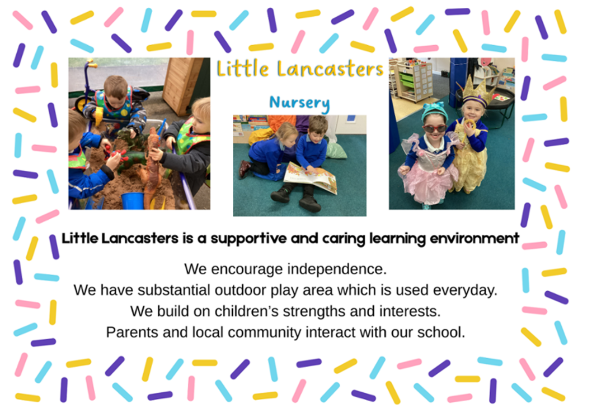

Willoughton’s Aims and Values


Willoughton Primary School is a small rural school at the heart of the community. We pride ourselves on creating a warm, caring and family atmosphere, in which all members of the community can learn and grow together. We are an inclusive school and have high expectations for all our children and for our school. We cater for children between 4 – 11 years old who are taught in mixed year groups.

Our exceptional staff are warm and caring whilst having the highest of expectations of each child. The teaching and learning that they provide is of the highest quality. Every pupil is encouraged to strive for personal excellence in all areas of school life. We aim to support pupils as they learn by giving them a strong sense of belonging, building self-esteem and developing a passion for learning and the confidence to try new things that we allow each child to flourish and truly achieve their potential.

Our Aims and Values
Growing minds, shaping hearts

We aim to nurture and challenge our children to flourish and be the best that they can be through our caring family atmosphere where all children are equally important to us.

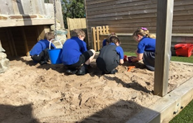
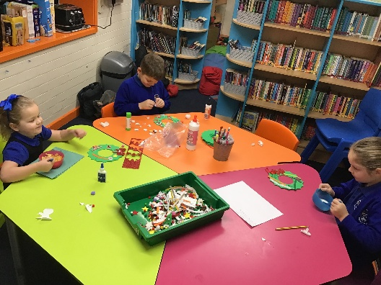

Our approach is to build on our six Values known as Cedric and our six golden rules:
- We are gentle
- We are kind
- We work hard
- We look after property
- We are honest
- We listen

These values inform our work to secure the highest possible outcomes for all our children in all areas of school life.

We recognise the vital importance of education in partnership with parents, governors and the local community.

School Management The staff are strongly committed to raising standards and are united behind a strong senior leadership team which comprises of the Headteacher, base leader, SENCO and SBM. This team seeks high standards, staff development and the building of positive relationships with the school community – all of which is considered within a child centred ethos.

The Organisation of Classes/Staffing - The school comprises of 3 classes (Class 1 EYFS, Year 1 and Year 2. Class 2 Year 3 and Year 4. Class 3 Year 5 and Year 6. The school also employs highly skilled teaching assistants who either support teaching and learning in the classroom, support pupils on a 1:1 basis or run intervention groups.

Executive Headteacher Job Description
(Please also refer to the Contractual framework for headteachers document STPCD)

Headteachers’ Standards 2020

Section 1: Ethics and professional conduct
Headteachers are expected to demonstrate consistently high standards of principled and professional conduct. They are expected to meet the teachers’ standards and be responsible for providing the conditions in which teachers can fulfil them.

Headteachers uphold and demonstrate the Seven Principles of Public Life at all times. Known as the Nolan principles, these form the basis of the ethical standards expected of public office holders:
- selflessness
- integrity
- objectivity
- accountability
- openness
- honesty
- leadership

Headteachers uphold public trust in school leadership and maintain high standards of ethics and behaviour. Both within and outside school, headteachers:
- build relationships rooted in mutual respect, and at all times observe proper boundaries appropriate to their professional position
- show tolerance of and respect for the rights of others, recognising differences and respecting cultural diversity within contemporary Britain
- uphold fundamental British values, including democracy, the rule of law, individual liberty and mutual respect, and tolerance of those with different faiths and beliefs
- ensure that personal beliefs are not expressed in ways which exploit their position, pupils’ vulnerability or might lead pupils to break the law

As leaders of their school community and profession, headteachers:
- serve in the best interests of the school’s pupils
- conduct themselves in a manner compatible with their influential position in society by behaving ethically, fulfilling their professional responsibilities and modelling the behaviour of a good citizen
- uphold their obligation to give account and accept responsibility
- know, understand, and act within the statutory frameworks which set out their professional duties and responsibilities
- take responsibility for their own continued professional development, engaging critically with educational research
- make a positive contribution to the wider education system

Section 2: Headteachers’ standards

School culture
Headteachers:
- establish and sustain the school’s ethos and strategic direction in partnership with those responsible for governance and through consultation with the school community
- create a culture where pupils experience a positive and enriching school life
- uphold ambitious educational standards which prepare pupils from all backgrounds for their next phase of education and life
- promote positive and respectful relationships across the school community and a safe, orderly and inclusive environment
- ensure a culture of high staff professionalism

- Teaching
Headteachers:
- establish and sustain high-quality, expert teaching across all subjects and phases, built on an evidence-informed understanding of effective teaching and how pupils learn
- ensure teaching is underpinned by high levels of subject expertise and approaches which respect the distinct nature of subject disciplines or specialist domains
- ensure effective use is made of formative assessment

- Curriculum and assessment
Headteachers:
- ensure a broad, structured and coherent curriculum entitlement which sets out the knowledge, skills and values that will be taught
- establish effective curricular leadership, developing subject leaders with high levels of relevant expertise with access to professional networks and communities
- ensure that all pupils are taught to read through the provision of evidence-informed approaches to reading, particularly the use of systematic synthetic phonics in schools that teach early reading
- ensure valid, reliable and proportionate approaches are used when assessing pupils’ knowledge and understanding of the curriculum

- Behaviour
Headteachers:
- establish and sustain high expectations of behaviour for all pupils, built upon relationships, rules and routines, which are understood clearly by all staff and pupils
- ensure high standards of pupil behaviour and courteous conduct in accordance with the school’s behaviour policy
- implement consistent, fair and respectful approaches to managing behaviour
- ensure that adults within the school model and teach the behaviour of a good citizen

- Additional and special educational needs and disabilities
Headteachers:
- ensure the school holds ambitious expectations for all pupils with additional and special educational needs and disabilities
- establish and sustain culture and practices that enable pupils to access the curriculum and learn effectively
- ensure the school works effectively in partnership with parents, carers and professionals, to identify the additional needs and special educational needs and disabilities of pupils, providing support and adaptation where appropriate
- ensure the school fulfils its statutory duties with regard to the SEND code of practice

- Professional development
Headteachers:
- ensure staff have access to high-quality, sustained professional development opportunities, aligned to balance the priorities of whole-school improvement, team and individual needs
- prioritise the professional development of staff, ensuring effective planning, delivery and evaluation which is consistent with the approaches laid out in the standard for teachers’ professional development
- ensure that professional development opportunities draw on expert provision from beyond the school, as well as within it, including nationally recognised career and professional frameworks and programmes to build capacity and support succession planning

- Organisational management
Headteachers:
- ensure the protection and safety of pupils and staff through effective approaches to safeguarding, as part of the duty of care
- prioritise and allocate financial resources appropriately, ensuring efficiency, effectiveness and probity in the use of public funds
- ensure staff are deployed and managed well with due attention paid to workload
- establish and oversee systems, processes and policies that enable the school to operate effectively and efficiently
- ensure rigorous approaches to identifying, managing and mitigating risk

- Continuous school improvement
Headteachers:
- make use of effective and proportional processes of evaluation to identify and analyse complex or persistent problems and barriers which limit school effectiveness, and identify priority areas for improvement
- develop appropriate evidence-informed strategies for improvement as part of well-targeted plans which are realistic, timely, appropriately sequenced and suited to the school’s context
- ensure careful and effective implementation of improvement strategies, which lead to sustained school improvement over time

- Working in partnership
Headteachers:
- forge constructive relationships beyond the school, working in partnership with parents, carers and the local community
- commit their school to work successfully with other schools and organisations in a climate of mutual challenge and support
- establish and maintain working relationships with fellow professionals and colleagues across other public services to improve educational outcomes for all pupils

- Governance and accountability
Headteachers:
- understand and welcome the role of effective governance, upholding their obligation to give account and accept responsibility
- establish and sustain professional working relationship with those responsible for governance
- ensure that staff know and understand their professional responsibilities and are held to account
- ensure the school effectively and efficiently operates within the required regulatory frameworks and meets all statutory duties.

Person Specification

Executive Head Teacher

Selection decisions will be based on the criteria outlined below. At each stage of the process an assessment will be made by the appointment panel to determine the extent to which the criteria have been met. When completing your application paperwork, you should ensure that you address each of the selection criteria and provide supporting evidence of how you meet the criterion through reference to your work or relevant experience. These criteria will be assessed using evidence from your application form, formal interview, interview tasks and references.

A. Qualifications & Experience
Essential | Desirable
Qualified Teacher Status (QTS) | NPQH
Significant and successful senior leadership experience in a primary school | Experience of working on more than one site
Commitment to ongoing professional development
Experience across the full primary range, including Foundation Stage

B. Safeguarding Children
Essential | Desirable
Current safeguarding training | Safer recruitment training
Enhanced DBS clearance | Experience as DSL/DDSL
Strong understanding of safeguarding and child protection systems
Evidence of maintaining a safe, well-ordered environment
Fully supportive references

C. Knowledge & Understanding
Essential | Desirable
Excellent understanding of the primary curriculum across all Key Stages | Experience monitoring and evaluating Pupil Premium impact
Clear understanding of the SEN Code of Practice with proven experience supporting pupils to overcome barriers to learning and fostering an inclusive culture | Experience working with external agencies
Ability to articulate and lead a clear vision for school improvement
Manages workload effectively and supports staff wellbeing
Commitment to developing a broad, balanced curriculum to nuture the whole child,
Provides constructive feedback promoting progress and achievement

D. Pupils & Staff
Essential | Desirable
Proven ability to manage behaviour positively and effectively | Skilled in fostering a culture of positive behaviour
Creates an environment supporting pupils’ personal and emotional growth
Sets aspirational standards for pupils and staff
Inspires, motivates, and develops others
Identifies and nurtures emerging leadership talent
Builds strong, respectful relationships and effective teams
Keeps abreast of educational research and developments

E. Systems & Processes
Essential | Desirable
Understands the impact of budgets and resource planning on sustainability
Builds positive relationships across the school community

F. The Self-Improving System
Essential | Desirable
Promotes diversity, equality, and inclusion | Experience of Ofsted inspection at leadership level
Fosters parental engagement and community partnerships
Encourages staff development and professional growth
Builds on previous Ofsted outcomes
Works collaboratively with governors, welcoming support and challenge
Communicates school performance clearly to stakeholders

G. Personal Attributes
Essential | Desirable
Dedicated, child-centred, and good-humoured | Emotionally intelligent and empathetic
Reflective and appreciative of existing achievements | Inspires trust and confidence
Flexible, approachable, and enthusiastic | Creative thinker with initiative
Resilient under pressure | Experience of networking
Excellent communicator with strong interpersonal skills

H. Leadership Skills
Essential | Desirable
Engages effectively with the wider community | Approachable and supportive leadership style
Leads across both schools, balancing their needs  with integrity, inspiration, resilience, and creativity | Motivates, coaches, and challenges staff
Demonstrates strategic oversight and distributive leadership
Confident, compassionate and adaptable leadership style suited to changing educational environments
Able to refect honestly on emotional responses and lead with authenticity and transparency
Skilled in managing time and priorities to avoid overload while supporting strategic goals.


The Cliff Federation
Recruitment Privacy Notice

About Us
The Cliff Federation is known as the "Controller" of the personal data you provide to us. The purpose of this privacy notice is to tell you how and why we use the information we gather about you when you apply to work with us.

Why do we collect your personal data?
It is necessary for us to collect and process personal data about you in order to assess your eligibility to work with us and to make a decision about your recruitment and employment. More specifically, this will include but is not limited to the following:
- Assessing your skills, qualifications and suitability for a role within the school
- Carrying out background and reference checks, where applicable
- Communicating with you about the recruitment process
- Maintaining records relating to the recruitment process
- To comply with legal or regulatory requirements e.g. Safer Recruitment

We will not collect any personal data that we do not need and as far as is reasonable and practicable will ensure that the information recorded is accurate and kept up to date.

What personal data do we collect?
The personal data we will collect includes:
- Personal contact details such as name, address, telephone number and email address
- Date of Birth
- National Insurance Number
- Employment history
- Qualifications and other academic achievements
- Contact information for the provision of references
- Identification documents
- Results of psychometric testing, where applicable.

We will also collect and use the following "special categories" of more sensitive personal data:
- Information about your race, ethnicity, religious beliefs, sexual orientation and political opinions
- Trade union membership
- Information about your physical and mental health, including any medical conditions.
- Information about criminal convictions and offences, including information from the Disclosure and Barring Service.

Who do we get your personal data from?
This information is collected in the following ways:
- Provided to us directly by you through the application form and at interview
- From your named referees

Who do we share your data with?
We will only share information when it is necessary to do so for the purpose of recruitment and in accordance with the law. Where necessary, we will share your data with organisations that deliver services on behalf of the school.

Where necessary we will share your personal data with the following categories of recipients:
- Disclosure and Barring Service
- Occupational Health Provider
- Previous employers and other individuals identified as capable of giving a reference
- Professional advisors and consultants involved in the recruitment exercise

How long do we keep your data for?
We are required to retain your personal data only for as long as is necessary, after which it will be securely destroyed in line with the school's retention policy.

Retention periods can vary and will depend on various criteria including the purpose of processing, regulatory and legal requirements, and internal organisational need.

Retention periods for recruitment data will be kept securely for up to 6 years after finishing employment with our school. Unsuccessful candidates data will be destroyed for up to 9 months after the closing deadline.

How do we keep your data safe?
We have an information security policy which sets out how we aim to keep your personal data secure. The policy can be found on our school website.

Access to information is strictly controlled based on the role of the professional. All staff are required to undertake regular data protection training.

Your personal data is not processed outside of the EU by the school.

Your Rights
You have a number of rights which relate to your personal data.

You are entitled to request access to any personal data we hold about you and you can also request a copy.

You can also request that we correct any personal data we hold about you that you believe is inaccurate;

You can request that we erase your personal data and request that we stop processing all or some of the personal data we hold.

We are obliged to consider and respond to any such request within one calendar month.

To exercise any of your rights please contact the schools’ Data Protection Officer, contact details below.

Further Information
If you wish to make a request or make a complaint about how we have handled your personal data please contact:
- Data Protection Officer Tina.dean@willoughton.lincs.sch.uk

Alternatively, you can contact the school by writing to: enquiries@willoughton.lincs.sch.uk

If you are not satisfied with our response or believe we are not processing your personal data in accordance with the law you can complain to the Information Commissioner’s Office (ICO) www.ico.org.uk

