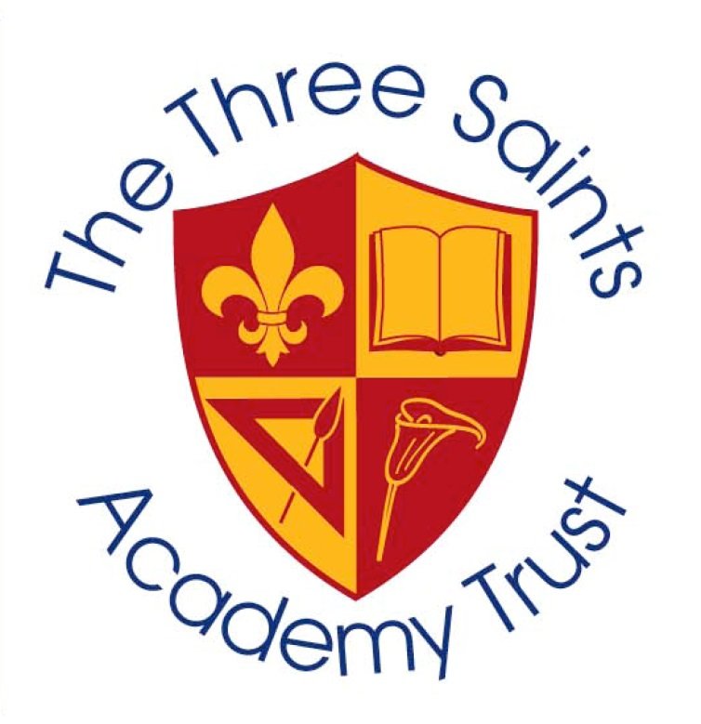
The Three Saints Academy Trust

We currently have the following vacancy, to commence 1st September 2025 or sooner/later depending on notice period.

- Executive School Business Manager

- Full-time, term time only plus 10 days

- Scale: PO4 SCP 35-38 - £44,711 to £47,754 FTE

- 37 hours per week x 45.6 weeks = Actual minimum pay dependent on continuation of employment will be £39,101 to £41,763

Directors of our multi academy trust are looking to recruit a highly motivated and inspirational Business Manager to work across two of the schools in the Trust. You will support the CEO, CFOO and Headteachers as part of our Finance and Business function in achieving our vision, aims and ethos.

You will work across two schools within our MAT as the SBM at each of the schools on a 50/50 basis.

St Marys and St Thomas CofE Primary School, Barton Close, St Helens
Willow Tree Primary School, Leach Lane, St Helens.

We are looking for someone who:
- Is an experienced School Business Manager who is ambitious and looking for a new challenge in their career
- Is extremely organised and efficient with great interpersonal skills
- Has considerable experience of financial management and who is able to deliver our school improvement plans within budget
- Has significant experience working in administration and managing the work of others
- Has problem solving skills and a “can do” attitude
- Can travel between the schools in our Trust.

To apply for this role please email the TTSAT CEO & CFOO on Kirsty.tennyson@three-saints.org.uk and maria.taylor@three-saints.org.uk to request an application pack and to arrange informal visits with the CFOO at the Trust’s Head Office which is located at Willow Tree School

Closing date: 13th June 2025 at 12 noon

