
Experienced Class Teacher
St Catherine’s CE Primary School, Kidderminster
Permanent – Main Pay Range 3 – Upper Pay Range 3
Start Date: 1st September 2026

Join Our Inspiring School Community
Following the retirement of a highly valued and committed teacher, we are excited to invite applications for an experienced and passionate Class Teacher to join our dedicated team at St Catherine’s in September 2026.
This is more than just a teaching role—it’s an opportunity to make a lasting difference, shape young lives, and contribute to a thriving, supportive church school community where children and staff flourish together.
You will take responsibility for delivering high-quality teaching and learning, creating a safe, engaging, and stimulating classroom environment, and ensuring every child is supported to achieve their very best.
There will also be opportunities to lead areas of the curriculum or contribute to whole-school development—perfect for someone ready to grow, innovate and take the next step in their career.

Our Vision
At St Catherine’s, our vision is at the heart of everything we do:
“To love like Jesus with our heads and our hearts, valuing the similarities and differences of everyone in our St Catherine’s family.”
We live this out through our core values of love and wisdom, guiding our relationships, our learning and our aspirations for every child.

Are you the teacher we’re looking for?
We are seeking a teacher who is:
- Creative, flexible, and forward-thinking
- Passionate about delivering a rich, engaging curriculum
- Committed to helping every child succeed and thrive
- Eager to innovate and bring fresh ideas into school life
- Able to create a purposeful, safe and inspiring classroom environment
- Motivated to work collaboratively and contribute to a shared vision
- Dedicated to professional growth—for themselves and others
- Ready to play a key role in strengthening our school community
If you’re someone who inspires confidence, nurtures potential, and encourages children to aim high, we would love to hear from you.
What We Offer
At St Catherine’s, we care deeply about our staff and offer:
- A warm, inclusive and supportive team environment
- A caring, child-centred ethos rooted in strong Christian values
- A strong commitment to staff wellbeing, including an Employee Assistance Programme
- High-quality professional development and training opportunities
- Support to develop leadership skills and career progression
- Dedicated time to plan and collaborate with colleagues
- Enthusiastic, well-behaved pupils who love learning
- A modern, well-resourced school
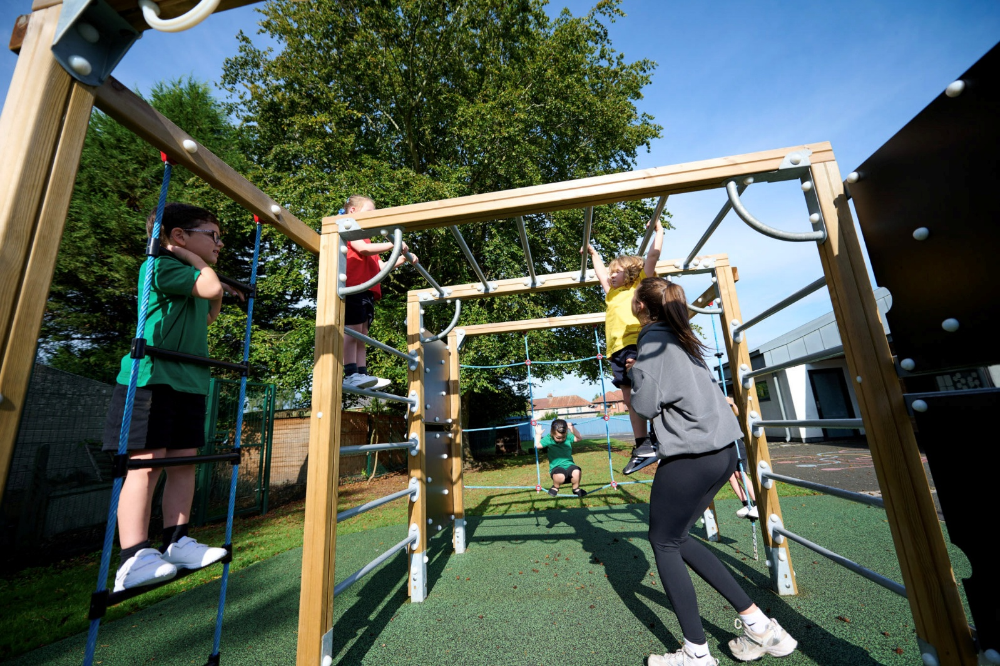
- A forward-thinking leadership team committed to supporting every member of staff
Job Description
Job Purpose:
- To carry out professional duties and to have responsibility for an assigned class
- To be responsible for the day-to-day work and management of an assigned class and the safety and welfare of the pupils, during on-site and off-site activities
- To promote the aims and objectives of the school and support the Christian vision

Key Responsibilities:

Teaching and Learning

- To deliver engaging, high-quality lessons that inspire and challenge all learners, across the primary age
- Promote excellent progress, attainment and behaviour
- Create a positive, inclusive classroom where every child feels valued
- Use assessment effectively to inform teaching and maximise outcomes
- Support pupils’ academic, personal and emotional development
- Work collaboratively with colleagues and contribute to whole-school improvement
- Build strong relationships with parents and carers
- Contribute to the wider life of the school, including events and enrichment opportunities
Safeguarding and Wellbeing
- Ensure the safety and wellbeing of pupils during all lessons and activities
- Follow school safeguarding policies and procedures
- Promote positive physical and mental wellbeing

Professional Responsibilities

- Work collaboratively with colleagues across the school
- Contribute to staff meetings and professional development
- Support and uphold the Christian vision and values of St Catherine’s CE Primary School
- Contribute to the wider life of the school community

Visits to the School:
Prospective candidates are warmly encouraged to visit the school to learn more about our community and vision.

Please contact our HR Manager, Julie Cook to arrange a visit with myself or a senior member of staff.
hr@stcatherines.worcs.sch.uk or call: 01562 823614 for further details and an application form.

Closing Date: Friday 24th April 2026
Lesson observations: Thursday 30th April 2026
Interviews: Friday 1st May 2026

Safeguarding Commitment
St Catherine’s CE Primary School is committed to safeguarding and promoting the welfare of children. This post is subject to an enhanced Disclosure and Barring Service (DBS) check and satisfactory references. The successful candidate will share this commitment and ensure the highest standards of care and protection for all pupils.

Class Teacher Person Specification
 | Essential Criteria | Desirable
Qualifications | - Qualified Teacher Status (QTS) | - Evidence of sustained professional development or further study  - Other relevant training (e.g. NPQ or equivalent)
Knowledge and Understanding | - A minimum of 2 years’ successful classroom teaching experience  - Strong knowledge of the National Curriculum and progression across phases  - Secure understanding of effective pedagogy and evidence-informed practice  - Knowledge of assessment, data analysis and its use to inform teaching and raise standards  - Understanding of curriculum design, sequencing and implementation  - Secure knowledge of safeguarding legislation and procedures | - Experience of teaching across at least two key stages  - Understanding of subject leadership, including monitoring, evaluation and action planning  - Knowledge of adaptive teaching and inclusive practice to meet diverse needs
Skills and Abilities | - Ability to consistently deliver high-quality teaching that leads to strong pupil progress  - Ability to design and implement a well-sequenced, engaging curriculum within a subject area  - Ability to use assessment effectively to identify gaps and adapt teaching  - Strong classroom management, promoting positive behaviour and attitudes to learning  - Ability to inspire, motivate and challenge pupils of all abilities  - Ability to lead or contribute to a subject area, including monitoring standards and supporting colleagues  - Strong communication skills, including working effectively with parents and carers  - Ability to work collaboratively and contribute to whole-school improvement  - Promote high standards of behaviour, inclusion and pupil wellbeing  - Ensure all pupils, including vulnerable groups, achieve well and are fully supported  - Experience of leading a subject, including developing action plans and evaluating impact | - Experience of coaching, mentoring or supporting colleagues to improve practice  - Experience of organising enrichment opportunities such as clubs, trips or wider curriculum activities
Personal Qualities | - Passionate, reflective and committed to high standards of teaching and learning  - Committed to the school’s Christian vision:  - Ability to demonstrate and promote the core values of love and wisdom  - High expectations for all pupils, ensuring they flourish academically, socially and emotionally  - Resilient, proactive and able to lead change positively  - Committed to ongoing professional development for self and others  - Strong team player with the ability to build positive relationships across the school community  - Fully committed to safeguarding and promoting the welfare of children | - Aspiration to further leadership roles within the school  - Commitment to developing partnerships within the wider school or local community

Criteria | Application form | Task | Interview
Qualifications:  - QTS  - Evidence of CPD / further study  - Additional training (e.g. NPQ) | ✔️  ✔️  ✔️ |  | ✔️  ✔️
Knowledge & Understanding  - 2+ years successful teaching  - Knowledge of National Curriculum & progression Understanding of effective pedagogy  - Assessment & data use  - Curriculum design & sequencing  - Safeguarding knowledge  - Teaching across two key stages (desirable)  - Subject leadership understanding (desirable)  - Adaptive teaching / inclusion (desirable) | ✔️  ✔️  ✔️  ✔️  ✔️  ✔️  ✔️  ✔️  ✔️ | ✔️  ✔️  ✔️  ✔️  ✔️  ✔️ | ✔️  ✔️  ✔️  ✔️  ✔️  ✔️  ✔️  ✔️
Skills & Abilities  - Deliver high-quality teaching  - Plan and implement curriculum  - Use assessment to adapt teaching  - Classroom management  - Inspire and challenge pupils  - Lead / contribute to a subject  - Communication with parents  - Work collaboratively  - Contribute to school improvement  - Promote behaviour, inclusion & wellbeing  - Support vulnerable pupils  - Subject leadership experience  - Coaching / mentoring (desirable)  - Enrichment activities (desirable) | ✔️  ✔️  ✔️  ✔️  ✔️  ✔️  ✔️  ✔️  ✔️  ✔️  ✔️  ✔️  ✔️ | ✔️  ✔️  ✔️  ✔️  ✔️  ✔️  ✔️  ✔️ | ✔️  ✔️  ✔️  ✔️  ✔️  ✔️  ✔️  ✔️  ✔️  ✔️  ✔️  ✔️
Personal Qualities  Passionate, reflective practitioner  Commitment to Christian vision (love & wisdom)  High expectations for all pupils  Resilience and leadership potential  Commitment to CPD  Team player / relationships  Safeguarding commitment  Aspiration to leadership (desirable)  Community engagement (desirable) | ✔️  ✔️  ✔️  ✔️  ✔️  ✔️  ✔️  ✔️ | ✔️  ✔️ | ✔️  ✔️  ✔️  ✔️  ✔️  ✔️  ✔️  ✔️

