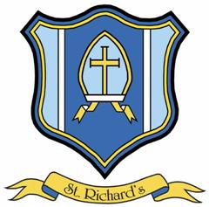

Headteacher: Mr M Holden

St. Richard’s Catholic Primary School
Sandy Lane
Skelmersdale
Lancashire
WN8 8LQ

Telephone (01695) 722346
Fax (01695) 735905
Email head@st-richards.lancs.sch.uk
May/June 2022
Dear Colleague

Welcome Letter

Thank you for your interest in our advertised post. We are currently looking to appoint an enthusiastic, excellent and experienced KS1/KS2 Teacher to join our outstanding school. The role would be for a permanent class teacher required from 1st January 2023 or earlier if agreement with current school.

Applications should be returned in hard copy format to Debbie Wenham (School Business Manager) by 12 noon on Friday 10th June 2022. (Please use Catholic Education Service application form).

Applicants are welcome to visit on one of the following dates, please call school office and confirm attendance:

Tuesday 7th June 8am

Wednesday 8th June 3.30pm

Potential Interview Date: Friday 17th June 2022

More information about our school is available from the website www.st-richards.lancs.sch.uk We hope this provides you with appropriate information about our school and the advertised post, to help you in your application.

If you have any queries, please contact the school office. We look forward to receiving your application.

Yours sincerely

Mr Michael Holden (Current Headteacher)

Mrs Jennifer Jackson (Headteacher from September)

