Together we aspire, learn and grow
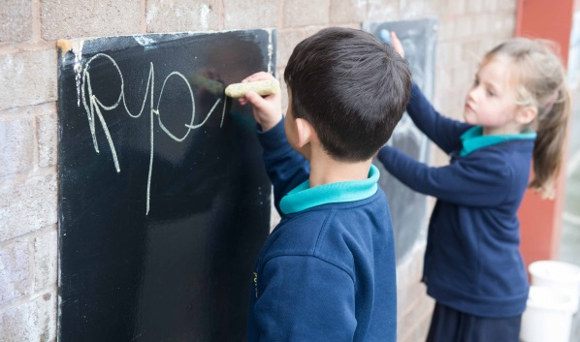
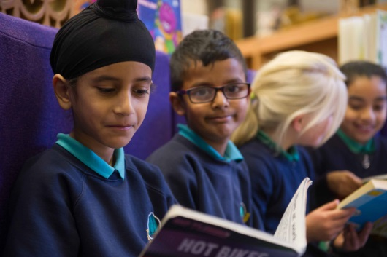

EXPERIENCED EARLY YEARS TEACHING ASSISTANT with SEND experience required
BAND 4/BAND 5 £18,562 to £19,698 (Full Time Equivalent) – DEPENDENT ON EXPERIENCE
An exciting opportunity has become available for a Teaching Assistant with specific experience of working with children with SEND in Early Years to join our friendly, inclusive and outward facing Nursery team.
At Poplars Farm we require staff with vision, commitment and a positive outlook, who are committed to deliver the best outcomes for all our children.
Our Nursery is purpose built and offers a high quality creative and inspiring learning environment to enable inquiring minds to flourish. We place a strong importance on personal and social development as well as academic progress across school.
Embedded in our values system (GROW) are local and global perspectives; we provide our pupils with the necessary guidance and support so that they see themselves as unique individuals who celebrate diversity and develop as responsible citizens. Our pupils start to ‘GROW’ as soon as they start nursery.
If you think this is the opportunity you have been looking for, please contact Mrs Tracey Simpson, School Business Manager for an application pack tsimpson@poplarsfarm.bradford.sch.uk
Completed application forms should be returned to school via email to tsimpson@poplarsfarm.bradford.sch.uk
Closing Date: Friday 24 September 2021 (9AM)
Shortlising: Monday 27 September 2021
Interview: Wednesday 6 October 2021

Experienced SEND Teaching Assistant (To include lunchtime supervision)
(Band 4 - Band 5 SCP 3-6 £18,562-£19,698 (full time equivalent) DEPENDENT ON EXPERIENCE
Poplars Farm Primary School is looking to appoint a teaching assistant who has specific experience in SEND within an Early Years setting.
The successful candidate will be a highly motivated person who will hold high expectations for all children and believe in teaching and delivering a stimulating and creative curriculum.
We are looking for a practitioner who:
- Is experienced in working in an Early Years setting
- Has high expectations of achievement and behaviour
- Is able to make a positive and valuable contribution to school improvement
- Has a strong ambition to make a difference for our pupils
- Is creative, caring, highly motivated and hard-working
- Is able to play a positive and active role in our dedicated team
- Is flexible
- Has excellent communication skills
- Has the ability to work with small groups of children.
- Is a team player
At Poplars Farm Primary School, we promote diversity and want a workforce which reflects the population of Bradford. Our school is committed to safeguarding and promoting the wellbeing of all children, and expects our staff and volunteers to share this commitment. All posts are subject to a DBS check.

