Experienced Key Stage 2 Teacher
Information Pack
May 2022

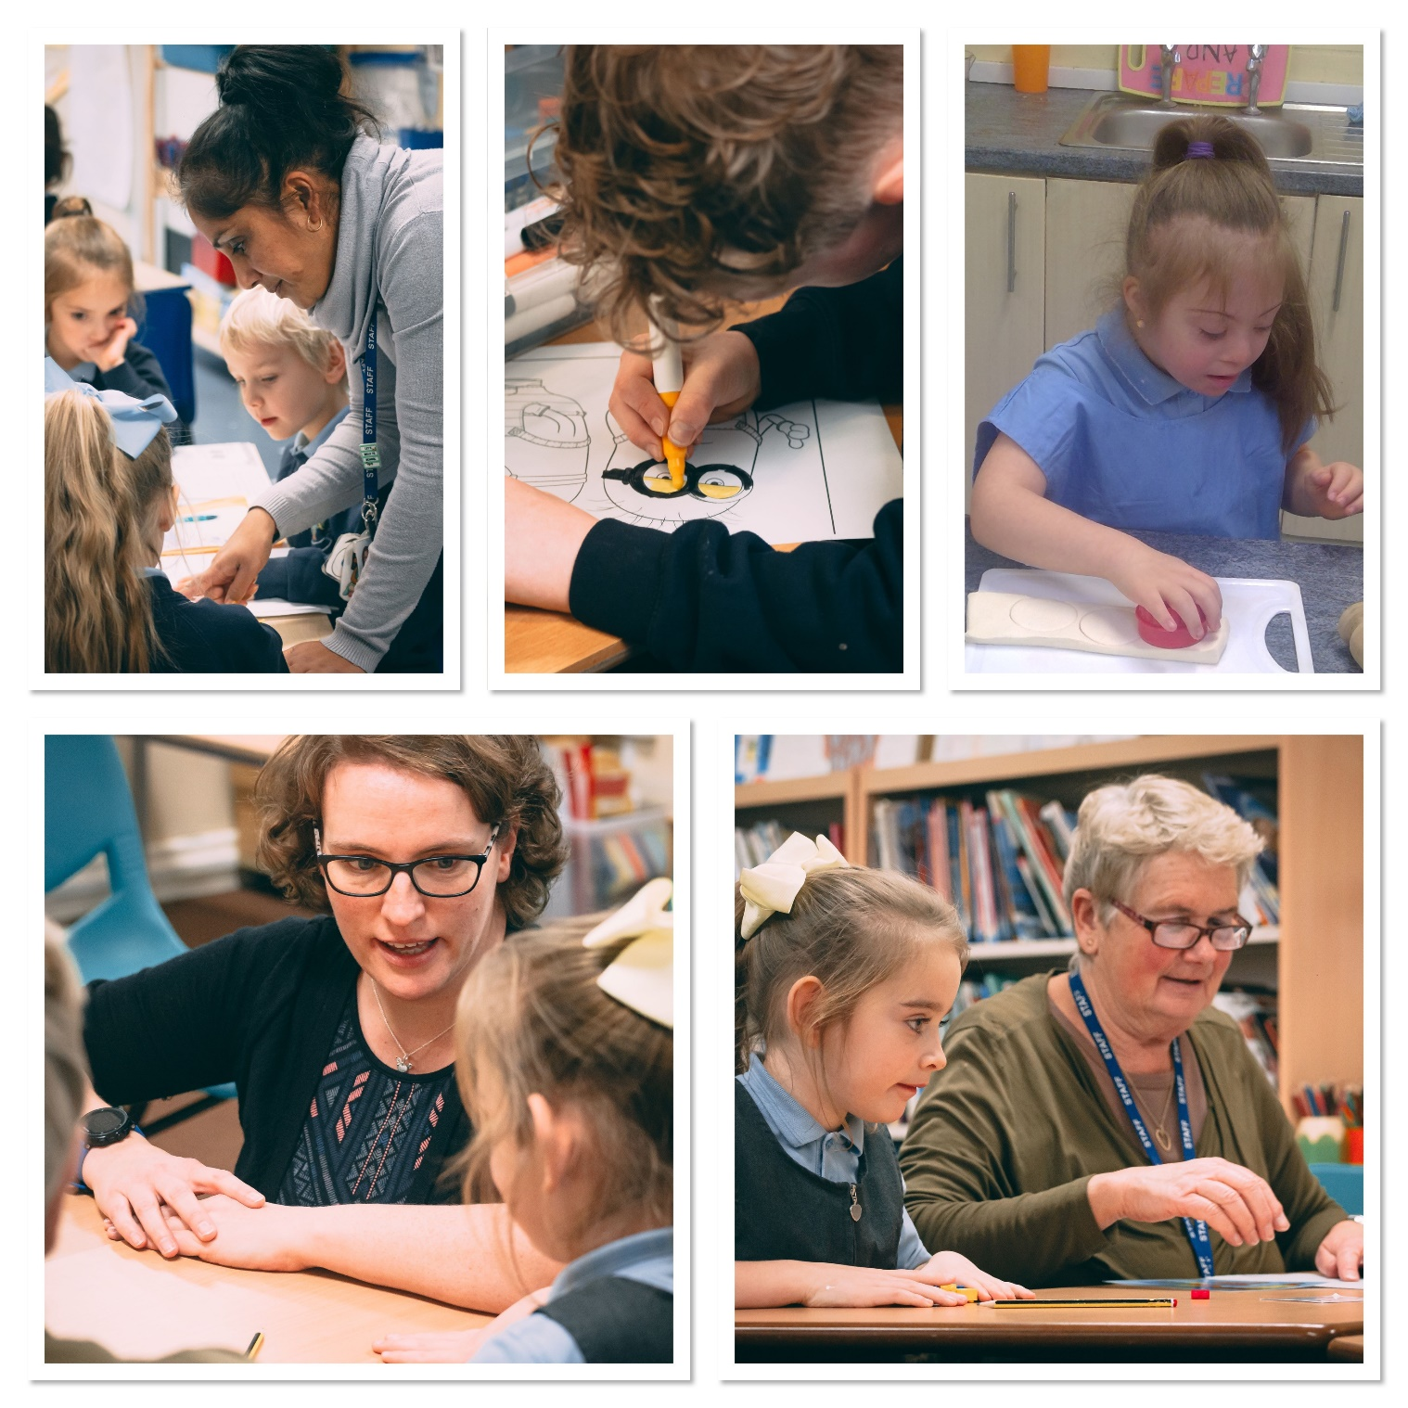

Thoughtful Healthy Resilient Independent Vocal Engaged

The Willows Primary School
Downing Close, Ipswich, IP2 9ER Telephone: (01473) 683178

Headteacher: Mr Paul Arch B.A. (Hons) QTS NPQH

Experienced Key Stage 2 Teacher Post
May 2022
Dear Potential Applicant;
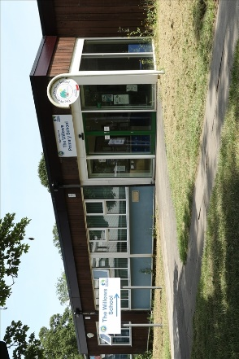
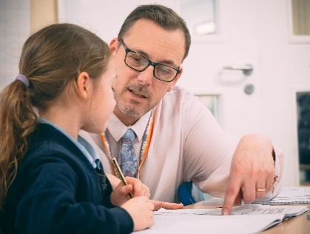
Thank you for the interest you have taken in this post. We are keen to welcome another experienced Key Stage 2 Teacher into our team, who would be able to work alongside some of our less experienced teachers, as well as have their own career aspirations.
About the School
The Willows Primary School first opened as Downing Primary School in 1968, but in more recent years has become known as The Willows Primary School. Since September 2018, the school moved from single, or one and half form entry, to two form entry, with the number of pupils on role continuing to increase.
The school was inspected by Ofsted in January 2020 who commented that “Pupils with special educational needs and/or disabilities (SEND) now have their needs identified and met well in English and mathematics. Teaching assistants have been trained well to support learning. As a result, the attendance and behaviour of pupils with SEND has improved”. They also recognised that “Leaders have worked hard and effectively over the last four terms to dramatically improve provision. There has been significant training to improve the general approach to teaching” and that “Pupils enjoy being at this school. Most attend well and are keen to learn. Staff expect pupils to behave well at all times”.

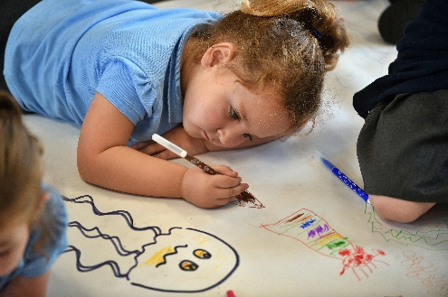
The school is located on the Chantry Estate in the West of Ipswich. The school is within easy reach from both the A12 and A14, as well as being only a twenty-minute walk from Ipswich Train Station. The school itself is located in one of the most deprived areas in Ipswich and has a much higher than average number of pupils who qualify for Pupil Premium (53%). The percentage of pupils with English as an additional language has been increasing over the last few years and is currently 23%. The school has 11% of its pupils on the SEN register, but this is steadily rising.
Within the school, there are 15 classrooms all equipped with either interactive whiteboards or large touchscreens. There are also three additional teaching spaces (classrooms) that are used for intervention lessons and small group work. We also have a number of smaller rooms used for small group work, as well a library, meeting room, school hall, sports dome, 2 playgrounds, a large field and our own school forest (which is used for Forest School sessions).
The school’s leadership team is made up of the Headteacher, Deputy Headteacher and two Senior Teachers (1 full-time and 1 part-time). Below this sits the leadership team, which encompasses the EYFS Phase Leader, Key Stage 1 Phase Leader, Upper Key Stage 2 Phase Leader and the subject leaders for Phonics, Reading, Writing, Oracy and Maths.
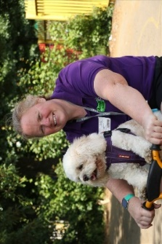
The school has a very nurturing and inclusive ethos. We have two full-time learning mentor/HLTAs and a Thrive practitioner to support the emotional well-being of our pupils. To further support our pupils’ well-being, we also work with a range of outside agencies which includes ‘Arnold the Wonder Dog’ and Jo Jones (Child Psychologist).
As a school, we are very excited about the opening of our own inclusion hub in our old caretakers’ bungalow. The building and surrounding grounds are having a complete revamp and will provide additional teaching and learning spaces for more of our vulnerable pupils.

Our pupils are delightful, polite, caring and want to learn. Some come from challenging home backgrounds and school can be their one safe place. A lot of work has recently gone into developing the pupil’s learning behaviours and oracy skills, as many start children join The Willows with very low communication skills.

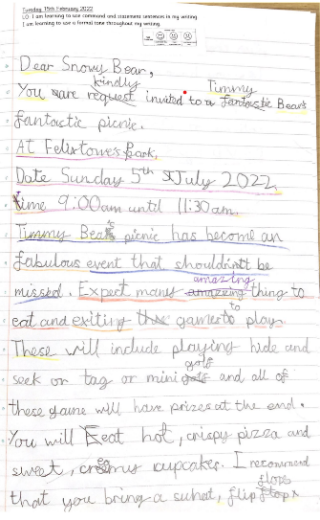
About Our Curriculum
We teach phonics, using Read Write Inc, on a daily basis for 30 minutes a day. Our writing curriculum is delivered using CUSP writing and is taught for one hour each day. It is supported using a range of high-quality model texts and balances the development of grammar skills and extended writing opportunities (more information can be found here). All classes also have a daily 30-minute whole class reading lesson.
Our afternoons are dedicated to the wider curriculum. As part of our curriculum development, we have introduced over the last few years ‘Knowledge Organisers’ for the wider curriculum areas. To develop the creative areas of our curriculum, we have recently introduced the CUSP Art curriculum, to great success, and very recently the CUSP Design and Technology curriculum. This year, we also have a specialist music teacher based at our school every other week. They work alongside our teaching staff to help to develop their own subject knowledge and abilities in teaching music.
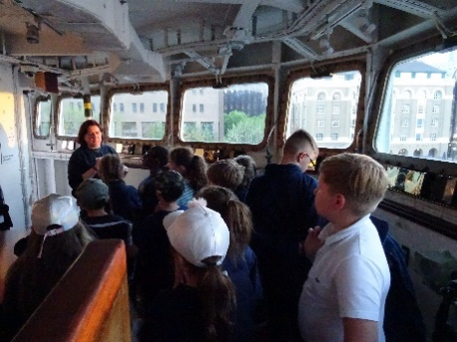
As a school, we also feel it is important that we offer our pupils a range of opportunities that they would normally not be able to have. This has included Year 5 sleeping on HMS Belfast in London for 2 nights and visiting famous landmarks in London, Year 2 visiting the Sea Life Centre in Great Yarmouth and Year 3 having a Roman theme day.

Our School Aims and Visions:
At The Willows Primary School, we believe every child is entitled to the best education and learning environment, so that they can succeed and extend themselves for their future learning.
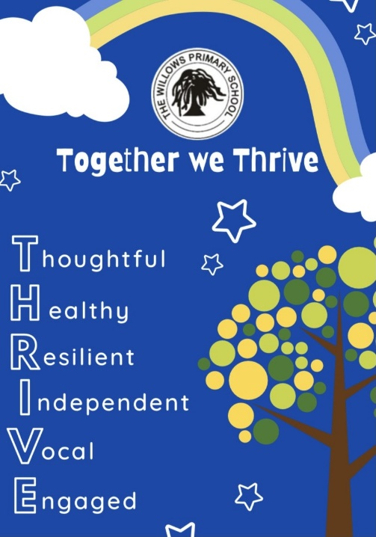
- Our aim is to develop pupils who are;
Thoughtful
Healthy
Resilient
Independent
Vocal
Engaged

Part of the Orwell Multi-Academy Trust
In April 2017, The Willows Primary School, Springfield Infants School, Handford Hall Primary School and Halifax Primary school, joined together to form the Orwell Multi-Academy Trust (OMAT). Since then Brooklands Primary School have joined the trust, along with Grange Primary School. This September, the trust opens its first new school, Grace Cook Primary School, in Stowmarket.
Each term there are at least two whole trust staff meetings, that include professional development opportunities such as writing moderation, reading developments and network meetings for subject leader. We also hold an annual conference for all teaching staff and have begun a programme of developing trust wide events for our pupils. The first of these was a carol concert at the Ipswich Corn Exchange, that featured pupils from all the schools performing on stage.
Applying for the post:

To apply for this post, please read this pack carefully and complete the official application form. Completed applications can be returned to school via post or emailed to: v.hunt@thewillows.omat.org.uk. Visits to the schools are most welcomed. To arrange a visit, please contact the Deputy Headteacher via email at the above email address or by phoning the school office on 01473 683178.

Thank you for taking the time to read this information pack and if you have any further questions, please do not hesitate to contact me.

Yours Sincerely
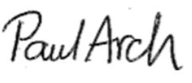
Mr Paul Arch B.A. (Hons) QTS NPQH
Headteacher
The Willows Primary School

About the Post:

Place of work: | The Willows Primary School, Ipswich
Salary details: | MPR / UPR
Job term: | Full-Time
Appointment: | Permanent
Closing date: | Tuesday 24th May 2022 at 1pm
Interviews: | Thursday 26th May 2022

Essential Skills Needed:
Qualifications: | - A clear DBS Check (E)  - Qualified Teacher Status (E)  - Degree or higher (E)  - GCSE English and Maths at grade C or above, or equivalent. (E)
Experience | - Experience of working in Key Stage 2 (E)  - Experience of working in upper Key Stage 2 (D)  - Knowledge and experience of supporting pupils with SEN within a mainstream classroom (E)  - Recent primary school experience and knowledge of the Primary National Curriculum (E).  - Experience of successfully leading a curriculum subject across the whole of the school. (D)
Training | - Committed to personal and professional development. (E)  - Up to date safeguarding training. (E)  - Middle leader/ subject leader training. (D)  - Mentoring/ Coaching training (D)
Knowledge &  Key Skills | - Knowledge of good assessment for learning practices. (E)  - Knowledge of successful behaviour management, approaches. (E)  - Knowledge and experience of ways to inspire and motivate learners. (E)  - A good knowledge of Child Protection practices and policy. (E)  - Ability to build excellent relationships. (E)  - Have good knowledge of SEN provision/interventions that enable learners to make good progress. (D)  - Excellent numeracy, literacy and communication skills. (E)  - Excellent team working skills. (E)  - Understanding of importance of confidentiality including GDPR. (E)  - Ability to use ICT effectively. (E)  - Knowledge of the CUSP writing, Art and Design Technology curriculum (D).
Personal Qualities: | - Well-motivated, calm, pleasant and hard-working. (E)  - Highest level of integrity. (E)  - Reliable, positive, flexible. (E)  - Able to use own initiative. (E)  - Excellent interpersonal skills. (E)  - Dedicated to maximising the success of all pupils. (E)  - Committed to the very best education for all pupils. (E)  - Positive about pupils embracing and celebrating diversity. (E)  - Committed to high quality teaching. (E)  - Aspirational for pupils. (E)  - Friendly and adaptable. (E)  - Approachable and supportive. (E)  - Committed to safeguarding, mental health and well-being. (E)

Class Teacher: Job Description:

Title and Grade of Post | Class Teacher  MPS and UPS
Status of Post | Class Teacher to include responsibility for a subject as specified. This is not applicable as NQT.  TLRs can be awarded on an annual basis for additional specific responsibilities.
Job Purpose | - To carry out the duties of a schoolteacher as set out in the current School Teachers’ Pay and Conditions document and subject to any amendments due to Government legislation. This includes any duties as may be reasonably directed by the Headteacher.  - To uphold the school’s policies and practices which underpin effective practice and the raising of standards  - To demonstrate highly effective inclusive practice with particular reference to pupils with special needs and English as an additional language  - To take responsibility for a class as directed by the Headteacher.
Reporting to | The post holder is responsible to the Headteacher and SLT of the school.
Main duties and responsibilities
- To create and manage a supportive, purposeful and stimulating learning environment which is conducive to children’s learning
- To provide displays that give colour, interest and information to support learning
- To plan and prepare lessons to deliver the National Curriculum ensuring breadth and balance in all subjects delivered.
- To identify clear teaching objectives and learning outcomes, with appropriate challenge and high expectations
- To maintain positive behaviour and discipline among the pupils, safeguarding their health and safety and creating a productive learning environment
- To organise and manage groups or individuals ensuring differentiation of learning needs, reflecting all abilities
- To plan opportunities to develop the social, emotional and cultural aspects of pupil’s learning
- To comply with the school system for monitoring, assessment, record keeping and reporting of children’s progress
- To support in the preparation of appropriate records for pupil transfer
- To ensure effective use of support staff within the classroom and to direct and manage them appropriately.
- To ensure school policies are reflected in daily practice and support the Headteacher in maintaining the ethos of the school
- To communicate and consult with parents over all aspects of their children’s education – academic, social and emotional.
- To take an active part in meetings to discuss and plan the work of classes within the phase in accordance with NC or LEA guidelines
- To liaise with outside agencies when required to do so
- To continue professional development and take an active part in training based on needs and maintain a professional portfolio of training undertaken
- Participate in the school’s Performance Management process
- Contribute to the coordination and development of a subject or an area of the curriculum.
(See Particular duties and responsibilities)

Particular duties and responsibilities
- To be responsible for developing, monitoring and reviewing the whole school approach to planning, teaching and learning of specified subject
- To ensure that the subject is implemented across the school
- To maintain personal expertise and an awareness of curriculum developments to lead and support best practice across the school.
- To provide an annual subject development plan in consultation with the Curriculum Deputy and therefore contribute to the School Improvement Plan.
- Undertake reviews of curriculum planning and evaluate work in subject planners
- Advise and assist SLT in the preparation of reports to Stakeholders relevant to specified subject
- To be responsible for the subject budget adhering to the principle of best value to ensure spending limits are not exceeded
- Maintain existing resources and ensure colleagues are familiar with them. Also explore opportunities to incorporate or develop new resources
- To act as a role model of good classroom practice for others and support them with effective delivery of specified subject.
- Monitor and evaluate the quality of teaching and learning in specified subject to identify areas for improvement
- Lead colleagues in planning and lesson practice and evaluation of teaching and learning to raise standards
- To provide guidance for colleagues in marking, assessment for learning and age related standards of attainment
- Liaise with the Curriculum Deputy regarding curriculum provision and the professional development of colleagues to ensure quality first provision of specified subject
- Ensure effective record keeping by all teachers to facilitate the monitoring of pupil progress
- To provide SLT with relevant performance and standards information as appropriate.
Safeguarding Children
- The Willows Primary School is committed to safeguarding and promoting the welfare of children and young people and expects all staff and volunteers to share this commitment.
- All staff are expected to have read the latest version of Keeping Children Safe in Education.
- All staff appointed to the school will require an enhanced DBS clearance.

