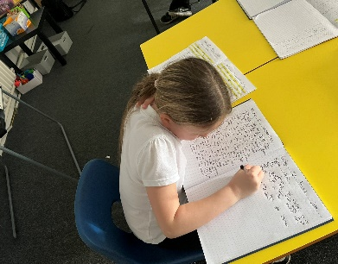

Vacancy | Experienced KS2 Teacher with TLR for Leading English
Location | Manor Green Primary Academy
Start date | 1st September 2024
Closing date & time Interview and assessment | - Closing date for applications: Friday 10th May 2024 at noon  - Shortlisting – W/C 13th May 2024  - Interview and Assessment day: Tuesday 21st May 2024
Salary | Teacher Main Scale with TLR 2a
Contract | Permanent
Return application to | Manor Green Primary Academy  Mancunian Road  Denton  M34 7NS  Or alternatively via email – f.miles@focus-trust.co.uk

Welcome from Mrs Victoria Saville, Principal, Manor Green Primary Academy

Dear applicant,

Thank you for taking an interest in the Key Stage Two/English Lead Teacher vacancy at Manor Green Primary Academy.

This is an exciting opportunity for an experienced Key Stage Two teacher with a proven track regard of achieving good progress and outcomes for all children who has a passion for English and has the knowledge, skills and experience to lead the subject. September 2024 is an exciting time at Manor Green working to further develop our English curriculum and to ensure that our outcomes in English are accelerated.

I am proud and privileged to be the principal of Manor Green where I am fortunate enough to lead a team of professionals dedicated to ensuring that every child knows that they can achieve anything that they set their minds to. Manor Green’s motto underpins all that we do; we aspire, we achieve and we succeed.

We are a learning community and our children, staff and parents learn and work together to live out our core values: Care, Share, Fair, Dare and Happy & Healthy. We expect all members of our learning community to be “Ready, Respectful, Safe” at all times.
We pride ourselves on offering a unique curriculum to meet the academic and holistic needs of all learners. Due to our context, we plan for some golden threads to run through our entire curriculum. These threads are:
- Oracy
- Diversity and culture
- Mental well-being (Thrive) and physical well-being
- Experiences and aspirations
- Life skills

Our curriculum, which is based upon the National Curriculum, is knowledge and vocabulary rich providing many opportunities to build cultural and social capital

- We want to inspire an ambition for our children and staff to deepen their curiosity about, understanding of, and respect for, the world around them. We want our children to become independent, resilient learners who are willing to take a risk and take responsibility for their own learning and we do all of this in a safe, engaging environment, promoting active learning.
- At Manor Green, it is our belief that all children have the right to be themselves and to be the best that they can be. We are inclusive of everyone, and work to ensure that our curriculum is inclusive of the nine protected characteristics. We are proud to have achieved the Educate and Celebrate gold award.
- Fostering high expectations of children’s abilities in school is the core purpose of any school, and our academy is no exception. We believe that all children should be given every opportunity to achieve their potential and to able to achieve their dreams.

If you have any questions or would like to come and see just how fantastic Manor Green is for yourself, please contact us.

Kind regards,

Victoria Saville
Principal

Welcome from Mrs Angela Leach, Chair of Governors

Dear applicant,

Thank you for taking the time to consider applying for the role of upper key stage 2 class teacher.
The Governing Body are looking to appoint the right person to support Manor Green on its improvement journey.
Manor Green is a wonderful place to work. It offers fantastic development opportunities, a supportive leadership and staff team and the chance to have a real impact on children's lives.
We look forward to hearing from you.

I hope we have given you a flavour of Manor Green Primary Academy. We have every confidence that we will successfully recruit an experienced upper KS2 teacher to develop the English curriculum further. We are a very supportive governing body with high expectations for our young people and staff, and hope that you feel encouraged to apply for the post.

We hope that you will find this information pack helpful in finding out more about this post. You are very welcome to make an appointment to visit the school. Please contact Mrs Miles on 0161 336 5864 to make an appointment.

If you would like a further conversation about any aspect of this post or about working as part of Focus-Trust, please do not hesitate me directly by email, v.saville@focus-trust.co.uk or contact the academy office team who will arrange a telephone call with myself.

Please contact us if you require any further information.

Please return all completed documents to f.miles@focus-trust.co.uk by the closing date of Friday 10th May 2024 at noon.

Academy details
Address
Mancunian Road, Denton, M34 7NS
Telephone 0161 336 5864
Website manorgreenprimaryacademy.co.uk

Job Description

School/Academy | Manor Green Primary Academy
Job title | Class teacher with TLR for Leading English
Accountable to | Principal
Line manager | Vice Principal

Introductory statement
The responsibilities and professional duties of the post are to be performed in accordance with the provisions of the most recent version of the Teachers’ Standards.

Teachers make the education of their pupils their first concern, and are accountable for achieving the highest possible standards in work and conduct. Teachers act with honesty and integrity; have strong subject knowledge, keep their knowledge and skills as teachers up-to-date and are self-critical; forge positive professional relationships; and work with parents, colleagues and external agencies in the best interests of their pupils.

Purpose of the role
To ensure all pupils achieve high standards of learning and well-being.

Main duties (TLR role and responsibilities)

Lead, manage and develop a subject or curriculum area; or to lead and manage pupil development across the curriculum

- To provide strategic leadership for the development and management of English throughout the school.
- To identify areas for development and improvement linked to the school improvement plan and national and local initiatives.
- To develop and monitor schemes of work for English across the whole school and ensure successful implementation which meets curriculum requirements.
- To have an overview of, and contribute to the planning and delivery of continuous professional development and training related to English.
- To develop strategies for the use of English to promote new teaching methods and improve learning throughout the school and monitor effectiveness in raising standards of teaching and learning.
- To monitor and evaluate pupil progress across the school in English.

Impact on the educational progress of pupils other than the teacher’s assigned classes or groups of pupils
- To ensure the provision of an appropriately broad, balanced, relevant and differentiated curriculum for pupils in English.
- To identify clear, appropriate targets for attainment and/or achievement across English.
- To monitor and evaluate pupil progress and achievement against targets.
- To lead evaluation strategies to contribute to overall school self-evaluation.
- To contribute to the school procedures for lesson observation.
- To implement school quality procedures and to ensure adherence across the school.

Leading, developing and enhancing the teaching practice of other staff

- To ensure the establishment of common standards of practice across English and develop the effectiveness of teaching and learning styles.
- To plan and implement strategies to improve English teaching where needs are identified.
- To provide induction, support and monitoring for new staff in English.
- To act as a role model of good practice for other teachers, modelling effective strategies with them.
- To ensure all staff in school are familiar with the aims and objectives of school priorities in English.

Teachers role and responsibilities

Set high expectations which inspire, motivate and challenge pupils
- Establish a safe and stimulating environment for pupils, rooted in mutual respect
- Set goals that stretch and challenge pupils of all backgrounds, abilities and dispositions
- Lead by example and demonstrate consistently the positive attitudes, values and behaviour which are expected of pupils

Promote good progress and outcomes by pupils
- Be accountable for pupils’ attainment, progress and outcomes.
- Plan teaching to build on pupils' capabilities and prior knowledge.
- Guide pupils to reflect on the progress they have made and their emerging needs.
- Demonstrate knowledge and understanding of how pupils learn and how this impacts on teaching.
- Encourage pupils to take a responsible and conscientious attitude to their own work and study.

Demonstrate good subject and curriculum knowledge
- Have a secure knowledge of all curriculum areas, foster and maintain pupils’ interest in the subject, and address misunderstandings.
- Demonstrate a critical understanding of developments in curriculum areas, and promote the value of learning and scholarship.
- Demonstrate an understanding of and take responsibility for promoting high standards of literacy, articulacy and the correct use of Standard English, whatever the teacher’s specialist subject.
- Demonstrate a clear understanding of the teaching of systematic synthetic phonics, reading and the teaching and application of basic skills.
- Demonstrate a clear understanding of the teaching of mathematics and the application of basic skills.

Plan and teach well-structured lessons
- Impart knowledge and develop skills and understanding through effective use of lesson time.
- Promote a love of learning and children’s intellectual curiosity.
- Set and assess homework and plan other out-of-class and enrichment activities to consolidate and extend the knowledge and understanding pupils have acquired.
- Reflect systematically on the effectiveness of lessons and approaches to teaching.
- Contribute to the review, design and provision of an engaging curriculum.

Adapt teaching to respond to the strengths and needs of all pupils
- Know when and how to differentiate appropriately, using approaches which enable pupils to be taught effectively.
- Have a secure understanding of how a range of factors can inhibit pupils’ ability to learn, and how best to overcome these.
- Demonstrate an awareness of the physical, social and intellectual development of children, and know how to adapt teaching to support pupils’ education at different stages of development.
- Make effective use of resources (including other adults) to impact on pupil learning and progress.
- Have a clear understanding of the needs of all pupils, including those with special educational needs; those of high ability; those with English as an additional language; those with disabilities; and be able to use and evaluate distinctive teaching approaches to engage and support them.

Make accurate and productive use of assessment
- Undertake formative, summative and statutory assessments in line with the Academy’s policy and assessment calendar.
- Make use of formative and summative assessment to plan for and secure pupils’ progress.
- Use data to monitor progress, set targets, and plan subsequent lessons.
- Give pupils regular and timely feedback, both orally and through accurate marking, and encourage pupils to respond to the feedback.
- Prepare and present written and verbal reports for parents and carers.

Manage behaviour and resources effectively to ensure a good and safe learning environment
- Have clear rules and routines for behaviour in classrooms, and take responsibility for promoting good and courteous behaviour both in classrooms, around the academy and when learning off-site, in accordance with the Academy’s behaviour policy.
- Have high expectations of behaviour, and establish a framework for discipline with a range of strategies, using praise, sanctions and rewards consistently and fairly.
- Manage classes effectively, using approaches which are appropriate to pupils’ needs in order to involve and motivate them.
- Maintain good relationships with pupils, exercise appropriate authority, and act decisively when necessary.
- Ensure the learning environment is kept well ordered, tidy and free from hazards.

Fulfill wider professional responsibilities
- Make a positive contribution to the wider life and ethos of the Academy and the Trust.
- Develop effective professional relationships with colleagues, knowing how and when to draw on advice and specialist support.
- Deploy support staff and other adults in a support role effectively.
- Liaise with external agencies with regard to pupil progress, safety and welfare.
- Take responsibility for improving teaching through appropriate professional development, responding to advice and feedback from colleagues and external advisers.
- Work with other staff across the Trust and in other maintained schools.
- Communicate effectively with parents with regard to pupils’ achievements and well-being.
- Lead an area or strand of school improvement (excl NQT).

Personal and professional conduct
A teacher is expected to demonstrate consistently high standards of personal and professional conduct. The following statements define the behaviour and attitudes which set the required standard for conduct throughout a teacher’s career.

- Teachers uphold public trust in the profession and maintain high standards of ethics and behaviour, within and outside the Academy, by:
- treating pupils with dignity, building relationships rooted in mutual respect, and at all times observing proper boundaries appropriate to a teacher’s professional position;
- having regard for the need to safeguard pupils’ well-being, in accordance with statutory provisions;
- showing tolerance of and respect for the rights of others;
- not undermining fundamental British values, includingdemocracy, the rule of law, individual liberty and mutual respect,and tolerance of those with different faiths and beliefs; and
- ensuring that personal beliefs are not expressed in ways which exploit pupils’ vulnerability or might lead them to break the law.
- Teachers must have proper and professional regard for the ethos, policies and practices of the Academyand the Trust, and maintain high standards in their own attendance and punctuality.
- Teachers must have an understanding of, and always act within, the statutory frameworks which set out their professional duties and responsibilities; and within the policies, handbooks and guidelines of the Academy and of the Focus-Trust.

General
The post holder will:
- Be expected to actively support work and values of the Focus-Trust;
- Be expected to undertake such additional duties as may reasonably be requested by the Principal or their representative.
- Respect confidentiality of staff, pupils, families and visitors and not breach this trust. Any breaches of confidentiality must be reported to the Principal immediately.
- Comply with the requirements of all policies, procedures & handbooks of the Focus-Trust and individual academy.
- Participate in arrangements for appraisal and in the identification of areas in which s/he would benefit from training and undergo such training.
- Proactively keep abreast of developments in relation to the post, and whenever possible and appropriate, attend professional development opportunities.
- Comply with and support all requirements related to equal opportunities and safeguarding children.

This job description is neither exhaustive nor exclusive, and it may, after consultation with the post holder be subject to modification and amendment in accordance with the needs of the academy.

Post holder: Signed ………………………………………… Name …………………………………..

Principal: Signed ………………………………………… Name …………………………………..

Dated: …………………………………………………..

Person Specification

Personnel specification
Key;
App- application form
Ref- Reference
SP- Selection process. This could include a range of exercise, including an interview
Knowledge, experience and skills
 | Essential/  Desirable | How identified
Experience | E/D | App/sp
Ability of raising attainment of all pupils | E | App
Ability to reflect on practice and improve teaching methods to increase pupils achievements | E | App
Ability to continually improve teaching and learning through schemes of work, assessment and extra curriculum activities etc | E | App
Knowledge
Up to date knowledge in the primary curriculum | E | App
Ability to use strategies needed to establish consistently high aspirations and standards of results and behaviour | E | App
Skills
Able to play a full and active role in a team | E | App/Ref
Clear understanding of expectations, accountabilities and consistency | E | App/Ref/SP
Aligned with the Trusts values | E | App/Ref/SP
Motivated to continually improve standards and achieve excellence | E | App/ref
Commitment to the safeguarding and welfare of all pupils | E | App/Ref
Excellent classroom practitioner | E | App/Ref/SP
Effective and systematic behaviour management, with clear boundaries, sanctions, praise and reward | E | Ref/SP
Excellent communication, planning and organisational skills | E | App
Fulfil wider professional responsibilities
Understand when and how to seek advice and support. | E | App/I
Able to develop and maintain good relationships with staff, parents, pupils, governors and the community | E | App/Ref
Committed to own development as a professional. | E | App/Ref
Able to reflect on own practice and identify areas for improvement | E | App/Ref
Qualifications and training
Qualified Teacher Status or other educational qualification | E
Qualified to degree level and above | E
Evidence of further professional development. | E
Personal qualities and attributes
Moral purpose (Equality, children and adults treated with respect) | SP
Excellent communicator (Listening, putting a message across) | SP
Child centred | SP
Resilient | SP
Integrity | SP
Self motivated and able to motivate others | SP
Enjoys challenge | SP
Works to deadlines | SP
Enthusiastic and optimistic | SP

About our Academy

Academy vision

‘Achieve, Aspire, Succeed’
Our Core Values
Care, Share, Fair, Dare, Happy & Healthy
At Manor Green we care through trust, respect, and empathy.
We share through teamwork.
We dare through resilience and trust.
We are fair through equality and integrity.
With happiness at the heart.

Our pupils

Our pupils are polite, well-mannered and very welcoming and are very proud of their school.
We pride ourselves on being “Ready, Respectful and Safe” at all times and see the role of Classroom Teacher at Manor Green Primary Academy as crucial to this.
Our staff
We have a very proactive and enthusiastic staff who work well as a team. They encourage the children to be responsible for their own behaviour and learning in a relaxed, happy and purposeful environment.
You will be joining our academy during an exciting phase in its development with a newly established SLT and a journey to revise our curriculum in order for it to fully meet the needs of our children.
Our geographical area
Manor Green Primary is a popular community academy located in the heart of Haughton Green, Denton, Manchester.
Our facilities
We have extensive grounds which include three linked playgrounds one of these includes a sports court, playing fields including a football pitch and open grassed areas. Our playgrounds have all undergone recent redevelopment including a new KS1 trim trail and a completely new Early Years area where children are encouraged to develop their imagination through various activities. The junior department is on two floors with eight classes plus a dedicated, fully stocked library. The infant department is single story with six classrooms, a nursery and a phonics library.
Our school organisation
Our academy is two form entry with fourteen classes plus a morning nursery offering 15 hours provision. We run a breakfast club from 7.30 am daily which is managed and led by Manor Green staff.
Our curriculum
Our curriculum is lively and inspiring, providing many opportunities for the children to develop socially, emotionally, spiritually and academically. We have exciting cross-curricular themes which include the requirements of the national curriculum. They also contain the other dimensions of learning such as citizenship, multicultural education, personal, social and health education (PSHCE) and environmental awareness. We take every opportunity to invite in visitors and go on school trips. and provide a wide range of clubs including sports, music and art activities. Children also have the chance to undertake responsibilities such as class monitors, year 6 play leaders, school council, eco-committee and digital leaders.
Our extra-curricular activities
We offer a wide range of after school clubs including sports, for example girls’ and boys’ football, rugby, cross country, dance, multi sports and choir.

Academy Quick Facts
Type of school | Primary
Age range | 3-11
Location/LA | Tameside
Number of children | 311
Number of teaching staff | 19
Number of support staff | 30
% FSM | 45%
% SEN | 25.4%
% EAL | 14%

Background to the Trust
Focus-Trust was incorporated in May 2012 as a primary trust. The Trust has links with the sponsor, Focus Education, but is an entirely separate legal entity. As with all academy trusts, the Trust is a company limited by guarantee and an exempt charity. The Trust’s offices are situated in a newly converted historic mill conversion in Chadderton, Oldham with excellent motorway networks to access our schools.

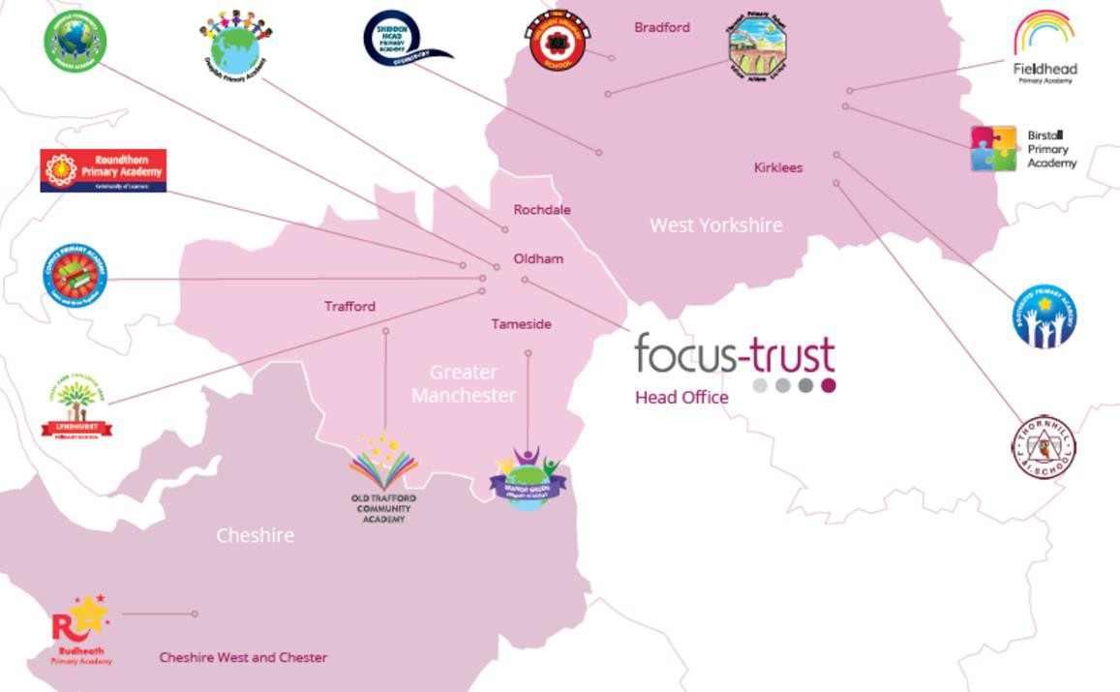

The defining feature of Focus-Trust is that it is a specialist primary phase trust. This means that the work of the Trust is driven by the distinctive needs of primary schools. Whilst the Trust has robust systems for accountability, each school has their own distinctive identity, ethos and culture, and this is a commitment to every school when they convert and join the Trust.

Focus-Trust currently has a small centrally employed team. The members of the team are highly skilled and committed to the vision, culture and values of the Trust.

All the schools within the Trust are willing partners who have actively chosen to join Focus-Trust and there is a very high degree of consensus, cooperation and commitment from within the group.

The Trust has robust policies and systems in place to govern and guide its work. These have been gradually implemented as the Trust has grown. The Trust has well-established productive relationships with trade unions and meets half termly with a group of national trade union representatives to discuss policy development. This has enabled us to introduce and change a range of policies in a streamlined and cooperative way.

Our Vision
‘Great schools at the heart of our communities’ - with our Community Champions and colleagues, we strive to ensure we are being civic leaders making a difference in the local and national communities and the community is supporting us.

Focus-Trust Mission
‘Learning together, making the difference’

Collective Efficacy
We have a well-developed and securely embedded culture of Collective Efficacy. By this we mean we have, ‘A shared commitment to work together on the things that matter to improve outcomes for all.’

The Focus-Trust Values
Professional honesty is at the heart of everything we do. The Trust knows the schools well because of the strong working partnership between academy leaders and the Trust Central Team. It is only by being honest and transparent with a balance of credible challenge and effective support, that we can move forward and get the best for all children and staff. Our work is underpinned by our values:

Care for children, adults and the learning environment
Dare to do things differently and have a go
Be fair, honest and inclusive – demonstrating integrity
Share concerns, expertise and best practice for the benefit of all learners

Our Moral Purpose

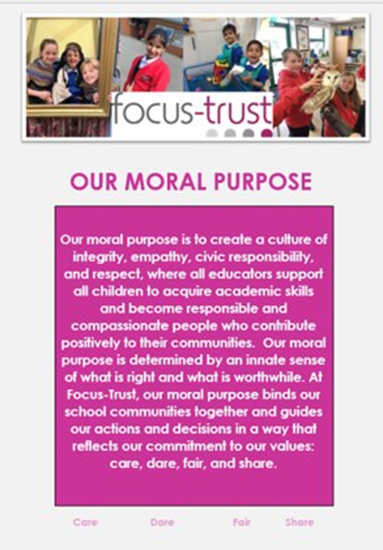

Our People Strategy

What you might want to know about Focus Trust

Pensions
Focus-Trust contributes to Teachers’ Pensions and Local Government pensions in the same way and with the same level of contribution as local authorities.

Employer Relations
Focus-Trust has a Trade Union agreement which recognises the teacher and support staff unions. This is further supported by an ongoing and productive relationship with key trade union officials.

Equality of opportunity
Focus-Trust is an equal opportunity employer, dedicated to a policy of non-discrimination in employment on any basis including age, gender, race, colour, nationality, ethnic origin, disability, gender, religion, age, marital status, sexual orientation and/or medical condition.

Safeguarding
Focus-Trust is committed to safeguarding and promoting the welfare of all children and young people. There is an explicit expectation that all employees share this commitment and adhere to all safeguarding policies and procedures. Applicants should be aware that the recruitment process will include an assessment of your suitability to work with children.

Dress code
We expect all staff to dress professionally and appropriately for the roles undertaken. We pride ourselves on the high standards of dress of both our pupils and staff; these standards are led by our staff who we expect to set an example.

Policies
Focus-Trust and the schools have a range of policies and handbooks that help to make clear our expectations and ways of working. These are always shared openly with staff and are accessible to everyone. There are several policies that prospective employees should be aware of when making an application. These can be found on the Trust website www.focus-trust.co.uk and school websites. All members of staff will be asked to sign a declaration as part of the induction process to acknowledge that they have read and understand the Code of Conduct and some of the key policies, e.g. Safeguarding and Child Protection, Health and Safety, Acceptable use of IT.

Right to work in the UK
Under the Asylum and Immigration Act 1996, it is a criminal offence to employ anyone who is not entitled to live or work in the United Kingdom. Applicants can expect us to ask for proof of this at interview stage, where you will be asked to provide some original documentation to confirm that you are eligible to work within the UK. Photographic proof of identity will also be required.

Validation of qualifications and identity
All shortlisted candidates will be asked to bring original certificates or relevant qualifications and identity documents to interview. These will be photocopied and kept on file and, if appropriate, may be confirmed as genuine with the relevant awarding bodies. The copies of the successful candidate will be retained on their personnel file. The copies of unsuccessful candidates will be treated as confidential waste and disposed of appropriately.

References and Social Media Checks
If you are shortlisted, we will take up references before the interview date. One of your referees must be your current or most recent employer. Two satisfactory references must be received before we can confirm any offer of an appointment. The information we request will relate to salary, length of service, skills and abilities, suitability for the job, disciplinary record and suitability to work with children. Copies of references or open references will not be accepted. On receipt of references, your referees may be contacted to verify any discrepancies, anomalies or relevant issues as part of the recruitment verification process.

In line with our safer recruitment policy, social media checks will be undertaken if you are shortlisted. This social media check is designed to complement the range of standard recruitment checks and allows us to identify a candidate’s online presence which potentially could damage the organisation’s reputation.

Knowledge and skills profile
This is an important part of your application and is your opportunity to explain how you meet the person specification for the post. You should demonstrate your skills, knowledge and experience and give short examples. Describe how you match the requirement of the job; include experience gained from previous jobs, community or voluntary work. Ensure that the information you give is well organised, relevant and brief. You may find it helpful to use sub-headings in order to keep your statement well focused. If you do not submit this profile, you will not be considered for short listing.

Disability
To comply with the Equality Act 2010, we are legally required to consider making reasonable adjustments to ensure that disabled people are not disadvantaged in the recruitment and selection process. We are therefore committed to meeting, wherever possible, any needs you specify on the application form. Please contact Natalie Harris if you need to discuss this in any detail. We will consider any reasonable adjustment under the terms of the Act to enable an applicant with a disability (as defined under the Act) to meet the requirements of the post.

Disclosure of a criminal record
Employment in this role is subject to an enhanced check with the Disclosure and Barring Service (DBS). Checks will also be made against the lists showing people barred from working with children. All checks must be satisfactory before any offer of employment can be confirmed and before commencement of work can take place.

Thank you for taking the time to read this information pack. We wish you every success in any application you may make.

