Dear Prospective Candidate,

I would like to thank you for the interest you have shown in this exciting opportunity to become part of our family at St. Bede C of E Primary Academy as an Assistant Headteacher with responsibility for EYFS. Please take a look at our school website, the job description and person specification for this role, and arrange a visit to the school to meet our wonderful staff and children.

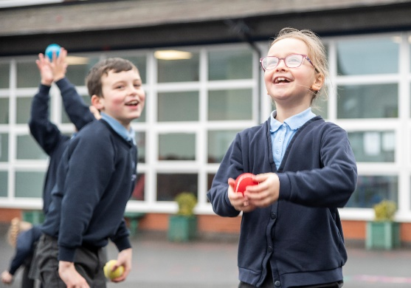 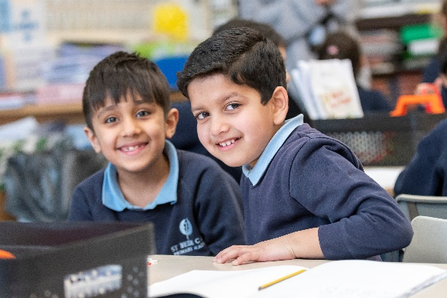

St. Bede is a popular three-form entry Academy with 630 pupils on roll, serving a wide community with pupils from different faiths. The present School was formed in September 1992 through the amalgamation of a well-established Infant and Junior School. It became an Academy on 1st July 2011 and is now part of a Multi-Academy Trust, along with our sister school Tonge Moor Primary Academy.

Collaboration between both schools in the MAT is strong, supporting staff’s workload and well-being, and career development. Staff members benefit from:

* On-site MAT HR support
* On-site full time MAT IT support
* On-site school term time nursery
* On-site 52 week private nursery
* On-site out of school club and holiday club
* Discounted childcare
* Bespoke personal development opportunities as well as full access to Schoot CPD package
* A committed Governing Body
* A supportive leadership team who prioritise workload and well-being
* Pupils who behave well, are eager to learn, are calm, happy and enjoy school life
* A family ethos that nurtures individual talent, empowering all to flourish

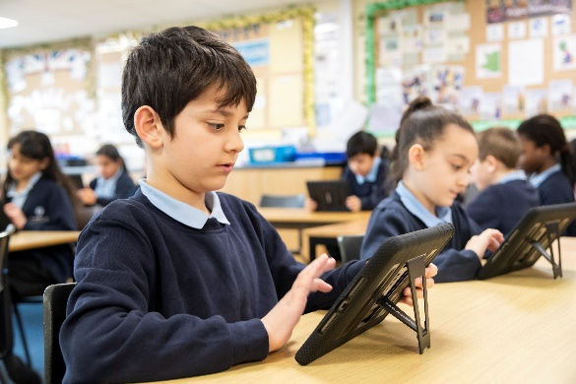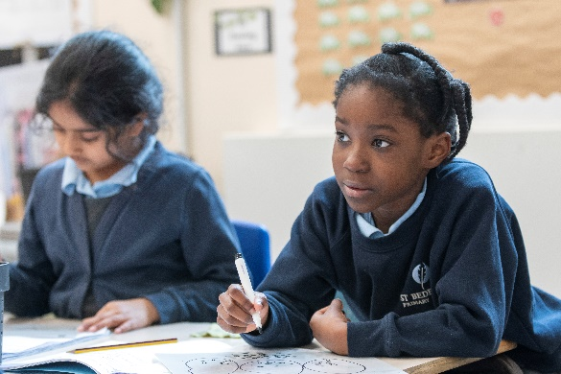

As a Church of England Primary school our school vision, values and scripture underpin our daily practice. We have a strong relationship with St. Bede's Church and this forms the basis of a very happy community. The School underwent its Statutory Inspection for Anglican and Methodist Schools in February 2023 and the glowing report with a secure ‘Good’ judgement captures life at St. Bede perfectly. The report can be found our school website.

The large school building is made up of: twenty two classrooms, a music room, a computing suite, a main hall, a small hall, an intervention classroom, a library, a staff PPA room, a meeting room, a staffroom and a number of office spaces. We have an urban site with no grounds or playing fields, although the school has access to the adjacent council playing fields which we are currently in talks with the council about purchasing for our children. We have two playgrounds, a Reception outdoor area, a Nursery outdoor area, a Year 1 outdoor area and an allotment.

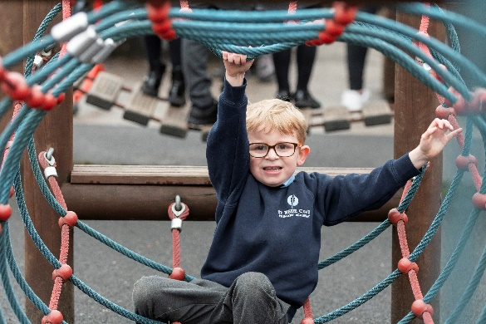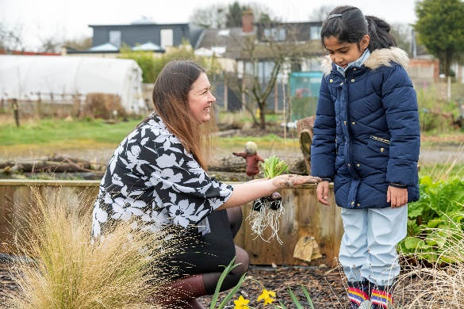

Our bespoke curriculum ensures that all children are provided with a broad, balanced curriculum taking into account their interests, needs and talents. Our curriculum is sequential from the EYFS to Y6 and is successfully designed to be ambitious and meet the needs of all pupils. We are proud to have specialist teachers in Music, Modern Foreign Languages, Computing and Art who teach from EYFS to Year 6.

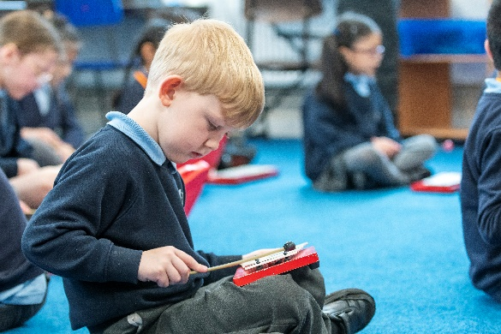

I am honoured and blessed to have worked at the school for 20 years and feel incredibly proud to be the Headteacher and part of the St. Bede family. Each day, I am surrounded by pupils and staff who are inspirational. St. Bede is a very special place to be and we look forward to receiving your application.

Please do not hesitate to email me with any questions ([blacka@stbedeacademy.org](mailto:blacka@stbedeacademy.org)) and please telephone the school office to arrange your visit (01204 61899).

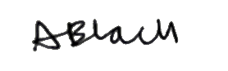Kind regards,

Anna Black  
Headteacher