April 2022

Dear Applicant

Congratulations on taking the best step in your new career by applying to become part of the Banister family.

As part of our family we will guarantee you a vibrant, dynamic and energetic staff who will support, challenge and inspire you within your new role. We will offer you a bespoke coaching programme to develop your talents within the classroom, opportunities to work with and learn from passionate staff within and beyond the school.

Not only do we have a “state of the art” building, but an innovative, creative and personalised curriculum which celebrates our cultural diversity offering an extensive range of learning experiences.

Our children love to learn, learn to lead, and lead to succeed. Do you want some first-hand experience? If so, please contact Dave Hockin at david.hockin@banisterschool.co.uk to book a time to come and spend some time with us.

Our ideal candidate will be committed to do “whatever it takes” in helping us to continue to create our outstanding school and environment, and will want to play an active role in shaping a school for generations to come. If you want to be part of a dynamic, forward thinking school and are committed to increasing the life chances of our children and your own learning development – we are the school for you!.

Yours sincerely

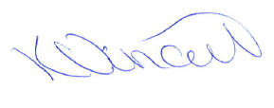

Miss Kate Vincent
Head teacher

