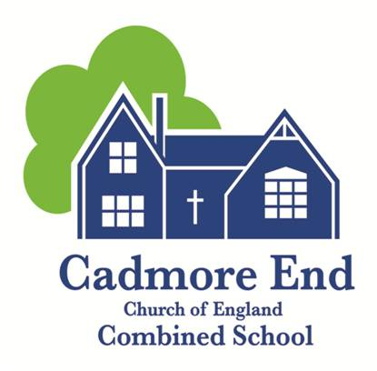
Reception Class Teacher Wanted!

Job Role: EYFS and Year 1 Class Teacher
School: Cadmore End CofE Combined School
Location: Marlow Road, Cadmore End, High Wycombe, Bucks HP14 3PE

Overview:
We are looking to hear from NQTs or EYFS teachers who would be interested in a two day jobshare working within our small mixed reception/year 1 class which will consist of around 12 children!

This is an exciting opportunity to play a vital role, in a dedicated team of staff, to ensure all our pupils leave Cadmore End having reached their full potential.

We strongly recommend that you come and visit us (abiding by current COVID restrictions) and see for yourself why Cadmore End is the school for you.

About Cadmore End Cof E Combined School:
We are a small, caring and very friendly combined school and nursery consisting of 70 pupils.

Our parents and local community are supportive and welcoming.

We take pride in the fact that we are very much an inclusive school that is recognised for its tolerance, respect and inclusive approach to ensuring that every child reaches their full potential. As described by all, we are ‘one big happy and supportive family’.

All our staff have regular internal and external CPD opportunities to ensure that they are equipped with the skills to enable not only their personal expectations are met but that all our pupils reach their full potential and become well rounded individuals.
Check out our website to find out more about us. www.cadmoreendschool.org

About the role:
The role is for two days a week and you will job share with an experienced and friendly lady!

To find out more about the role, please visit our website, click on ‘Vacancies’ and the Job Description and Person Specification can be found there.

About you:
The successful applicant will:
- Be able to deliver consistently good and outstanding teaching and learning in order to help all pupils achieve their full potential.
- Have experience of teaching in EYFS.
- Be able to work effectively as part of a team, accept challenges and motivate others.
- Be able to adapt lessons to teach a wide range of abilities.
- Have high expectations of themselves and their pupils and a clear vision of educational excellence.
- Be eager to embrace CPD opportunities and support from our friendly and supportive SLT.
- Be responsible for promoting and safeguarding the welfare of pupils within the school.
- Be sympathetic to the ethos of a Church of England school.
- Enjoy staff socials and have a good sense of humour!

Duties and Responsibilities of Class Teacher:
- All teachers are required to fulfil the 2012 Teachers’ Standards in line with the appropriate Career Level Profile.
- All teachers are required to carry out the duties of a class teacher as set out in the current School Teachers’ pay and conditions

Safeguarding
Cadmore End CofE Combined School is committed to safeguarding and promoting the welfare of children, young people and vulnerable adults and expects all staff and volunteers to share this commitment. The successful candidate will have to meet the person specification and will be required to apply for a DBS disclosure. We particularly welcome applicants from under- represented groups including those based on ethnicity, gender, transgender, age, disability, sexual orientation or religion.
Further information/how to apply:
Please contact our lovely school secretary – Jenny Coyle – who will provide you with further information or to book you in for a visit (abiding by current COVID restrictions)

Email: office@cadmoreendschool.org
Phone: 01494 881460

