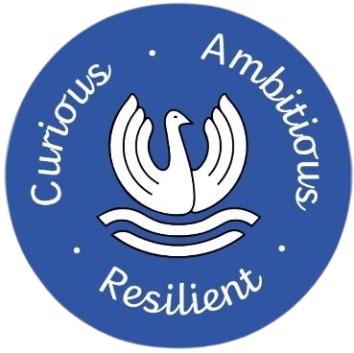
Gosford Park Primary School
Humber Avenue
Coventry
CV1 2SF
Tel: 024 76223281
Interim Headteacher: Mrs Joanna Jacobs

www.gosfordpark.coventry.org.uk
Gosford Park Primary School
One Community, Many Cultures; Growing and Learning Together

EYFS Class Teacher Vacancy

The Governors, staff and children at Gosford Park Primary School are seeking to appoint an innovative, highly driven, and motivated teacher to join our school family. We are seeking a highly effective teacher, with experience in the Early Years Foundation Stage, with secure subject knowledge in this areas.

What we can offer:
- Gosford Park Primary School is a friendly and supportive school environment.
- A forward thinking and creative place to work.
- A fantastic, diverse community of children, families and staff who all share the same values of our school, ‘Curious, Ambitious & Resilient’
- A commitment to your professional development, either as an ECT or experienced teacher, our Senior Leadership Team create personalised professional development plans that place innovation and children’s learning at the centre of what we do.

If you feel you could join our School family, and you feel you have the necessary skills to contribute to our continuing improvement journey, we would love to hear from you.
An opportunity for a TLR for the right candidate.
Visits to the school are warmly welcomed and highly recommended: If you wish to arrange a visit, please contact Mrs Laura Baldwin, our School Business Manager, on lbaldwin@gosfordpark.coventry.sch.uk.
Application forms and further details are available to download below.
Completed application forms are returnable to lbaldwin@gosfordpark.coventry.sch.uk
Closing date: Sunday 22nd February 2026
Interview date: W/C 23rd February 2026

Gosford Park Primary School is committed to safeguarding and promoting the welfare of children and expects all staff and volunteers to share this commitment. The successful candidate will be required to undergo an enhanced CRB check.
Job Description: Reviewed February 2026

