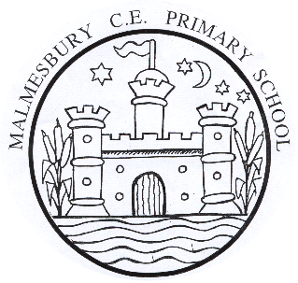
Malmesbury C of E Primary School

Person Specification – EYFS Class Teacher

 | ESSENTIAL | DESIRABLE
Qualifications: | - Qualified Teacher Status or ECT
Experience | - Communicating with Parents and members of staff  - Experience of effective EYFS teaching | - Experience in developing and supporting teaching  - Experience in implementing change within a setting  - Experience of managing teaching assistants
Professional knowledge and understanding/  qualities | - Committed to equality for all pupils.  - Knowledge and understanding of systematic synthetic phonics  - Understanding of Assessment for Learning  - Good organisational skills including planning, monitoring and evaluation  - Excellent behaviour management skills  - Understanding of Assessment and Tracking in EYFS and beyond  - Seeks innovative approaches to learning and teaching  - Experience of working in a successful team  - Understanding of the 2021 Early Years Framework  - Good communication skills | - Knowledge of teaching a creative curriculum  - Good ICT skills  - Knowledge of current educational legislation, developments and initiatives that influence EYFS  - Knowledge of Little Wandle SSP Scheme
Professional Development | - A strong commitment to undertake further professional development | - Have recently undertaken a balanced programme of training  - Ability to lead a curriculum subject
Personal Skills and Attributes | - Ability to empathise with pupils and parents  - Self-confidence, enthusiasm and a good sense of humour  - Willingness to work as part of a team and play an active role in school life | - Willingness to lead extra-curricular activities  - Ambition to develop career in the future

