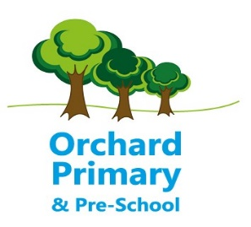

Early Years Class Teacher
School: Orchard Primary School Start Date: September 2021
Contract: Full Time and Permanent Salary Range: Main Scale
Closing date: 5pm Monday 14 June 2021 (unfortunately, due to current circumstances, we will not be holding show rounds). Please use our website as a reference guide to the school. All applications should be made by email to office@orchardprimary.org.uk and will be acknowledged upon receipt.
Interviews: w/c 21 June 2021
Orchard Primary School is situated in the market town of Pershore and is part of the Avonreach Academy Trust. In September 2019, we opened our doors to our new Primary age range. In September 2021, our Year 6 children will be moving on to become our first Year 7 class within the Trust. We have just completed an exciting build and we are now looking for an inspirational Early Years Teacher to work closely with our Pre-school team. You will be based in one of our new classrooms and have the opportunity to develop the newly created Early Years outdoor space.
This position would suit someone with recent experience of Early Years.
The successful candidate will have:
- Sound knowledge of the EYFS Curriculum
- Good understanding of the KS1 National Curriculum
- Excellent team building skills
- A creative and flexible approach to the teaching and learning of the curriculum
- To promote our curriculum through ‘enthusing our children with a love of learning’
- Be resilient, hard-working and share good practice with others
- Promote the needs of all learners to reach their best possible outcomes
- A commitment to support the wider life of the school
- Experience of leading a curriculum subject

At Orchard Primary we can offer you:
- A strong team ethos built on shared core values
- A very supportive community who work alongside the school
- Exceptional pupil behaviour and attitudes to learning
- Hard-working, supportive colleagues and Leadership Team
- CPD to support any areas of development

Orchard Primary School is committed to safeguarding and promoting the welfare of children and young people and expects all staff and volunteers to share this commitment. This post is subject to an enhanced DBS disclosure and two satisfactory references.

