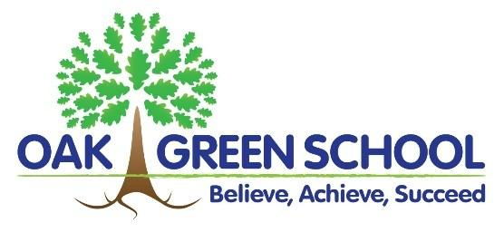
EYFS Interim (1-Year Maternity) Assistant Headteacher
2021-2022
Advert - Staff Vacancy

We are looking for an enthusiastic Interim Assistant Headteacher to lead our EYFS department as 1-year maternity cover. This teacher will lead our two Nurseries (2-Year olds and 3-Year olds) and 3 Reception classes. As a member of our Extended Strategic Leadership Team, the successful candidate will drive forward the Early Years Foundation Stage Curriculum, assessment and the continued improvement of our environment at an exciting time for the Early Years.
The successful candidate will be motivated, knowledgeable and keen to further develop our settings and move all areas forward with the support of an experienced and ambitious team. This is a very exciting opportunity to take on a new challenge, in a fabulous school that has its large Foundation Stage at the heart of the school.
Location: Aylesbury Required from Jan/Feb 2022
(Initially) temporary position of a 1-year contract (maternity cover) full-time (preferred) or PT
Closing date: midday Monday 8th November 2021 Interviews w/c 8.11.21
To Leadership Pay 1- 5: dependent on experience (e.g. L2 @ £42 193) Non-contact: x1 d.p.w. (inc P.P.A.)
We are looking to recruit a qualified teacher (QTS) with EYFS teaching experience of 2+ years. No ECTs/NQTs please.
This is an excellent opportunity for a current middle or senior leader with further leadership aspirations to lead a phase in our thriving, successful primary school, with happy well-motivated children and friendly, supportive staff. Our diverse community is committed to achieving the very best outcomes for all children in our 3-form entry school and ASC ARP; this starts strongly in Nurseries and Reception - ‘Our Wonderful Learners’ (OWLs).
We will support the right candidate throughout this post and potentially beyond. You’ll be supported to develop autonomous leadership of your areas of responsibility, offered CPD and enabled to grow into the role. You will join a happy, hardworking staff team who care deeply about improving the life-chances of our children.
The post would suit a talented teacher, with some leadership experience desirable, but not essential. The previous skills of the successful candidate are important, but we place equal value on someone having the right motivation, resilience, empathy and aspirations to work with our youngest children and continue to drive forward standards in EYFS. If you have these qualities, we’ll look forward to receiving your application! Thank you.
Please see the Job Description and Person Specification for full details of qualifications and requirements and refer to these in your application, If you believe that you have the knowledge and skills we are looking for, please contact us on 01296 423895, or email office@oakgreen.bucks.sch.uk. We do welcome visits; call the office to arrange these.
Our 4 Assistant Headteachers play key roles, with the Strategic Leadership Team, in promoting the aims and objectives of the school, and managing learning, standards, staff, policies, practice and resources, to achieve the aims and objectives of Oak Green school and monitor progress towards their achievement.
Oak Green School is committed to safeguarding and promoting the welfare of children and it is necessary for all staff to share this commitment. Applicants will be subject to an enhanced DBS check and other pre-employment screening.

