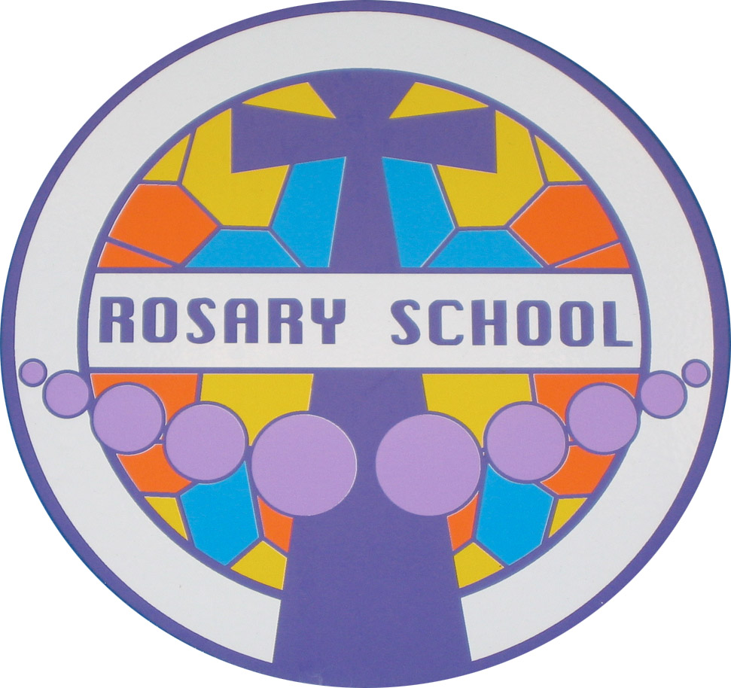
Rosary Catholic Primary School
238 Haverstock Hill
Hampstead
NW3 2AE
Tel: 0207 794 6292
www.rosary.camden.sch.uk
admin@rosary.camden.sch.uk

Head Teacher: Sophie Kennedy

Dear Potential Applicant,

Thank you for your request for an application pack for the post of Class Teacher at Rosary Catholic Primary School.

Our School is committed to providing a learning experience where children are known as individuals and as such, can offer positive, hardworking and enthusiastic children who are proud of their school and motivated to learn. We have high expectations for all our children and aim to provide a stimulating and exciting curriculum to enable them all to achieve.

Our team are genuinely friendly and welcoming and believe in positive team work. Staff development is a high priority for us and should you be successful, we will guarantee access to high quality CPD Programme and development opportunities.

Visits are warmly welcomed and will be arranged by the Senior Admin Officer, Mrs Meschini.

The closing date for applications is Friday 21st March 2025 at 12pm. Interviews for successful applicants will be held week beginning 24th March 2025.

I look forward to meeting you.
With very best wishes

Yours sincerely

Sophie Kennedy
Headteacher

