EYFS/KS1 CLASS TEACHER
College Town Primary School
Branksome Hill Road, Sandhurst, Berkshire, GU47 0QF
01276 31933
www.collegetownprimary.com

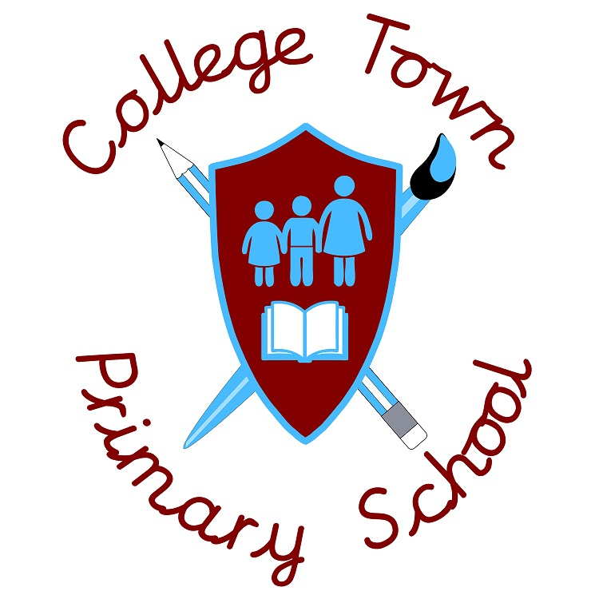

To start September 2021 Salary: MPS/UPS

Great schools can ONLY exist with great teachers!
So.... are you a skillful, conscientious and resilient teacher ready to join our Primary School?

Our school is committed to developing a working environment where excellence is the expectation. This philosophy permeates everything we do for both adults and children alike.
The school fully acknowledges the demands of teaching and has established working practice which supports the recommendations from the May 2018 Government Consultation Response on 'Strengthening Qualified Teacher Status and improving career progression for teachers.' From September 2018 the school has employed a highly experienced and skilled specialist Teaching and Learning practitioner who supports all teachers to ensure everyone can be the best that they can be.
Whether you are an experienced teacher or an NQT we can offer you:
- a school committed to improving outcomes for all
- a school where potential is recognised and rewarded
- a school where work life balance is ensured through the effective use of 1265hrs
- pupils with a thirst for learning and the behaviour to enable them to succeed
- professional, supportive and dedicated colleagues
- a modern and exceptionally well-resourced school
We are looking for a team player who:
- demonstrates personal responsibility for their own development and the progress of their pupils
- has proven effective teaching within 3-7 age range (this could be a teaching practice)
- is enthusiastic, motivated with high expectations of self and others
- is keen to develop their skills throughout the whole school
- is committed to raising standards
- is able to fully support the school’s vision
NQTs are welcome to apply
Applications
Please apply online at www.bracknell-forest.gov.uk/jobs. To arrange a visit please contact the school secretary@collegetownprimary.com
- Closing date for application is Friday 26th March with Interviews to be held the week commencing 29th March.
- However applications will be reviewed on receipt and interviews may be held earlier as required. We reserve the right to close the advert early so early application is advised.
College Town Primary School is committed to safeguarding and promoting the welfare of all our children and expects all staff and volunteers to share this commitment. All appointments will be made subject to an enhanced DBS check and references will be taken up before interview.

