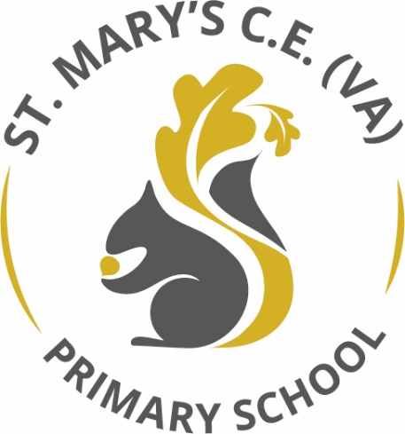

RECRUITMENT PACK

ST. MARY’S CE (VA) PRIMARY SCHOOL

Post of EYFS / KS1 Class Teacher
(Maternity Cover)

St. Mary’s CE (VA) Primary School Wakefield

Post of EYFS Teacher

This Recruitment pack includes the following documents:

- Copy of the Advertisement

- Letter of Introduction from the Chair

- Appointment Timetable

- Job Description

- Person Specification

- For copy of Ofsted Report – Please refer to www.ofsted.gov.uk (URN 108269)

- Form RO2 “Posts Exempt from the Rehabilitation of Offenders Act 1974”

- Application Form

For information about teaching in the Wakefield District:

http://www.wakefield.gov.uk/Education/TeachingInWakefield/default.htm

For information about curriculum standards in the District:

http://www.gowild.org.uk/curriculumstandardsandsupport/default.htm

For an overview of the District :

http://www.wakefield.gov.uk/AboutWakefield/default.htm

For facts and figures about Education in the District:

http://www.wakefield.gov.uk/Education/Schools/default.htm

St. Mary’s CE (VA) Primary School Wakefield

Post of Year EYFS Teacher

APPOINTMENT TIMETABLE

Advertisement:
Tours of School | Contact School for mutually agreed times
Closing Date | 12.00 pm Monday 21st June 2021
Short Listing Meeting | Monday 21st June 2021
Interviews | Thursday 1st July 2021
Appointment to Commence: | 1st September 2021

SCHOOL VISITS

Visits to the school are welcomed as this is the best way to see and get a feel of our wonderful School (Social distancing will be in place). Please telephone the School Office on 01924 303625 from Monday 7th June or email office@stmaryswakefield.co.uk we look forward to hearing from you. Thank you.

APPLICATION METHOD

Please return your completed application form to:
St. Mary’s CE (VA) Primary School, Charles Street, Wakefield. WF1 4PE
By 12:00 pm on Monday 21st June 2021.
If you have not heard anything by 24th June 2021 then please assume your application has not been successful.

