



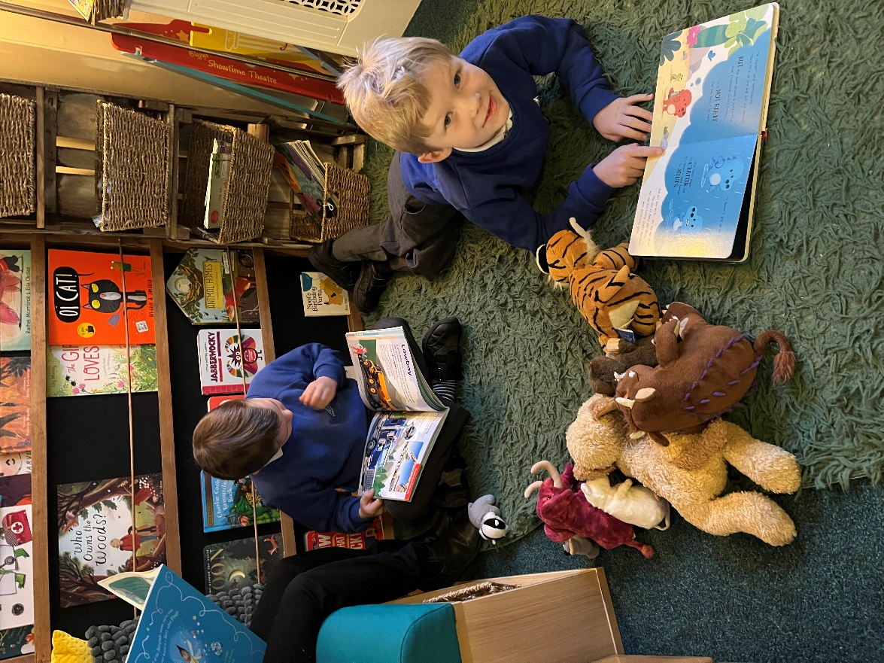

**EYFS/KS1 Class Teacher**

**Lealholm Primary School**

**Recruitment Information Pack**

[**www.lealholm.n-yorks.sch.uk**](http://www.lealholm.n-yorks.sch.uk)

## 

## Contents

About the School 3

Application Process 8

Job Description and Person Specification 9 – 11

Application Guidance 12

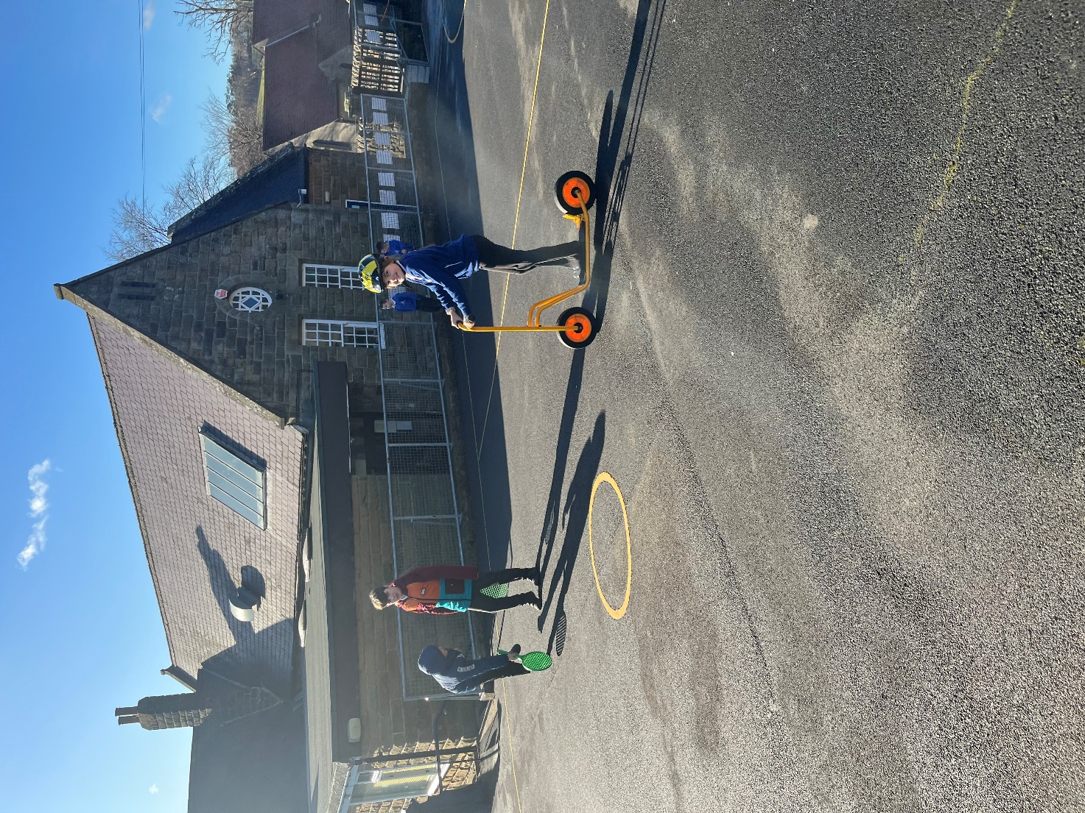

**Lealholm CP School**

Our committed staff team are dedicated to providing a wealth of opportunities to all the pupils. Our broad, balanced and inclusive curriculum has been developed to ensure that it encompasses the local area and we pride ourselves on the strong links we have with our community. Currently, we are developing our bespoke ‘river school’ curriculum, making regular and responsible use of our picturesque location in the heart of the North Yorkshire Moors National Park. In addition to this, we have our ‘farm visit enhancement schedule’ which means that children learn more about their local heritage and the different types of farming that we have locally. We are embarking on our journey to achieving our silver Rights Respecting Schools Award which ensures that we create a safe and inspiring place for children to learn, be respected, their talents are nurtured, and it allows us to embed these values into daily school life: giving children the best chance to lead happy, healthy lives and to be responsible, active citizens. In order to support teaching and learning across the curriculum, and prepare children for 21st century Britain, we have 1:1 ipads for all pupils.

We ensure that within our curriculum we provide children with a vast range of adventurous sporting activities, which develop and build their resilience and allow them to gain worthwhile and extraordinary experiences such as canoeing, sailing and beck scrambling.

We are proud to be a founding member of the Yorkshire Endeavour Academy Trust. Opportunities to work collaboratively with pupils from other schools within the Trust are actively planned into the school year. We ensure that pupils from our small village community have opportunities to develop confidence and build relationships with their peers beyond Lealholm, in preparation for their eventual transition to secondary school.

Staff have high expectations of all pupils and are keen to develop their resilience, independence and communication skills. Staff, pupils, parents and governors have worked together to create a set of oaths, which aim to enhance pupils’ broader development during their time at Lealholm in order to ensure that all pupils are effectively prepared for the next stage of their educational journey.

Our small team of staff are welcoming and friendly. Their passion and motivation shines throughout the school. Don’t delay, come and see for yourself.

For more information about Lealholm, please visit our website: [www.lealholm.n-yorks.sch.uk](http://www.lealholm.n-yorks.sch.uk)

**Yorkshire Endeavour Academy Trust**

**Our Vision and Values**

## Vision

* **Ethical** action for a world class education.
* **Nurturing** relationships at the heart of our communities.
* **Brave** leadership in a changing landscape.

## Values

* Providing world-class education to all children through an ambitious curriculum.
* Encouraging curiosity and a lifelong love of learning.
* Wrapping around our community through an inclusive nurturing approach.
* Taking pride in local heritage whilst preparing our children to be global citizens.
* Collaborating with partners in education and universal services to support each child’s unique journey.
* Highlighting and sharing excellent educational practice for the benefit of all.
* Growing and developing people in all roles to be their very best.

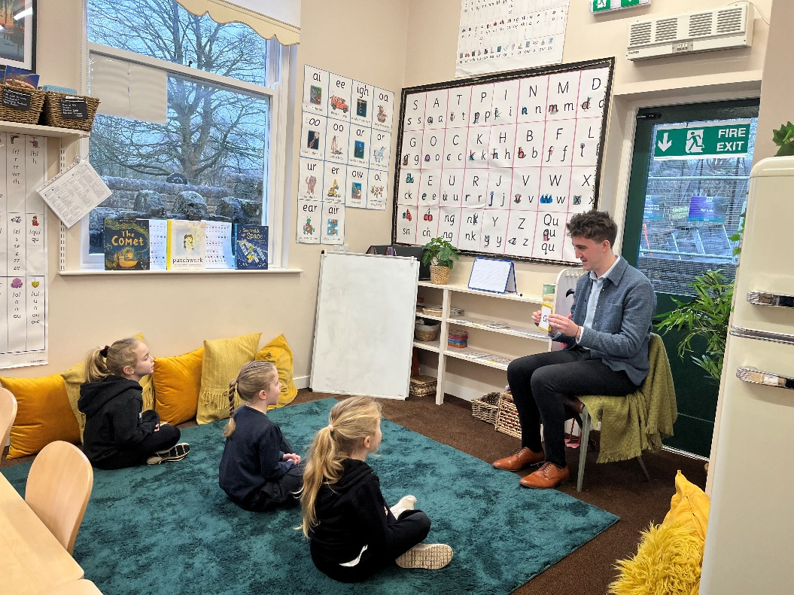

**Schools in Yorkshire Endeavour Academy Trust**

**Airy Hill Primary School**

Pupils succeed and flourish at our school. They achieve well across the whole curriculum. We have a very strong school community where staff care for our pupils and their well-being. Children’s behaviour is excellent throughout our school and reflects our high expectations. Not only do pupils behave very well, but they look out for one another and are helpful, polite and welcoming to visitors. Children are keen to talk about how much they enjoy their learning. They feel safe and know that there are adults that they can talk to if they have concerns. Our school values run deeply through the life of our school and are easily identified by anyone visiting us. Relationships between adults, children and our wider community are excellent. Children learn about their local heritage as well as aspects of culture from around the globe - they value and celebrate the differences in each other.

For more information about Airy Hill, please visit our website: [www.airyhill.n-yorks.sch.uk](http://www.airyhill.n-yorks.sch.uk)

**Glaisdale Primary School**

Glaisdale school currently has 34 pupils on roll across two classes: Explorers (EYFS/KS1) and Adventurers (KS2). We have a relatively new staff team who have worked hard in recent months to develop our curriculum, sports offer, school council and EYFS provision.

Our children love the great outdoors and our rural location provides lots of opportunities for sport and adventurous activities. We would love our new teacher in charge to share this passion, taking the lead on improving our sports and PE provision in order to achieve local, regional and national recognition.

Staff have developed excellent relationships with our parents and 100% of those completing a recent survey said they would recommend Glaisdale to other parents.

For more information about Glaisdale, please visit our website: [www.glaisdaleprimaryschool.co.uk](http://www.glaisdaleprimaryschool.co.uk)

**Castleton Community Primary School**

Castleton currently has 53 pupils on roll across two classes: Acorns (EYFS/KS1) and Oaks (KS2). Outdoor learning is a key feature of our provision and children have regular opportunities to participate in a range of outdoor activities. Hidden behind our historic building are extensive grounds, which include tiered gardens featuring a pond, greenhouse, adventure play area, stage, quiet zone, forest school site and an outdoor classroom. Our children are also interested in music and the arts. Our parents are very keen to be involved in the life of the school and we have an active PTFA.

For more information about Castleton, please visit our website: [www.castletonprimaryschool.co.uk](http://www.castletonprimaryschool.co.uk)

**Oakridge Community Primary School**

There is a real family feel to Oakridge; our children are happy and care for one another. Staff are committed to providing a wealth of opportunities to all pupils, ensuring that no child’s experience is limited by the small size of the school (currently 32 children on roll including nursery) or their individual needs.

Children at our school are provided with a wealth of opportunities. Our broad, balanced and inclusive curriculum is grounded in our local area with our school at the heart of the local community. Our children and staff enjoy their role in the community and our PTFA take a proactive role in supporting these events and bring a real richness to our interactions with the community.

Our bespoke Garden School curriculum makes use of our superb outdoor facilities including raised beds and a pond. As well as using our environment to support learning in traditionally classroom based subjects, our children learn how to grow vegetables, whittle branches and cook on an open fire**.**

For more information about Oakridge, please visit our website: <https://www.oakridge.n-yorks.sch.uk/>

**West Cliff Primary School**

West Cliff Primary School is a warm and friendly community school that provides education from children aged 2-11. It currently has 210 children on roll, divided into 8 classes (one for each year group). One of our classes is a nursery class that takes children from 2 years old.  The school mainly takes children from the west side and the centre of Whitby - but is accessible from all parts of the town.

We pride ourselves on providing a warm and welcoming environment for children and adults alike, and we strive to provide the very best standard of education possible for our children.

The school has a before and after school club (The Ocean Fun Club), offering wraparound care for children from 7.45 until 5.15.  This is open to all children including our nursery children.

We are a Beach School as we believe that the beach is a fantastic resource that can be used, both to learn and have fun on.

For more information about West Cliff, please visit our website: [www.west-cliff.n-yorks.sch.uk](http://www.west-cliff.n-yorks.sch.uk/beach-schools/)

## Application Process

The closing date for all applications is **Sunday 16th March 2025, 23:59**

Lesson observations for shortlisted candidates will take place between **Monday 24th and Wednesday 26th March 2025.** These can be in a setting of the candidates choosing.

Interviews will be held at Lealholm Primary School on the **Tuesday 1st April 2025.**

**Please apply via NYC Jobs**

An email will be sent to shortlisted candidates with details of the shortlisting outcome and interview process.

**Queries / Visits**

Visits to the school and informal chats with our Headteacher Ben Russell are welcomed. Please contact Chloe Bullen on 01609 536 964 or via [nyes.resourcing@northyorks.gov.uk](mailto:nyes.resourcing@northyorks.gov.uk)

**Job Description**

**JOB TITLE: Class Teacher**

**GRADE: MPS**

**RESPONSIBLE TO: Teacher in Charge, Head teacher and Governors**

**RESPONSIBLE FOR: Deployment of support staff allocated (where relevant)**

**JOB PURPOSE: Promote effective learning, appropriate achievement and educational, social and personal progress of all pupils for whom the teacher is designated as being responsible, consistent with the aims of the school and the unique needs of each individual.**

**KEY RESPONSIBILITIES:**

**1. Develop and maintain an up-to-date knowledge and understanding of the areas of teaching and pupil support for which post-holder is responsible**

**2. Plan work to meet the learning needs of allocated pupils in a consistent and effective way**

**3. Use appropriate teaching and classroom management strategies to motivate pupils and enable each to progress**

**4. Monitor the progress of pupils for whom the postholder is responsible to set expectations and give constructive feedback**

**5. Maintain appropriate records to demonstrate progress made by pupils**

1. **Participate fully in professional development activities to develop practice further, sharing the learning from these as appropriate**
2. **Make an active contribution to the policies and aspirations of the school**

**To fulfil all of the requirements and duties set out in the current Pay and Conditions Documents relating to the conditions of employment of teachers**

**To fulfil all of the responsibilities and duties required by the School’s policies on teaching and learning.**

**To achieve any performance criteria or targets arising from the School’s Performance Management arrangements**

**This job description will be reviewed annually.**

**Person Specification**

|  |  |  |
| --- | --- | --- |
| **Attributes** |  | **Desirable/ Essential** |
|  | **Considerable experience of teaching in primary schools**  **Able to evidence excellent pupil progress**  **Experience of working positively and closely with staff, parents and guardians**  **Effective experience in creating a positive climate and environment to secure accelerated learning**  **Recent OFSTED experience** | **Essential**  **Essential**  **Essential**  **Essential**  **Desirable** |
| **EDUCATION AND TRAINING** | **QTS**  **Thorough knowledge of teaching, learning and curriculum in primary schools**  **Commitment to continued professional development**  **Evidence of recent & relevant training**  **Safeguarding Awareness** | **Essential**  **Essential**  **Essential**  **Essential**  **Essential** |
| **PROFESSIONAL KNOWLEDGE AND SKILLS** | **An excellent classroom practitioner**  **Effective use of assessment data to plan sequence of learning that secures accelerated progress**  **Work effectively as part of a team, relating well to colleagues, pupils and parents**  **Excellent use of ICT to support learning**  **High expectations of all pupils**  **Detailed knowledge of the National Curriculum and its planning and delivery**  **Implications of the Code of Practice for Special Educational Needs for teaching and learning**  **Evidence of ability to maintain high standards of behaviour and develop attitudes of care, control and cooperation**  **Experience of curriculum planning as part of a team**  **Ability to self-motivate and lead a team of support staff**  **High level of oral and written communication skills and ability to communicate with a wide range of audiences**  **Able to offer subject expertise**  **High level of organisational and planning skills**  **Ability to use initiative, solve problems, make decisions and motivate others**  **Ability to relate to and empathise with pupils and to build trusting relationships with them** | **Essential**  **Essential**  **Essential**  **Essential**  **Essential**  **Essential**  **Desirable**  **Essential**  **Essential**  **Essential**  **Desirable**  **Essential**  **Essential**  **Essential**  **Essential** |
| **ANY ADDITIONAL FACTORS** | **A commitment to abide by and promote equal opportunities, Health and Safety and Child Protection Policies**  **Commitment to an involvement in extra-curricular activities** | **Essential**  **Essential** |

**We are committed to safeguarding and promoting the welfare of children and young people and expects all staff and volunteers to share this commitment.**

**This post is exempt from the Rehabilitation of Offenders Act 1974 and the appointment is subject to a satisfactory enhanced level disclosure and S128 clearance from the Disclosure & Barring Service (DBS).**

**IMPORTANT ADVICE ON COMPLETING THIS APPLICATION**

Your application form plays an important part in your selection. Please ensure you address all the essential requirements listed in the specifications. The following advice should help you to complete the application form as effectively as possible.

**Data Protection**

The information that you state on this application form will be used by the school and the Council to consider you for a job vacancy. To find out about how we use your personal data for the purposes of recruitment please see our Privacy Notice at [www.northyorks.gov.uk/working-us](http://www.northyorks.gov.uk/working-us).

**Rehabilitation of Offenders**

The post you are applying for requires you to have an enhanced Disclosure and Barring Service criminal records check for work with children, with a barred list check if you work in regulated activity. This check for disclosure of criminal history will include spent convictions, pending prosecutions / current court proceeding and police enquiries.

Should you be shortlisted, you will be asked to disclose full details of your criminal history prior to your interview. This includes any information deemed relevant as part of Keeping Children Safe in Education which may arise in an online search undertaken on shortlisted candidates. This information may be discussed with you at your interview in order to assess job related risks, but we emphasise that your application will be considered on merit and ability and you will not be discriminated against unfairly. Failure to disclose this information will result in any offer of employment being withdrawn.

Please also see the policy statement on the Recruitment of Ex-offenders below.

**Information in Support of your Application**

Every post advertised is supported by a full person specification. The specification lists all the essential skills, experience and qualifications which are necessary for the job and the criteria against which you will be assessed, both through your application form and at interview.

As part of the application process, you may have been asked to demonstrate within this application form how you meet some or all of the criteria or key competencies outlined in the person specification. Rather than simply repeating your career history, look at the skills and experience required by the job and provide evidence that you possess them by giving **specific and detailed examples** which include a focus on outcomes and on your own contribution to the scenario. Try to use different and varied examples wherever possible.

When completing these sections, do not forget the skills and experience you have gained outside full-time work. Outlining your previous work experience or other responsibilities may help you to uncover skills which you have taken for granted and which are clear signs of your ability to do the job.

**Canvassing**

You must not try to influence an elected Council Member, any council employee or a member of the school governing body, to act in your favour, as this will disqualify you. If you are related to a Councillor, a Council employee or a governor you must indicate this in the relevant section of the application form.

**Policy Statement on the Recruitment of Ex-offenders (Source** [**www.gov.uk**](https://www.gov.uk/government/publications/dbs-sample-policy-on-the-recruitment-of-ex-offenders/sample-policy-on-the-recruitment-of-ex-offenders)**)**

1. As an organisation assessing applicants’ suitability for positions which are included in the Rehabilitation of Offenders Act 1974 (Exceptions) Order using criminal record checks processed through the Disclosure and Barring Service (DBS), this school complies fully with the DBS [code of practice](https://www.gov.uk/government/publications/dbs-code-of-practice) and undertakes to treat all applicants for positions fairly.
2. This school undertakes not to discriminate unfairly against any subject of a criminal record check on the basis of a conviction or other information revealed.
3. This school can only ask an individual to provide details of convictions and cautions that it is legally entitled to know about. Where a DBS certificate can legally be requested (where the position is one that is included in the Rehabilitation of Offenders Act 1974 (Exceptions) order 1975 as amended, and where appropriate Policy Act Regulations as amended) this school can only ask an individual about convictions and cautions that are not protected.
4. This school is committed to the fair treatment of its staff and potential staff, regardless of race, gender, religion, sexual orientation, responsibilities for dependents, age, physical/mental disability or offending background.
5. This school has this written policy on the recruitment of ex-offenders, which is made available to all DBS applicants at the start of the recruitment process.
6. This school actively promotes equality of opportunity for all with the right mix of talent, skills and potential and welcome applications from a wide range of candidates, including those with criminal records. Candidates are selected for interview based on their skills, qualifications and experience and criminal record information is only requested from short-listed candidates.
7. A disclosure is only requested from the DBS after a thorough risk assessment has indicated that one is both proportionate and relevant to the position concerned. For those positions where a criminal record check is identified as necessary, all application forms, job adverts and recruitment briefs will contain a statement that a DBS certificate will be requested in the event of the individual being offered the position.
8. This school ensures that all those who are involved in the recruitment process have been suitably trained to identify and assess the relevance and circumstances of offences.
9. This school also ensures that they have received appropriate guidance and training in the relevant legislation relating to the employment of ex-offenders, e.g. the Rehabilitation of Offenders Act 1974.
10. At interview, or in a separate discussion, this school ensures that an open and measured discussion takes place on the subject of any offences or other matter that might be relevant to the position. Failure to reveal information that is directly relevant to the position sought could lead to withdrawal of an offer of employment.
11. This school makes every subject of a criminal record check submitted to DBS aware of the existence of the [code of practice](https://www.gov.uk/government/publications/dbs-code-of-practice) and makes a copy available on request.

This school undertakes to discuss any matter revealed on a DBS certificate with the individual seeking the position before withdrawing a conditional offer**.**