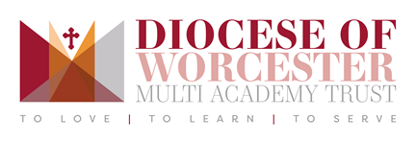
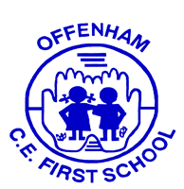

“Growing deep roots. Producing good fruit”

EYFS/KS1 Teacher Maternity Cover

Start date 1st September 2024
Salary M1-M6
Contract Temporary until July 2025 (maternity cover)
Applications close 10th June 2024
Interviews 20th June 2024

ECTs considered Yes

We are part of the Diocese of Worcester Multi Academy Trust and are committed to the safeguarding and flourishing of all children and staff in our care.

Our vision for the school is summed up by the words:

LOVE, TRANSFORMATION and GROWTH

Our vision sits at the heart of all that we do and all that we are.
We are looking for an enthusiastic, motivated and committed teacher to teach at our school. We want someone with excellent teaching skills and high expectations of pupil progress, attainment and behaviour; someone who shares our commitment to the vision that underpins all that we do.

This post is for a mixed Reception/Year 1.

We would like to hear from you if you:
- are an excellent classroom practitioner committed to your professional development
- have high expectations for learning and behaviour
- have good interpersonal and communication skills
- are able to be flexible and to work as part of a small team
- are willing to play a full part in the life of the school and the local community
- can provide a learning environment that enables all children to meet their potential
- are committed to school improvement and raising levels of pupil achievement.

Visits to the school are warmly welcomed. Please contact the school office on Tel: 01386 442038 or email: office@offenham.dowmat.education

You can also apply on MyNewTerm. Please see the link below:

https://mynewterm.com/jobs/143814/EDV-2024-OCFS-69229

