Stratton Primary School
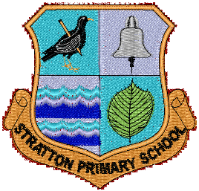

New Road • Stratton • Bude • Cornwall • EX23 9AP

Tel: 01288 353196

E-mail: secretary@stratton.cornwall.sch.uk
http://www.stratton.cornwall.sch.uk

Monday 22nd March 2021

EYFS/KS1 Teacher

The Headteacher and Governors of Stratton Primary are seeking to employ a permanent fulltime Teacher to join our EYFS/KS1 Team (Payscale M1-M3) in September 2021.

We are looking to appoint an enthusiastic, committed, highly motivated, creative and inspirational teacher to join our school.

Stratton School is an expanding school with an increasing roll currently – 354 pupils. We cannot offer school visits at the moment but encourage applicants to view our website video
https://www.stratton.cornwall.sch.uk/information-for-new-starters-september-2021/

If you would like to know, more please email Penny Simpson head@stratton.cornwall.sch.uk

Application forms and further details are available from the school website.
Deadline for applications is midnight on Thursday 15th April 2021.
Interviews will take place on Thursday 22nd April 2021.

Stratton Primary School is committed to ensuring the safety of children within their care and the post will be subject to an enhanced DBS check.

