Hayfield Cross
Church of England School
Welcome to

Want to be part of an amazing team?

We are currently seeking a suitably amazing Reception Class Teacher to take on a maternity cover contract at Hayfield Cross Church of England School initially for the period of May 2023-February 2024. We are looking for a full time experienced teacher. Experience of leading Reception would be beneficial but not essential.

The post will be in Reception Class working as part of our excellent Reception Team. They will lead their phase team to ensure that the children in their class have excellent learning and high expectations. As a Phase leader, you will play an essential role in supporting your phase to ensure children and staff well-being is prioritised, deal with operational issues within their phase and ensure that high quality teaching and learning and structures are in place to support children to make accelerated progress.

Everyone in our team is passionate about our school so we only want the very best people working with our children. We expect everyone to be totally committed and willing to go the extra mile every day to make our school a success and be actively involved in all aspects of school life. We are proud to be a Church of England School and this is reflected through our Christian Values of Joy, Integrity and Fellowship upheld by everyone in our school community. In return you will be joining an exceptional team who enjoy working in a positive school and share many social events together.

For more information about our school please visit our school website http://hayfieldcross.org.uk . Please email all enquiries and questions to the school office bursar@hayfieldcross.org.uk and follow the instructions in the application pack on how to apply. We would encourage visits to our school. We hope you will be excited about this opportunity to join us and be a part of something special. We look forward to meeting you soon.
The closing date for this post is Friday 28th April at 12pm

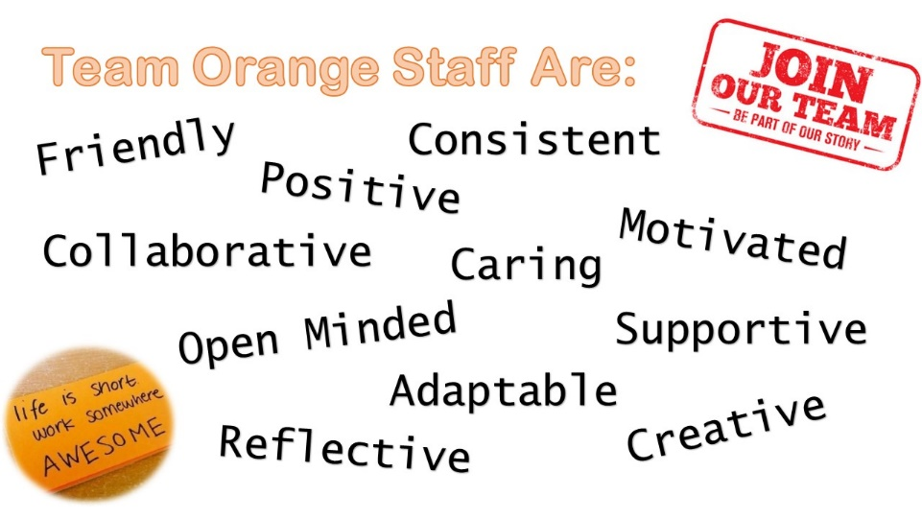

How to Apply

Applications should all be made electronically via the Teach Northamptonshire website: www.teachnorthamptonshire.com

Please do not upload a separate CV and letter of application onto the website. Instead, complete our own standardised ‘Personal Statement Form’ (available on our Teach Northants website advert page) along with the online application.

This MUST be uploaded into the Letter of Application section of the Teach Northamptonshire online application as it will be used for shortlisting.

Please ensure your supporting statement covers all of the aspects in the person specification provided in this pack as this will be used to shortlist candidates.

The closing date is Friday 28th April at 12pm

Please be aware that we are committed to safer recruitment and safeguarding and all offers of employment will be conditional pending positive references, enhanced DBS, qualifications and medical checks. Where possible references will be gathered after shortlisting prior to interview.

Job Title: | Class Teacher | Job Category: | Teacher
Location: | Hayfield Cross Church of England School,  Off Cranford Road,  Hayfield Crescent,  Kettering,  Northamptonshire,  NN15 5FJ | Travel Required: | No
Level/Salary Range | MPS 1-6 | Position Type: | Full-time  (part-time applications also considered)
Date Posted: | 30th March 2023 | Closing Date: | 28th April 2023 at 12pm
For more information please contact:
Dawn Fraser
School Business Manager
bursar@hayfieldcross.org.uk

01536 606093

Class Teacher Job Description

Duties

The duties outlined in this job description are in addition to those covered by the latest School Teachers' Pay and Conditions and the Teachers Professional Standards. It may be modified by the head teacher, with your agreement, to reflect or anticipate changes in the job, commensurate with the salary and job title.

Teaching and learning

- Identify and adopt the most effective teaching approaches for all pupils including those identified in vulnerable groups, gifted or talented and those with SEND.
- To promote the progress and well-being of every child.
- To use effective assessment methods, planning and differentiation to raise standards of pupil attainment and progress for all children.
- To report on assessment data and pupil progress to the Senior Leadership Team.
- To follow all school systems and expectations for teaching, learning and behaviour.
- To adhere to the teaching standards and uphold the professional code of conduct expected of professional teachers.

Safeguarding

- To share in the school commitment to safeguarding and promoting the welfare of children.
- To adhere to all safeguarding policies, practices and expectations including online safety.
- To have a thorough knowledge of all vulnerable groups in your class and follow any strategies or plans to support them as advised.
- To undertake safeguarding training and seek additional information and training as appropriate.

Standards and quality assurance

- Uphold the school's code of conduct.
- Ensure pupil progress and maintain up to date data on standards.
- Ensure that required deadlines are met on time.
- Support the aims, ethos and expectations of the school.
- Actively participate in staff training and seek appropriate training opportunities to develop self.
- Attend team and staff meetings.
8. Work with governors, other agencies and linked schools as appropriate.

Other duties and responsibilities

- Ensure that all school expectation and policies are adhered to at all times, seeking clarification if unsure.
- Represent the school in a positive and professional manner in all interactions with stakeholders and the wider community including through the use of ICT based social networking.
- Ensure that confidential school information is not released to other members of staff, parents or children unless through authorised channels.
- Undertake any reasonable additional duties as directed by the Head Teacher.

Phase Lead
- Have a strategic overview of expectations for the phase/pupils
- Lead one core or statutory subject and one other area (if a phase leader)
- Analyse data of the phase/group of children
- Monitor the effectiveness of the teaching in the phase/for the group of children
- Support effective transition through the phase
- Work with other leaders to develop the SIP and monitoring its implementation in the phase/for the group of children
- Manage staff in the phase (if phase leader)/Support/direct staff allocation for group of children by phase leaders (if SENDCo)
- Deliver and support CPD for staff
- Report to SLT and Governors

School Development Lead (not NQT or temporary contracts unless agreed):

In addition to the professional duties of a class teacher, all teachers are expected to undertake the following duties in relation to leading an aspect of school development, initiative or curriculum area.
- Promote their focus area within the whole school curriculum and keep its profile high with all staff.
- Advise on the development of their focus aspect and support colleagues on its implementation.
- When requested, present the Head Teacher and Governors with accurate and up-to-date information, based on ongoing monitoring, of standards and progress across the school in their aspect with particular attention to the end of Key Stages.
- Monitor and evaluate the expectations and effectiveness of activities within their aspect and report to the Head Teacher.
- Monitor and evaluate year group subject content to ensure sufficient challenge for the children.
- Produce and monitor an action plan of the subject identifying priorities and advising the Head Teacher of spending needs. Where appropriate use this document to support the Head Teacher in developing the School Improvement Plan.
- Develop and review policy documents where necessary.
Class Teacher Person Specification

To be covered by Application Form and Cover Letter
Essential | Desirable
Qualifications and Self Development
Degree | Further relevant professional qualifications
Qualified Teacher Status
Relevant recent roles or professional development that helps prepare for this position.
Experience, Knowledge and Understanding
Experience of teaching in a Primary school | Experience of working in Reception
A good understanding of the new EYFS framework | Experience of using Tapestry EYFS profiling
Ability to deliver quality EYFS English and Maths including at greater depth to ensure good progress of all children | Leadership of a team or phase
Understanding of working with children with a range of learning needs/ SEND and strategies to support them effectively | An understanding of teaching phonics through Little Wandle
A good understanding of effective practice, planning and resourcing in Early Years education.
Skills
Able to inspire, motivate and inspire pupils to achieve their potential | Ability to plan for and manage teaching assistants effectively to ensure positive impact on pupils.
Ability to plan effective learning across all areas of the EYFS curriculum and ensure all children are able to access these effectively.
Very high expectations for behaviour and learning and the ability to deliver these in the classroom.
Ability to communicate effectively orally and in writing
Personal Ethos
High expectations for children in both learning and behaviour | A personal Christian faith
A positive and energetic attitude with high expectations of self as a professional teacher
Able to work effectively as part of a team and contribute positively to the life of our school

To be covered at Interview (not on application form)
Essential | Desirable
Qualifications and Self Development
Self-motivated and eager to develop professional knowledge, skills and understanding
Experience, Knowledge and Understanding
A clear understanding of expectations for learning and how to secure excellent outcomes.
An ability to reflect effectively about own practice and hold yourself to account | An understanding of the ‘drawing club’ strategy
An understanding of different vulnerable groups and how to support them effectively | Knowledge of OfSTED expectations, Education Acts and other relevant legislation
Knowledge and understanding of effective EYFS assessment. | Experience of using assessments to set targets
A thorough understanding of, and commitment to uphold all safeguarding systems and policies
Understanding of how to promote children’s SMSC development including the schools Christian Values and British Values
Skills
Practical understanding of effective teaching, learning and classroom management strategies | Enthusiasm and ability to use ICT creatively across the curriculum
Resilient under pressure | A creative approach to developing an effective learning environment
Able to challenge, investigate, solve problems and make decisions
Ability to lead and support TA’s effectively to support children’s learning
Able to deal sensitively with staff, parents and pupils
An ability to work with and engage parents effectively to represent the school positively
Personal Ethos
A passion and enthusiasm for teaching with a desire to fulfil every child’s potential | A commitment to the school’s wider community and the Church.
Calm and positive approach | Ambition to be an outstanding teacher actively involved in all aspects of our school.
An understanding and appreciation of our schools Christian Values and ethos.

