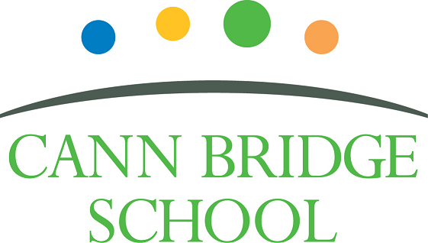

**Early Years Foundation Stage Leader**

**November 2024**

**Welcome from the Headteacher**

Dear Prospective Candidate,

Thank you for your interest in joining our dedicated and compassionate team at Cann Bridge School. As the Headteacher, I am delighted to introduce you to our school and the opportunities that await you here.

Cann Bridge School, located in Estover, Plymouth, is a local authority maintained special school serving children and young people aged 3 to 19 years from Plymouth, Devon, and Cornwall. With a capacity for 108 pupils, we are an oversubscribed school, currently educating 118 learners.

Our school is uniquely designed for children and young people with complex cognition and learning needs, all of whom have an Education, Health, and Care Plan indicating either Severe Learning Difficulty or Profound and Multiple Learning Difficulty. Many of our learners also have additional specific learning difficulties, such as Down's Syndrome, Autistic Spectrum Condition, speech and language difficulties, physical disabilities, or complex medical conditions. To learn more about Cann Bridge School and the wonderful things happening, please visit our:

* Website: [www.cannbridgeschool.co.uk](https://cannbridgeschool.co.uk/)
* Facebook: [www.facebook.com/cannbridgeschool](https://www.facebook.com/cannbridgeschool)
* School Newsletters [www.cannbridgeschool.co.uk/newsletters-forms](https://cannbridgeschool.co.uk/newsletters-forms/)

At Cann Bridge School, we are committed to creating a nurturing and inclusive environment where every learner is given the support and encouragement they need to thrive. We are learner-focused, and it is our mission to provide the highest quality of education tailored to the unique needs of each child and young person. Our dedicated and hardworking staff create a calm and purposeful environment, delivering personalised learning opportunities through our Pathways to Independence Curriculum. Detailed outlines of our EYFS and 14 to 19 Curriculum are also available on our website.

With a history spanning over 60 years, previously known as Downham School, Cann Bridge School moved to its current purpose-built facilities on the Tor Bridge Partnership site in 2012. We are co-located with Torbridge High, Torbridge Primary, and Plym Bridge Nursery. Recent expansions include a Post-16 unit (Post Bridge College) in 2016, remodelling in 2022, and the addition of two modular classrooms in 2024. We are fortunate to have excellent facilities and resources including sensory rooms, immersive room, warm water pool, science garden, soft play and Forest Schools area to name a few. We continuously striving to enhance and develop these further and our active Friends of Cann Bridge (PTFA) plays a crucial role in supporting these endeavours.

Our school is undergoing significant and exciting changes, as outlined in our School Development Plan (SDP), which identifies key areas for improvement to ensure we remain progressive and provide the highest quality education for our learners. The SDP is available on our website. We are dedicated to ongoing training and development for our staff, ensuring they are equipped with the latest knowledge and techniques in special education.

We are seeking an exceptional EYFS Leader at Cann Bridge School to build upon the strong foundations already established in our Early Years Foundation Stage (EYFS). This pivotal role is both challenging and immensely rewarding, as you will be responsible for preparing our youngest learners to develop a lifelong love of learning. As the EYFS Leader, you will have the opportunity to make a profound impact on the lives of our children, preparing them well for Key Stage 1 and beyond. In this role, you will implement a flexible and responsive curriculum that meets the individual strengths and needs of each learner. We are looking for a dynamic and aspirational leader who shares our commitment to the education of children and young people with Special Educational Needs and Disabilities. Together, we will prioritise meeting the unique needs of our learners, ensuring they are well-prepared for their futures. Your leadership will inspire both staff and learners, creating an inclusive and nurturing environment where every child can thrive.

We look forward to welcoming passionate, innovative, and caring individuals to our school. If you are ready to take on this rewarding challenge and make a positive impact, we would be thrilled to receive your application. We encourage all applicants to visit the school prior to applying.

Once more, thank you for your interest in the role of EYFS Leader at Cann Bridge School. We look forward to receiving your application.

Warm regards,



Shane Baker

Headteacher

**Our Vision & Values**

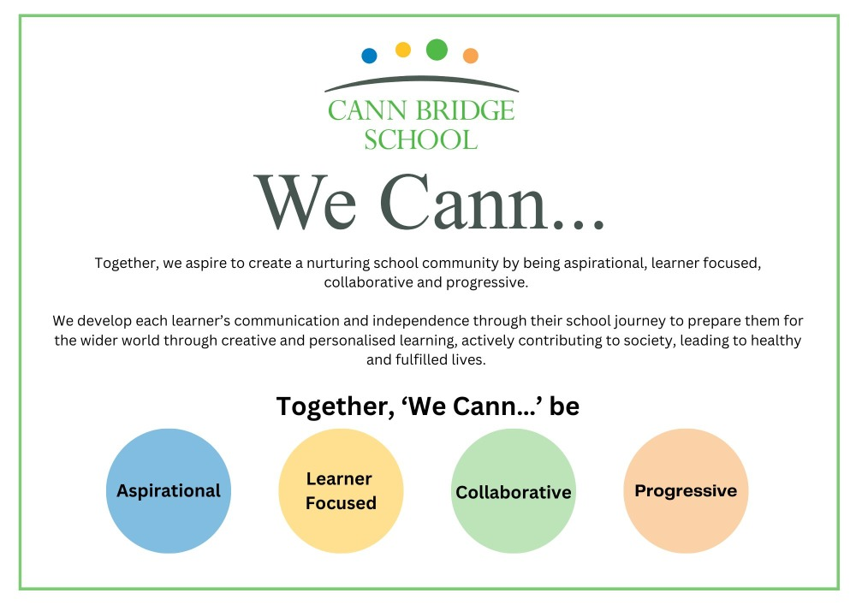

**The Role**

The role of an EYFS Leader at Cann Bridge School is pivotal in shaping the educational experiences of our youngest learners, all of whom have Special Educational Needs and Disabilities (SEND). This position involves leading the development and implementation of a high-quality, inclusive Early Years Foundation Stage (EYFS) curriculum that is meticulously tailored to the unique needs of each child. You will create a stimulating and nurturing learning environment that fosters creativity, curiosity, and a love for learning. As the EYFS Leader, your collaboration with parents, carers, and other professionals ensures a holistic approach to each child's development, making sure that every child receives the comprehensive support they need to thrive.

In addition to curriculum leadership, the EYFS Leader will oversee the daily operations of the EYFS setting, managing a team of dedicated support staff to ensure that all children receive the highest standard of care and education. This includes providing guidance, support, and professional development opportunities for the team, fostering a culture of continuous improvement and reflective practice. You will monitor and evaluate the effectiveness of the EYFS provision using data, evidence-informed research, and feedback to inform practice and drive improvements. Strong communication skills are essential, as you will report on pupil progress and development to families and school leadership, ensuring that everyone involved in the child’s education is engaged and informed. Your leadership will be instrumental in maintaining compliance with educational policies, promoting best practices, and ensuring the highest standards of care and educational outcomes for all children in the EYFS.

**Recruitment Timeline**

* Opportunities to visit Cann Bridge School: 19th Nov @ 10am or 26th Nov @ 2pm. Please contact the school to arrange your visit or to request an alternative time – 01752 207909 or [HR@cannbridge.co.uk](mailto:HR@cannbridge.co.uk)
* Application closing date: Midday 29th November
* Candidate shortlisting: Afternoon 29th November
* Interviews: Wednesday 4th December 2024

Complete applications should be sent to: HR@cannbridge.co.uk

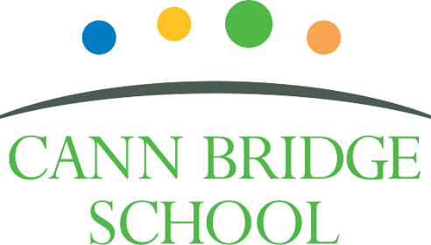

**Job Description: Early Years Foundation Stage Leader**

Cann Bridge School is committed to creating a diverse workforce. We’ll consider all qualified applicants for employment without regard to sex, race, religion, belief, sexual orientation, gender reassignment, pregnancy, maternity, age, disability, marriage, or civil partnership.

**Job details**

**Position:** Early Years Foundation Stage (EYFS) Leader

**Location:** Cann Bridge School, Estover, Plymouth

**Salary:** Main Pay Range 1 to 6 or Upper Pay Range 1 to 3, plus Special Educational Needs Allowance 1 and TLR2a.

**Contract type:** Full-time permanent

**Reporting to:** Headteacher, Deputy Headteacher and Governing Body

**Responsible for:** EYFS support staff

**Start Date:** January 2025 or April 2025

**Main purpose**

In addition to:

* Fulfilling the professional responsibilities of a teacher, as set out in the School Teachers’ Pay and Conditions document
* Meeting the expectations set out in the Teachers’ Standards
* Leading by example through exceptional teaching and leadership

The EYFS leader, under the direction of the Headteacher and Deputy Headteacher, will take lead responsibility of the EYFS to secure:

* Improved standards of learning and achievement for all in EYFS
* Lead the development and implementation of a high-quality, inclusive Early Years Foundation Stage (EYFS) curriculum tailored to the needs of children with Special Educational Needs and Disabilities (SEND).
* Monitor and evaluate the effectiveness of the EYFS provision, using feedback and data to drive improvements and ensure the highest standards of care and education.
* Ensure compliance with relevant educational policies, regulations, and best practices in early years education.
* Engage in ongoing professional development to stay current with best practices in early years education and SEND.
* Ensure that all statutory requirements for learners in early years are met.
* Provide leadership, direction and management to ensure sustained improvement of the EYFS.
* To share in and support the leadership of the school as a member of the school’s leadership team.
* To lead the school in policies and practices of continuous school improvement and staff development in relationship to the early years.
* Have a good understanding of and be able to present coherent and accurate account of the children’s progress and other early years self-evaluation evidence in a format appropriate to a range of audiences, including governors, the local community and external audits.
* Lead the development and implementation of an early year’s strategic development plan.
* Work with the leadership team to monitor, evaluate and review the effects of policies, priorities and targets of the school in practice, and act if necessary.
* Contribute to the schools Self Evaluation Form (SEF).
* Support families with the induction and well-being of their child when they arrive in early years.
* Take lead for the transitions into early years following local guidance and best practice.

**Duties and responsibilities**

**Strategic direction**

* Develop and implement policies for the EYFS in line with our school’s commitment to high-quality teaching and learning
* Consult parents and staff about the EYFS and its effectiveness, and assess the feedback against the school’s mantra, vision and values
* Work with other middle and senior leaders to ensure the curriculum meets the needs of all learners
* Work with subject leaders to understand how their subject is developed at the EYFS
* Liaise with Plymouth City Council on EYFS-related projects and activities staying up to date with developments in the city
* Share outstanding EYFS practice, knowledge and expertise throughout the school as appropriate
* Contribute to the development, implementation and evaluation of the school’s policies, practices and procedures, so as to support the school’s vision and values
* Make a positive contribution to the wider life and ethos of the school
* Work with others on curriculum and learner development to secure co-ordinated outcomes
* Lead EYFS enhanced transition-in offer

**Leading the curriculum**

* Develop and review regularly the vision, aims and purpose for EYFS
* Monitor changes to EYFS teaching, learning and school improvement, and share with staff as appropriate
* Oversee the planning of a curriculum that:
  + Is diverse and inclusive
  + Meets the needs of all pupils and the requirements of the EYFS framework
  + Is well sequenced to promote pupil progress towards the early learning goals (ELGs)
  + Is effectively and consistently implemented across the EYFS
* Make sure there is an effective system of assessment that meets the requirements of the EYFS framework and tracks the progress of pupils to check the curriculum has a positive impact on learning
* Have an overarching responsibility for pupils’ achievement and standards in the EYFS
* Complete all statutory assessments and returns for EYFS

**Teaching**

* Plan and teach well-structured lessons to assigned class/es, following the school’s plans, curriculum and schemes of work
* Assess, monitor, record and report on the learning needs, progress and achievements of assigned learners, making accurate and productive use of assessment
* Adapt teaching to respond to the strengths and needs of learners
* Set high expectations which inspire, motivate and challenge learners
* Promote good progress and outcomes by pupils
* Demonstrate good subject and curriculum knowledge

**Leading and managing staff**

* Hold regular team meetings on the EYFS to keep staff informed of developments or changes
* Provide support to staff regarding teaching and learning, resources, and planning in the EYFS
* Monitor teaching and learning to assess how well the EYFS is being implemented and how well it is delivered
* Provide feedback to staff based on the above observations to identify training needs and provide continuing professional development (CPD) in the EYFS
* Take a leading role in inducting new EYFS staff and making sure they uphold expected values and teaching standards
* Identify, coordinate and or deliver identified continuous professional development needs linked to the school development plan.
* Support staff to make accurate assessments, and manage internal moderation.
* Monitor staff wellbeing, working with senior leaders to address wellbeing challenges as appropriate

**Efficient and effective deployment of resources**

* Create a safe, welcoming environment and take care of the classroom accommodation
* Audit the indoor and outdoor learning spaces in the EYFS to evaluate the quality of the overall learning environment
* Ensure resources used are diverse, inclusive and accessible
* Support continuous provision in the EYFS, which allows pupils to play independently and gives them a sense of ownership over their environment
* Audit, check and manage resources to ensure they are up to date and match learner and curriculum needs
* Manage the EYFS budget effectively
* Manage, monitor and review the range, quality and quantity of all available resources in order to improve pupils’ achievements, ensure efficiency and securing value for money.

**Health and safety**

* Promote the safety and wellbeing of learners and staff
* Maintain good positive behaviour support to ensure a good and safe learning environment
* Maintain and develop a learning environment in line with the school’s policies maintaining good housekeeping and health and safety expectations

**Professional development**

* Take part in the school’s appraisal procedures
* Take part in further training and development in order to improve own teaching
* Take part in the appraisal and professional development of others, where appropriate

**Communication**

* Communicate effectively with learners, parents and carers and staff
* Lead a weekly class meeting with own class team
* Communicate effectively with governors and multi-agency professionals.

**Working with colleagues and other relevant professionals**

* Collaborate and work with colleagues and other relevant professionals within and beyond the school
* Develop effective professional relationships with colleagues
* To actively develop professional relationships with parents and carers and the wider community, including pre-schools and nurseries, to facilitate and support transitions.

**Personal and professional conduct**

* Uphold public trust in the profession and maintain high standards of ethics and behaviour, within and outside school
* Have proper and professional regard for the ethos, policies and practices of the school, and maintain high standards of attendance and punctuality
* Understand and act within the statutory frameworks setting out their professional duties and responsibilities

**Management of staff and resources**

* Direct and supervise support staff assigned to them
* Deploy resources delegated to them

**Safeguarding**

* Work in line with statutory safeguarding guidance (e.g. Keeping Children Safe in Education, Prevent) and our safeguarding and child protection policies
* Work with the designated safeguarding lead (DSL) to promote the best interests of learners, including sharing concerns where necessary
* Promote the safeguarding of all learners in the school

Please note, this is illustrative of the general nature and level of responsibility of the role. It is not a comprehensive list of all tasks that the EYFS leader will carry out. The postholder may be required to do other duties appropriate to the level of the role.



**Person Specification: EYFS Leader**

|  |  |  |  |
| --- | --- | --- | --- |
| **Criteria** | **Qualities**  **Essential** | **Qualities**  **Desirable** | **Method of Assessment** |
| **Qualifications and training** | * Qualified Teacher Status QTS or equivalent * Degree * Recent and relevant EYFS training and development | * Qualification in Special Educational Needs * Relevant National Professional Qualification (NPQ) | Application form |
| **Experience** | * Successful teaching experience in an EYFS setting/specialist setting * Experience of leading subject/curriculum/phase development across a whole school * Demonstrable evidence of raising the standards of teaching, learning and assessment * Experience of writing intended subject/department/school development and improvement plans, monitoring implementation and reporting on impact. * Experience of managing a department/phase budget * Proven experience working with learners with SEND * Teaching, learning and assessment practices which demonstrate improved pupil outcomes over time. * Creating Individualised Education Plans (IEPs) (known as Personalised Learning Goals at Cann Bridge School) * Adapting teaching methods and resources to meet the needs of diverse learners * Implementing positive behaviour management strategies consistently in line with schools’ policies and procedures * Experience of managing a team * Experience of working with multi-agencies and families * Evidence of supporting and developing practice of others | * Successful experience of EYFS leadership * Contribution to whole school self-evaluation (SEF) and development planning (SDP) * Experience of teaching children and young people with severe learning difficulties * Effective collaboration with external agencies | Application form  Interview process |
| **Skills & Knowledge** | * Proven ability to develop good/outstanding practice * Understanding of high-quality teaching and learning strategies in the EYFS, and the ability to model this for others and support others to improve * Good understanding of the Education, Health, and Care Plan (EHCP) and how these can be used to personalise learning. * Leading support staff appraisal processes * Excellent communication skills, both verbal and written, with the ability to engage effectively with learners, families, and colleagues. * Ability to build effective professional working relationships * Able to use technology systems integrally to monitor and support the raising of learner achievement * Understanding of safeguarding and child protection * Good ICT skills, particularly using ICT to support learning * Knowledge of Keeping Children Safe in Education (KSCiE) and Prevent * Ability to communicate a vision and inspire others * Expert knowledge of the EYFS statutory framework * Knowledge of total communication approaches | * Experience and/or knowledge of CPI Safety Intervention training or similar i.e. Team Teach * Experience and/or knowledge trauma informed practice * Demonstratable knowledge of current research-based teaching principles and strategies i.e EEF and Rosenshine Principles * Knowledge and experience of using Makaton, ELKLAN, PECS, core boards, AAC devices, TEACCH. | Application form  Interview process |
| **Personal qualities** | * A commitment to getting the best outcomes for all learners and promoting the ethos and values of the school * High expectations for children’s attainment and progress, improving outcomes for children with SEND. * Ability to work under pressure and prioritise effectively, ensuring a work-life balance * Commitment to maintaining confidentiality at all times * Commitment to safeguarding and equality and diversity, ensuring that personal beliefs are not expressed in ways that exploit the position * Empathetic and patient, with a strong understanding of the challenges faced by learners with special needs. * Motivated, with a positive attitude and the ability to inspire and engage learners. * Able to work collaboratively and build effective teams with good presence * Strong personal integrity, honesty, dedication, reliability, and resilience * Demonstrate initiative in solving problems * Good organisational skills * Maintain and promote the expected professional standards of self and others (Teachers’ Standards) * Aware of own strengths and areas for development with a commitment to own professional development. | * Able to manage and resolve conflict | Application form  Interview process |

This job description may be amended at any time in consultation with the postholder.

**Last review date:** November 2024

**Line manager’s signature:** _______________________________________

**Date:** _______________________________________

**Postholder’s signature:** _______________________________________

**Date:**  _______________________________________