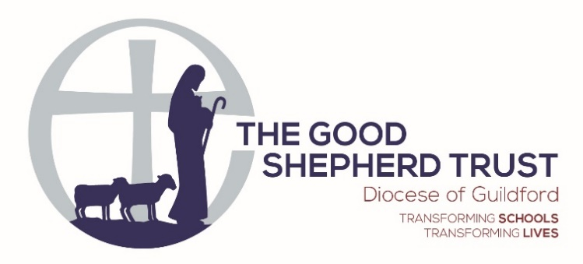

Early Years Leader
The Holme C of E Primary School

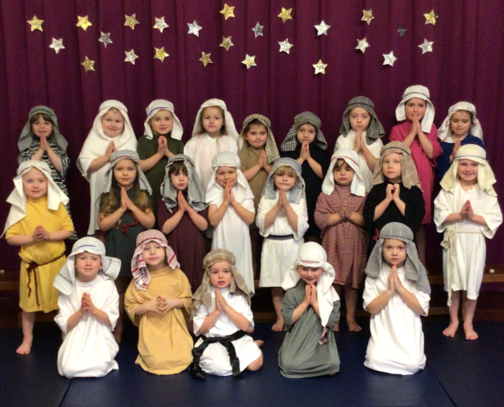

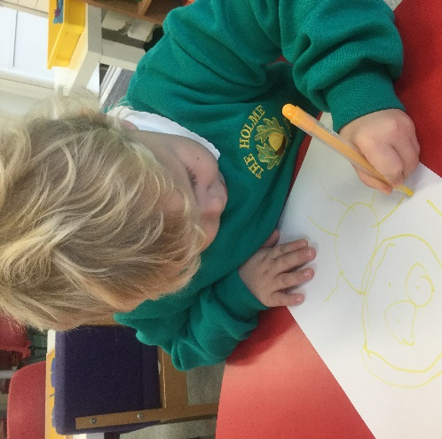
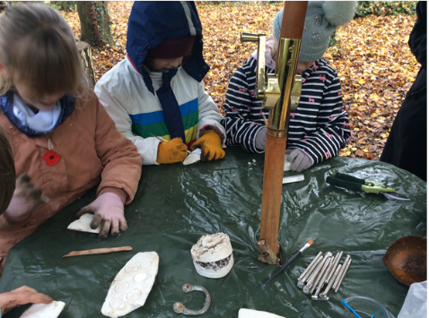

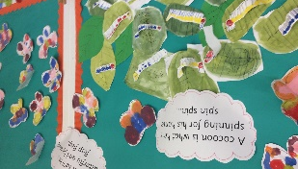
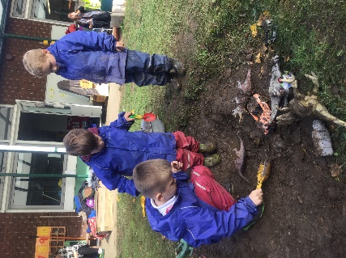

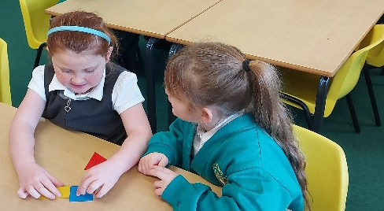
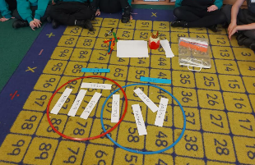

Candidate Information Pack

WELCOME LETTER

Dear Applicant,

Thank you for your interest in this exciting opportunity to apply for the role of Early Years Leader and Reception class teacher at The Holme C of E Primary School, an academy within The Good Shepherd Trust. We are seeking a passionate, inspirational person to join our team and to lead our large Early Years curriculum.

Children are at the heart of everything we do at The Holme. Our vision, values and our ethos make our school a very special place to both learn and work in. We endeavour to make every opportunity, in every moment of everyday, a valuable and enjoyable learning experience for our children. Although I have only been part of The Holme team for a relatively short period of time, the sense of community, family and inclusion I have experienced has been immense and I hope to pass on that ‘welcoming feeling’ to the successful candidate.

The post will provide many personal and professional development opportunities in a role where you will be making a real difference to our children every day. You and I will work closely together to encourage high standards and set those firm foundations for our children as they move to KS1 and KS2. You will be leading by example with our reception class responsibility. If you are passionate about Early Years education, enjoy responsibility able to work positively as part of a team and have the children at the heart of everything you do, then this could be an extremely exciting opportunity for you.

We very much encourage and welcome visits to the school and we look forward to hearing from you. Please contact the school office on 01428 714409 in order to make an appointment.

I look forward receiving your application.

Sarah Stevenson
Headteacher

ABOUT US – THE HOLME C OF E PRIMARY SCHOOL

The Holme is an ‘ever growing’ school in the heart of the local community. We are an approachable, supportive and inclusive school and we are very proud to provide a happy, positive environment where children have the aspiration and self-belief to achieve their goals, whatever they may be.

The Holme is an academy in the Good Shepherd Trust, a visionary Trust, which together with our school leadership team; enable us to give our children the very best possible primary school experience.

The Trust vision:
‘Transforming schools – transforming lives
In the name of Jesus the Good Shepherd’

This means The Trust are fully committed to establishing academies, which educate the whole child for life in all its fullness, within the heart of their local community. Further information about our Trust can be found later in this pack and by the following link: http://www.goodshepherdtrust.org.uk/

We also have a Local Committee, who meet at least once per half term. They are sharply focussed on the ‘offer’ that pupils’ receive and how this can be further improved. They are an experienced team that are rooted within the local community, receiving advice, support and training from the Trust’s central team as required.

As a Church of England school, The Holme has very clear Christian values and a strong ethos, which permeates every aspect of our school and is built around enjoyment in learning.

We work closely with parents to inspire enthusiasm for learning and are proactive in promoting that partnership. We value the support and commitment that parents offer, both to the school as a whole and to their own child’s education. We believe that working together enables our children to achieve their full potential through high quality teaching and an exciting curriculum.

Our School Vision and Values of Love, Courage and Wisdom

Growing together, as we journey with God, in Love, Courage and Wisdom...

With Love, we make our school, our community and our world better, loving both our togetherness and our difference. We love ourselves, we love each other even when that is hard, as God loves us.

With Courage, we are tenacious in embracing challenge and having the highest aspirations, as God strengthens us.

With Wisdom, we make good choices, learn from our mis-steps and aim for excellence, as God teaches us.

Our vision and values are fundamental to our school and underpin everything we do as we strive to support and challenge the children to become well-rounded citizens who have a love of learning and are ready for the next stage of their education. As well as our Christian Values, we encourage all our children to be responsible citizens who are ‘Ready, Respectful and Safe.

We know that every child has the capacity for success and we have tailored a bespoke curriculum to enable our children to learn about the world around them, trying a wide variety of experiences and discovering and succeeding in their own talents and passions. Our topic/enquiry based curriculum is further enhanced by a range of both visits and visitors and wider opportunities such as after school clubs, residential experiences and participation in local and national events, such as ‘Young Voices’.

The school is fortunate to benefit from superb facilities, including a mini-bus and extensive grounds, with a large, purpose built Forest School area that is integral to the school’s curriculum. There are also strong links with the local church.

There is an onsite pre-school called ‘Little Badgers,’ with whom the school have a good relationship. This partnership successfully supports the transition of families into their Reception year, alongside a programme of home visits and ‘stay and play’ sessions.

Friends of The Holme (FR OTH) are an active body within the school community and have continued to seek innovate ways to support the school during recent lockdown periods.

Safeguarding
The Holme is committed to safeguarding and promoting the welfare of children and young people, and expects all staff and volunteers to share this commitment. We ensure that all our employment practices reflect this commitment.
Job Profile – Reception class teacher and Early Years Lead
(See separate Job description and person specification documents)

SALARY: MPS + TLR/UPS (dependent on experience)

RESPONSIBLE TO: Head Teacher

CORE PURPOSE:
- To support and lead learning and teaching in Early Years Foundation stage as our reception class teacher and Early Years Foundation Stage Leader, for pupils in all areas of the curriculum.
- To support colleagues to secure strong progress for all groups of pupils.
- To ensure the consistent application and implementation of school policies across the EYFS.
- To act as the immediate Line Manager for the EYFS Team and be an Appraiser within the school appraisal process.
- To support the work of the Senior Leadership Team and the implementation of the School Priorities and School Development Plan.

RESPONSIBILITIES:
- To be an exemplar of consistent good practice as a Class Teacher, fully complying with all aspects of the Teacher Standards to a high standard.
- Fulfil the professional responsibilities of a teacher, as set out in the School Teachers’ Pay and Conditions Document and the School’s Class teacher Job description
- To be an effective Subject Leader, developing policy and leading the work of colleagues in your subject area(s) to promote effective learning for pupils
- To coordinate the day-to-day management of the EYFS/Yr R Team and be responsible for the communication of this to all team members.
- To coordinate opportunities for working collaboratively across the EYFS/KS1 Team to support learning.
- To maintain a termly overview of the progress the children are making in all 17 areas of learning
- To oversee the effective moderation and up to date marking and assessment of work within your team.
- Hold team members to account for the children they support through moderation, particularly focusing on those children who are just dipping below expected progress.
- To feedback regularly to the Senior Leadership Team and vice versa.
- To be an Appraiser of staff performance.
- To support the Leadership Team in the delivery of the in-house CPD training programme.

KEY ACCOUNTABILITIES:
Strategic Development
- To contribute to the implementation of the School Development Plan, supporting the consistent implementation of priorities and school policies.
- To monitor the quality of learning and teaching, in line with school policy, to promote consistently good pupil progress across the EYFS Team.
- Make a positive contribution to the wider life and ethos of the school
Learning and Teaching (see class teacher Job Description)
- Plan and teach well-structured lessons to assigned classes, following the school’s plans, curriculum and schemes of work
- Assess, monitor, record and report on the learning needs, progress and achievements of assigned pupils, making accurate and productive use of assessment
- Adapt teaching to respond to the strengths and needs of pupils
- Set high expectations which inspire, motivate and challenge pupils
- Promote good progress and outcomes by pupils
- Demonstrate good subject and curriculum knowledge
- Participate in arrangements for preparing pupils for external tests
- Lead and Managing Staff
- To act as an Appraiser for staff within the school.

PERSONAL SPECIFICATION (See separate document)
You will be able to demonstrate the following competencies:
- Ability to lead, motivate and support others
- Ability to foster a sense of team spirit
- Ability to remain positive and enthusiastic
- Ability to consistently deliver high standards of learning and teaching in your own classroom
- Ability to lead a subject area(s) across the school
- Ability to keep abreast of current educational thinking
- Ability to work strategically and consider the whole school’s needs as well as those of your Team
- Ability to communicate effectively
- Ability to organise, prioritise and delegate
- Ability to analyse and use data effectively

Some experience of EYFS/Reception and KS1 is essential.

The Good Shepherd Trust is committed to safeguarding and promoting the welfare of children and young people, and expects all staff and volunteers to share this commitment. We ensure that all our employment practices reflect this commitment.
About The Good Shepherd Trust

The Good Shepherd Trust is a multi-academy Trust within the Diocese of Guildford. It currently has 16 schools, 15 primary (7 sponsored academies and 8 converter academies) and one converter secondary school. Currently, the Trust is consolidating and developing a strategy for school hubs for the purpose of collaboration to improve outcomes for children and is seeking to streamline and centralise services in order to better support all the schools within the Trust. We are guided by our principles and it is these with our Vision and Values that create the culture of how we work together:

- Distinctively Christian, with leadership characterised by serving others
- With schools and for schools
- A stronger family by sharing expertise
- Collaborating for the common good
- Strong stewardship and effective governance

Educationally our consolidated outcomes (for schools that meet the 3 year criteria for inclusion) across the Trust are in line with national average for all MATs and within the Trust community are outstanding, good and improving schools.

The Trustees are ultimately accountable for the performance of the Trust and have a key role in setting the strategic direction and managing risk. The Trustees delegate some responsibilities to local governing committees through the scheme of delegation.

The Trust has an active central team, based in Guildford, providing support for school improvement and educational outcomes, safeguarding, governance, admissions, human resource management and finance. There are exciting developments in the pipeline to further develop the central function for the benefit of using our resources wisely and benefitting all our schools.

In February 2020 the Trust welcomed a new Chief Executive Officer to lead the next phase of Trust development.

How to Apply:
Please complete the full application form. Within this form you are asked to provide a supporting statement and it is here that you should set out your reasons for applying for this job and address the requirements of the person specification. Applications will only be considered if this form is completed in full.

Dates:
Closing date: 12.00 noon on Monday 11th October 2021
Shortlisting: Tuesday 12th October 2021
Interview dates: Wednesday 20th October 2021

Questions and Visits:
We welcome questions from prospective candidates. If you would like to arrange a visit of a conversation with the Headteacher, please contact the school on 01428 714409 or via email at adminoffice@holme.goodshepherdtrust.org.uk

