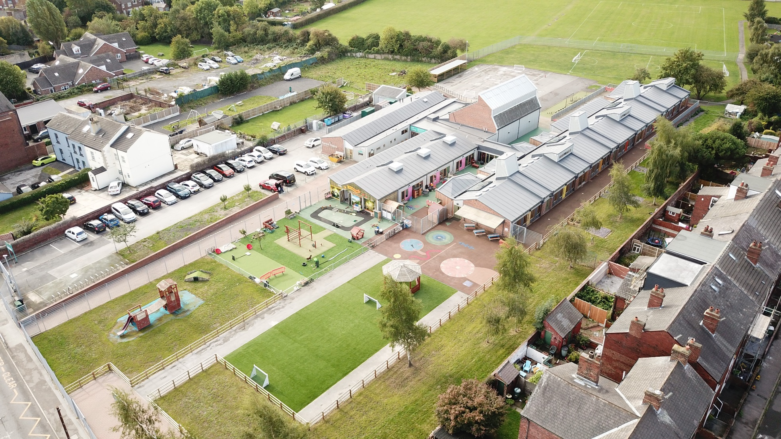

**EYFS Teaching Assistant**

**Recruitment Pack**

**Sandal Magna**

**Community Academy**

**Advert**

|  |  |
| --- | --- |
| Title | EYFS Teaching Assistant (with Level 3 EYFS) |
| Location | Sandal Magna Community Academy, Belle Vue Road, Agbrigg, Wakefield, WF1 5NF |
| Days/Hours | Monday to Friday (28.75 Hours Per Week) |
| Pay Range | Grade 4, SCP 5 - 6 |
| Required from | September 2025 |

We are looking for a dynamic, enthusiastic and committed Level 3 EYFS Teaching Assistant to work alongside our Nursery and Reception staff to provide a high-quality learning experience for children in the Early Years unit.

The successful candidate will be required to engage in the planning and undertaking of learning experiences for all children and contribute to the developing of areas of continuous provision under the direction of the Nursery Manager and the Early Years Leader.

The Department for Education have specific Early Years Qualifications Criteria that EYFS staff must have. This can be found at [Early years qualifications achieved in the United Kingdom - GOV.UK (www.gov.uk)](https://www.gov.uk/government/publications/early-years-qualifications-achieved-in-england)

We are looking for someone who:

* Has Level 3 qualification in Early Years
* Has high expectations and is committed to ensuring all children make strong progress based on their starting points
* Is a creative practitioner;
* Has the ability to inspire and motivate;
* Has experience of working in Early Years
* Is able to communicate well with good interpersonal skills;
* Is committed to an inclusive ethos where every person matters;
* Has good behaviour management skills;
* Has knowledge and experience in children with additional needs;
* Can work well as part of a team, specifically the Early Years Leader;
* Is warm, kind, caring, positive and has a sense of humour.

We can offer:

* A nurturing, caring and inclusive school;
* A forward-thinking Trust that takes professional development, workload and staff wellbeing seriously;
* A friendly, hard-working, professional and supportive team of staff and governors;
* Happy and enthusiastic children who enjoy learning and behave well;
* A commitment to your professional development.
* A staff Wellbeing Service incorporating many professional services.

Photocopies of qualifications will need to be seen to check that you meet the official criteria.

**Closing Date:** Friday 12th September 2025

**Shortlisting Date**: Monday 15th September 2025

**Interviews:** To Be Confirmed

**REPORTING TO**

Early Years Leader & Senior Leadership Team

**OVERALL PURPOSE OF THE POST**

To work under the guidance of EYFS Leader and SLT to engage in implementing an appropriately balanced early years curriculum whilst providing a caring, safe and welcoming environment for children which will allow each child to develop at their own rate in accordance with the current Curriculum Development Framework Document.

#### **KEY RESPONSIBILITIES**

* Engage with the team’s planning and organising of children’s learning through play and appropriate learning experiences.
* Observe, record and assess through interaction, the needs of individual children.
* Monitor and evaluate children’s progress.
* Implement and raise awareness of equalities within the establishment.
* To promote Emotional Personal Social Development (EPSD) through good health, safety and caring practices.
* To provide appropriate learning experiences for children with special educational needs.
* To implement child protection procedures and to support children and families through crisis.
* To participate in school outings, adhering to Health and Safety guidelines.
* To support and develop parental participation and relations with the community.
* To be involved in the purchasing, utilising and maintaining appropriate resources associated with delivering the pre-school curriculum.
* Work co-operatively and effectively within a professional team whilst respecting each person’s abilities and aptitudes.
* To work collaboratively with other professionals from a variety of disciplines.
* Contribute to staff meetings relating to all relevant and current topics.
* To be a positive role model.

Accountability

* Accountable for meeting the needs of all children.
* Developing purposeful liaison with parents/carers.
* Liaising and providing information for relevant agencies.
* To adhere to and implement local and national policies.

**Job Description**

**Job Description**

##### *Demands*

* The ability to respond effectively to children in a stimulating learning environment using a variety of strategies and techniques.
* Participation in both formal and informal staff training activities in order to maintain and update knowledge.
* Lifting and manoeuvring of heavy equipment, which should be undertaken within Health and Safety procedures.
* The job may expose staff to various viruses from Chickenpox to HIV/Hepatitis, which will require compliance with Health and Safety procedures.
* The job may expose staff to physical and verbal abuse, which should be reported through agreed procedures.
* The job may demand certain administrative duties, i.e., collecting money, filling in forms, etc.
* Confidentiality to be respected at all times.
* Intimate personal cares may at times need to be undertaken.

Communications

* The postholder will be required to:
* Contribute, as part of a professional team, to reports made available to relevant staff and agencies.
* Participate in meeting, e.g., Individual Educational Programmes, Reviews, Transitions and Records of Needs.

Working Environment

* Postholders will normally be located within a nursery setting, working with others to deliver a pre-school curriculum within a caring and stimulating environment under agreed ratios.
* This will include working with small groups of children out with the nursery on outings and within the framework of Health and Safety guidance to staff.

**KEY OUTCOMES/ACTIVITIES**

* In some positions, postholders will fulfil their remit in other settings such as primary schools and special group settings.

Other duties commensurate with the grade of the post as directed by the Headteacher.

**The duties and responsibilities highlighted in this Job Specification are indicative and may vary over time. Post holders are expected to undertake other duties and responsibilities relevant to the nature, level and scope of the post and the grade has been established on this basis.**

|  |
| --- |
| **RESPONSIBILITY OF RESOURCES** |
| **Employees (Supervision):** None |
| **Financial:** None |
| **Physical:** Effective use of learning materials and resources. |
| **Customers and Clients:**  To work with the Nursery Team and Reception teachers and to plan, organise and deliver high standards of childcare and education activities for children and parents. |

|  |
| --- |
| **WORKING CONDITIONS** |
| The nature of the post requires some ongoing considerable physical effort e.g. regular lifting or carrying, pushing or pulling items of moderate weight.  The post involves contact with people which through their circumstances or behaviour regularly places emotional demands on post holder.  The post holder may need to undertake some personal intimate cares (following policy)  The post holder may be subject to some exposure to disagreeable or unpleasant people related behaviour. |

|  |
| --- |
| **CHARACTERISTICS OF THE POST** |
| The ability to regularly attend meetings as required by the Headteacher/Line Manager.  Employees are encouraged to participate in training activities in order to enhance their own personal development.  All employees of a school have a responsibility for promoting and safeguarding the welfare of children and young people.  **The employment checks are required:**   * Evidence of entitlement to work in the U.K. * Childcare Disqualification Declaration (where applicable) * Evidence of essential qualifications – see page 1 of this job specification * Two satisfactory references * Confirmation of medical fitness for employment * Registration with appropriate bodies (where applicable)   **The following employment checks are required for those positions which are based in a school or working with vulnerable young people and adults:**  **Evidence of a satisfactory safeguarding check e.g. An Enhanced DBS Disclosure** |

**Job Description**

**Person Specification**

|  |  |  |
| --- | --- | --- |
| **Knowledge, Experience and Skills** | | |
|  | Essential | Desirable |
| **Qualifications/Training** | | |
| NVQ Level 3 in Children’s Care, Learning & Development **Or** The Council for Awards Children’s Care and Education (CACHE) Diploma **Or** The Business and Technical Education Council (BTEC) Diploma in Childcare **Or** Diploma for the Children and Young People’s Workforce (Level 3) EYFS | ✓ |  |
| **Experience** | | |
| Knowledge of the individual development needs of young children. | ✓ |  |
| Understanding and respect of the central role of parents/carers in the lives of young children. | ✓ |  |
| Understanding of current pre-school education and childcare provision and procedures. | ✓ |  |
| Effective communication skills. | ✓ |  |
| Knowledge of ICT. | ✓ |  |
| Appropriate knowledge in First Aid | ✓ |  |
| Child Protection issues. |  | ✓ |
| Health, Safety and Security issues. |  | ✓ |
| Data Protection issues. |  | ✓ |
| **Experience** | | |
| Working or caring for children | ✓ |  |
| **Competencies and Other Skills** | | |
| Some ICT skills required for accurate record keeping | ✓ |  |
| Effective inter-personal skills. | ✓ |  |
| Ability to work independently using own initiative. | ✓ |  |