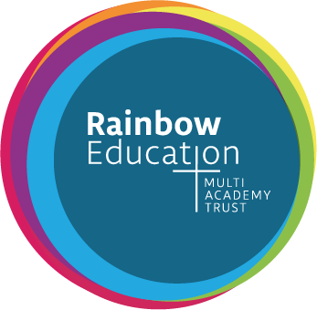

Role Details:
Position: EYFS One to one support

Salary: Grade 2

Hours: Term Time Only/Part time / Fixed term / Mon-Fri / 8.00am-3.45pm (plus an extra hour each Wednesday for staff training/development)

Location: Croxteth Community Primary School

We wish to employ a 1:1 Learning Support Assistant, to support a child with additional learning needs. They will be a key adult for the child, supporting with planning and teaching.

The successful candidate will have experience with children with complex needs.

KEY TASKS AND RESPONSIBILITIES:
- Act as a one to one for a child
- Build a strong relationship with the child you are working with
- Under the guidance of the teacher/SENCO, carry out activities/tasks to support the child’s development
- Where required, support other children in the setting
- Attend any relevant CPD sessions
- Alongside the SENCO contribute to One Page Profiles
- Build a strong relationship with the child’s family and other relevant agencies/professionals
- Consistently and effectively implementing agreed behaviour management strategies
- Helping to make appropriate resources to support the pupil

EXPERIENCE ESSENTIAL:

• Post experience of working with children in a school setting
Rainbow Education Multi-Academy Trust is committed to safeguarding children and promoting children's welfare. This post is subject to all the relevant pre-employment checks set out in 'Keeping Children Safe in Education’, including an enhanced DBS certificate with a barred - list check.

Completed applications and letters of application should be sent via email to vacancies@remat.org.uk

Closing date: 14/10/2022
Shortlisting: 14/10/2022
Interview date: W/C 26/09/22

