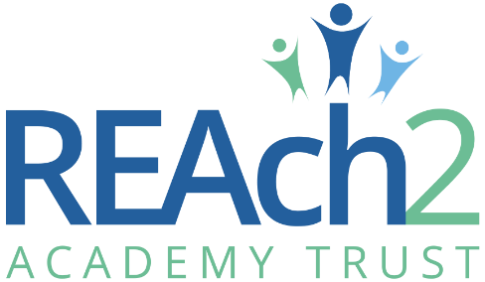
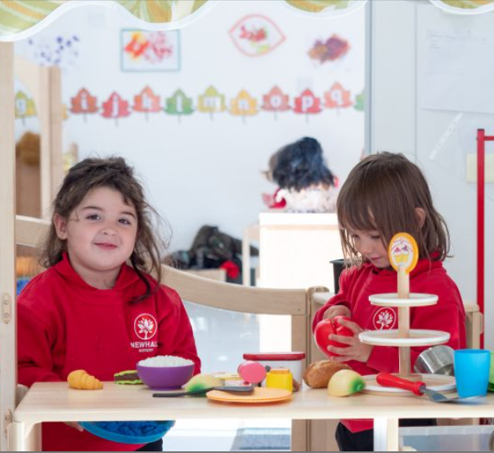

EYFS Practitioner Application Pack

Contents
Letter from Catherine Paine, Chief Executive Officer 3
Letter from Mr B Duffy, Headteacher, Newhall Primary Academy and Nursery 4
Our Cornerstones and Touchstones 5
The role 6
The application 9
The application process and timetable 9
Safeguarding, Safer Recruitment and Data Protection 10
Job Description 11
Person Specification 13

Letter from Catherine Paine, Chief Executive Officer

Dear Candidate
Thank you for your interest in this role within the REAch2 Academy Trust.
This is a hugely exciting time for our family of schools. The Trust has been recognised by the Department for Education as being well placed to raise standards and achieve excellence for pupils in a growing number of schools nationwide. We are presented with a rare opportunity to make a real difference to the lives and life chances of so many primary school children – many of whom haven’t previously received the educational opportunities they deserve.
The Trust includes schools at all stages of development, from those requiring significant improvement through to existing outstanding schools. As a Trust we are clear about the importance of achieving long term sustainability for our schools. Our vision is to enable individual academies to flourish with real autonomy, whilst also ensuring a strong ethos of support and collaboration across our schools.
Employees within REAch2 belong to a national community of professionals, and benefit from a wide range of networks and development opportunities across the Trust. In time, our best teachers are able to work across schools, develop specialisms and step up to leadership roles within and beyond their own academy. The Trust provides a strong culture of collaboration and support, together with high expectations for staff and pupils alike.
Those we recruit are able to demonstrate that they share our values, are highly motivated to work with colleagues within and beyond their school to continuously develop their skills and pursue professional excellence and are committed to providing the highest standards of teaching for all children. If that is you then we would be delighted to receive your application.
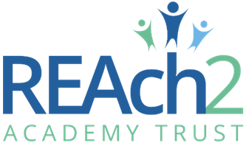
Catherine Paine

CEO

Letter from Mr B Duffy, Headteacher, Newhall Primary Academy and Nursery

Dear Candidate
Welcome to Newhall Primary Academy and Nursery.
Our school opened in September 2018. We are a two-form entry primary school and nursery in Harlow, currently teaching children up to Year 5. We will continue to grow over the next year until we are at full capacity of 420 children in the main school. Our nursery is open all year round, taking children from one year to school age with spaces for 56 children.
We are a warm and welcoming school and nursery with state-of-the-art facilities including bright and modern classrooms and learning areas, an arts studio, a cookery room, a library and large fields and playground spaces.
Our staff are a dedicated team who strive to give the best for all children at Newhall. We have a well-structured curriculum, aiming for high academic standards across all subjects. Our children experience a broad and exciting curriculum which ensures opportunities for learning are maximised both in and outside the classroom. At the heart of our curriculum is reading: we ensure our children are confident readers who are well-equipped to meet the demands of our curriculum and develop a love of a range of books and authors.
We create a safe and calm environment for our children to learn where everyone is valued, respected and included. We ensure our children are well equipped to thrive in the world around them, ensuring we cater for their social and emotional needs.
Links between our school and local community are very important to us. We have a very active PTA ‘Friends of Newhall’ who facilitate a wide range of activities for our children, raising money for our school and charities.
I look forward to receiving your application.

Mr B Duffy
Headteacher

Our Cornerstones and Touchstones
REAch2 is defined by the values of excellence, quality, delivery and standards – these features give the Trust its enduring attributes and its inherent reliability.
However, what gives each REAch2 Academy its uniqueness are the Touchstones of the Trust (seen on the right). Just as 500 years ago touchstones were used to test the quality of the gold they marked, so too our touchstones find what is precious and set these things apart. They are used to express the values and ethos of the Trust and describe what the Trust wants to be known for and how it wishes to operate.
With good leadership, we aspire to develop children academically, emotionally, physically and spiritually. We notice talent and spot the ‘possible’ in people as well as the ‘actual’. Developing potential across our Trust becomes a realisation that there is a future worth pursuing for everyone.
Children deserve enjoyment in their learning and the pleasure that comes from absorption in a task and achieving their goals. Providing contexts for learning which are relevant, motivating and engaging, release in children their natural curiosity, fun and determination.
Inspiration breathes energy and intent into our schools: through influential experiences, children can believe that no mountain is too high and that nothing is impossible.
REAch2 serves a wide range of communities across the country and we celebrate the economic, social, cultural and religious diversity that this brings: embracing inclusion ensures that we are a Trust that serves all, believing that everyone can succeed.
We take our responsibility seriously. We act judiciously with control and care. We don’t make excuses, but mindfully answer for our actions and continually seek to make improvements.
REAch2 is a Trust that has a strong moral purpose, our integrity is paramount. Our mission is to change children's lives by providing the very best quality education we can. Through this, children can fulfil their potential, become happy, successful adults and contribute effectively and meaningfully to society. We welcome the fact that all our decisions and actions are open to scrutiny. You can learn more about REAch2 at our website: www.reach2.org

The role

EYFS Practitioner at Newhall Primary Academy and Nursery, Roundhouse Way, Harlow, Essex, CM17 9SF
Newhall Primary Academy and Nursery is currently recruiting to the role of EYFS Practitioner on a permanent part-time all year round contract starting as soon as possible.
Hours: 20 hours per week, all year round
Salary: SCP 5-6 (£23,500 and £23,893) FTE plus Outer Fringe Allowance
Duties include:
- To provide a high standard of physical, emotional, social and intellectual care for children place in the setting.
- To give support to their staff within the setting.
- To work as part of a team in order to provide an enabling environment in which all individual children can play, develop and learn.
- To build and maintain strong partnership working with parents to enable children’s needs to be met.

We need:

An Early Years Practitioner to work with colleagues in the Nursery classes and create a stimulating, safe and caring teaching and learning environment. We are looking for an individual who is able promote the physical, emotional, intellectual and social development of every child within the Foundation Stage.

So, if you are:
- an excellent practitioner, keen to work in a supportive and principle-based school.
- driven by a strong moral purpose to enable all children to achieve and have integrity.
- passionate about creativity and have an excellent sense of humour.
- warm in character, easy to work with and committed to teamwork, recognising that more can be achieved together than is possible as individuals.
- a professional who values wellbeing but unafraid of hard work.
- calm and able to handle pressure and setbacks with a smile.
- keen to be challenged to become the best you can be.
- able to be pushed at an accelerated rate of development, and reflective and proactive enough to make it happen.
- determined to succeed with a ‘find a way or make one!’ attitude.
- committed to safeguarding and promoting the welfare of children and expect all staff and to share this commitment.

Then you’d love to work at Newhall Primary Academy and for REAch2. This is not just another job. This is a chance to be part of something exciting and very worthwhile. This opportunity will open doors both professionally and personally to anyone who joins our quest.

We can offer you:
- A Leadership Team dedicated to helping you develop an outstanding career and balanced life.
- A supportive school that will provide you with the tools that you need to succeed.
- Exciting, leadership development and early promotion opportunities for the right candidates across the Trust.
- The chance to work with a fantastic team, with the best possible opportunities to share ideas, planning, assessment etc.
- Opportunity to work alongside outstanding teachers, to observe and share practice on a regular basis, developing pedagogy through reflectivity.
- The chance to use / develop personal curriculum strength
- An excellent CPD training programme.
- A dynamic, creative staff, dedicated to achieving whole-school improvement and building lifelong friendships
- The chance to make a real difference.

Background information about the School
Our school opened in September 2018. We are a two-form entry primary school in Harlow, currently teaching children up to Year 5. We also have a nursery which is open all year round and takes children from 1 year to 5 years. We will continue to grow over the next year until we are at full capacity of 420 children in the main school.

Our curriculum aims to promote for all children:
- A love of reading, ensuring our children are confident and fluent readers enabling them to access a range of high-quality texts and the curriculum.
- The development of rich subject knowledge and vocabulary within a coherent, broad and balanced curriculum for all children.
- The acquisition of skills across all areas of the curriculum and enabling children to choose and apply these in relevant situations including beyond the classroom.
- A love of learning through the enrichment of the curriculum with visits and experiences to create creative, independent and confident learners.
- The nurturing of positive relationships to create respectful citizens who work co-operatively with one another.
- Successful lifelong learners with a high self-esteem, who can reach their full potential and are well-prepared for the next stage of their education.

We are a caring employer who invests in the future of our employees, as only through their excellence can we deliver excellence for the children and families whom we serve. To see more information about the school, please visit our website Newhall Primary Academy and Nursery

As a member of the REAch2 Trust, a national family of primary academies, Newhall Primary Academy and Nursery is committed to raising standards and achieving excellent for all pupils whatever their background or circumstance. The Trust provides a strong culture of collaboration and support, together with high expectations for staff and pupils alike. Newhall Primary Academy and Nursery is committed to safeguarding and promoting the welfare of children and young people / vulnerable adults and expects all staff and volunteers to share this commitment. This position is subject to an enhanced DBS check and satisfactory written references.

The application

You are invited to submit an application form to Mr B Duffy, Headteacher by email recruitment@reach2.org

REAch2 Academy Trust have an Equal Opportunities Policy for selection and recruitment. Applicants are requested to complete the Trust’s online Equality & Diversity Monitoring Form separately.

In accordance with our Safeguarding Policy the successful candidate will be required to have an enhanced DBS check.

To arrange an informal discussion or nursery visit please contact Ms E Pike, Nursery Manager via the nursery office on 01279 351104 or by email nursery@newhallacademy.org.

The application process and timetable

Application deadline: | Friday 21st June 2024 at 12pm (midday)
School visits: | By appointment only, please contact Nursery office to arrange
Interviews: | TBC with shortlisted candidates
Contract details: | Permanent, part-time (20 hours per week), all year round
Salary: | SCP 5-6 (£23,500 - £23,893) FTE plus Outer Fringe Allowance
Start date: | As soon as possible (pending safer recruitment checks)

The candidates selected for interview will be informed after shortlisting and full details of the interview programme will be provided.

Safeguarding, Safer Recruitment and Data Protection

At REAch2 we recognise that those who work in an academy are in a unique position in their care of children. The responsibility for all staff to safeguard pupils and promote their welfare, as stated in Section 175 of the Education Act (2002) is one that is central to our ethos, our policies and our actions. All children are deserving of the highest levels of care and safeguarding, regardless of their individual characteristics or circumstances, and we are committed to applying our policies to ensure effective levels of safeguarding and care are afforded to all our pupils.

We will seek to recruit the best applicant for the job based on the abilities, qualifications, experience as measured against the job description and person specification. The recruitment and selection of staff will be conducted in a professional, timely and responsive manner and in compliance with current employment legislation, and relevant safeguarding legislation and statutory guidance.

All information is stored securely and any information supplied by unsuccessful candidates will be destroyed through a confidential waste system six months after the decision has been communicated, in accordance with our information and records retention policy.

The Trust ensures all applicant data is stored and processed appropriately. For further details on how your information will be managed during the recruitment process please refer to our Privacy Notice for Job Applications.

Job Description

Post: EYFS Practitioner
Responsible to: Room Leader/Nursery Manager/Headteacher

Core Purpose
- To provide service delivery within the requirements of the Early Years Foundation Stage Framework, Every Child Matters and Ofsted Care Standards.
- The Room Leader or Lead Professionals are responsible for planning the overall policy and curriculum, and the Early Years Practitioners are given some responsibility for planning part of the programme and are to play a full part in its implementation
Responsibilities
- Share responsibility for safety, health and welfare of children at all times
- Ensure all children have access to the full curriculum
- Relate well to children
- Guide the development of children’s social behaviour and attitudes
- Meet the physical needs of children encouraging good standards of personal hygiene whilst promoting independence
- Frequently supervise children on activities without a room leader present including outdoor activities
- Observing and assessing children’s development and progress
- Keeping accurate records of observation, assessment and development of children
- Acting as a key worker for a group of children
- Organising materials and equipment for use within the nursery
- Sharing responsibility for care and maintenance of resources and equipment
- Assisting in preparation and clearing up of activities and encouraging children to help
- Sharing responsibility for board displays
- Contributing to curriculum development ensuring a stimulating environment
- Taking responsibility for specific pre-planned activities
- Taking on other tasks such as Play/Lunch Time supervision and to support the school when required
- Attend staff and planning meetings when required
- Encourage parents and carers to be involved in the setting and their children’s learning
- Establish good relationships with parents and carers
- Build up a trusting relationship with parents/carers of key worker group
- Take part in home visits when appropriate and required
- Support the aims and policies of the setting
- Promote the ethos of the setting at all times
- Be familiar and assist with any medical or toiletry routines as necessary.
- Any other duties that may reasonably fall within the scope of the post but not specified
- Undertake paediatric first aid training

Person Specification
 | Essential | Desirable
Right to work in the UK | *
Knowledge/Qualifications and experience
Full and relevant Early Years Level 3 qualification | *
Suitable Level 2 Literacy and numeracy qualifications | *
Evidence of additional qualifications suitable to Early Years Educator role |  | *
Graduate qualification |  | *
Experience of working with and supporting children with a range of educational needs | *
Experience of working and supporting children of a variety of ages | *
Intermediate knowledge of ICT | *
Awareness of Keeping Children Safe In Education | *
Basic knowledge of Health and wellbeing, safety and child protection | *
Understanding of the Schools Ethos and Values | *
Understanding of Data Protection and confidentiality | *
Basic knowledge of First Aid |  | *
Understanding of the development of EAL learners |  | *
Understanding of the development of SEN learners |  | *
Skills , abilities and personal attributes
Evidence of a commitment to safeguarding and promoting the welfare of children and young people | *
Commitment to promote and support the aims of REAch2 | *
Ability to solve problems, use initiative and find solutions | *
Active listener | *
Good communication (written and verbal) | *
Highly motivated | *
Commitment to promote and support the aims of REAch2 | *

