**James Montgomery Academy Trust**

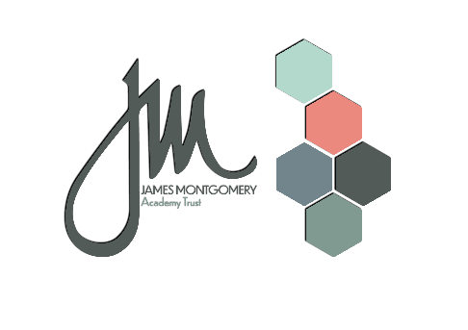

**A little bit about us:**

Our Trust has officially been in existence since 2016 and we have, in that time, grown from an initial group of 5, to now be working across 20 converted schools. All our schools are in the primary phase, encompassing primary, infant and junior, and are all based in South Yorkshire.

The Trust Board is determined to see a high performing and successful Multi-Academy Trust that delivers the very best educational experience for the pupils attending our schools. Our schools play a key role in the community supporting our families and offering our children opportunities to grow and thrive, academically, socially and emotionally. We want our children to be confident and resilient.

**Trust Vision and Values**

***Our schools are child-centred, inclusive and distinctive, delivering excellence in education, sharing best practice and building aspiration.***

**Trust Core Principles**

Together we will:

* Consistently put children at the heart of decision making
* Champion school individuality
* Continually improve through innovative and research driven practice

**School Improvement Strategy Goal**

The school improvement strategy of JMAT aims to create a self-improving school led system through collaboration, support and challenge.

**Together we will promote and secure:**

* Individuality
* Good levels of achievement for all
* High quality teaching and inclusive practice underpinned by research
* Aspirational leadership and governance
* Access to high quality CPD
* Best practice across the Trust and wider partnerships
* Value for money
* Safe schools