St Peter’s CE Primary School  Chippenham Mews London W9 2AN  Headteacher: Mrs Alice Ducros  Deputy: Mrs Hattie Friedman  Telephone: 020 7186 0082  Email: office@stpeterscm.co.uk  Website: www.stpeterscm.co.uk | 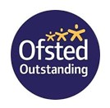 | 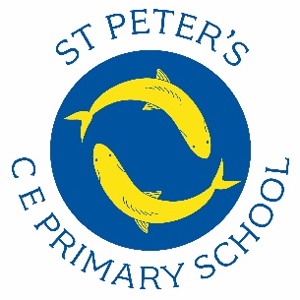

Dear Applicant,
I am thrilled you are applying for the Reception Class Teacher position at St Peter’s. St Peter’s CE Primary school is a vibrant and supportive environment where staff work collaboratively to ensure that all children achieve their full potential. We are proud of our dedicated team of teachers and teaching assistants who provide high-quality education and intervention support.
Our school vision ‘Living life in all its fullness’ is built upon four key words—Invite, Include, Imagine, and Inspire—which underpin everything we do. These vision words guide our approach to teaching and learning, fostering a welcoming and inclusive environment where every child is encouraged to dream big, think creatively, and reach their full potential. Through our curriculum, extracurricular activities, and daily interactions, we ensure that these principles shape the experiences of our children, staff, and wider school community.
St Peter’s is a small, multicultural school of 210 pupils in Westminster, well-regarded in the local community. Our children come from diverse social and economic backgrounds, and we take pride in fostering an inclusive and nurturing atmosphere. Parents and governors are highly supportive, making St Peter’s a wonderful place to teach.
We are committed to high expectations for both our students and staff. Our curriculum is ambitious and exciting, designed to inspire and challenge our children. We provide a wide range of enriching experiences, including educational visits, hands-on learning opportunities, and immersive trips that broaden children’s horizons and enhance their understanding of the world. We instil strong values that guide our approach to teaching and learning.
In our most recent staff survey, 100% of teachers stated that they are happy and proud to work at our school, with all staff believing that their well-being is a top priority. If you are passionate about education and eager to inspire young learners, we would love to welcome you to our team. Collaboration is at the heart of our school, and you will find a friendly and supportive environment where staff work together to share ideas and best practices. Everyone supports each other in all sorts of ways, whether sharing ideas, discussing planning or just being a friend.
We are committed to high standards and we never make excuses for children. We find St Peter’s children work hard and enjoy being challenged. It is a real joy to work with children who are self-motivated, enjoy each other’s company and are a delight to teach. Likewise, the staff at St Peter’s work extremely hard and are all prepared to go the extra mile. Our last Ofsted report in 2023 was Outstanding.

We are all very proud of the secure, stimulating environment we provide and we are looking forward to welcoming a new member of staff to our team.
Visits to the school are strongly encouraged. Please contact Mrs Friedman our Deputy Headteacher at Deputy@stpeterscm.co.uk to arrange this. I look forward to reviewing your application and learning more about how you can contribute to St Peter’s. If you have any questions, please do not hesitate to contact us.
Yours sincerely,
Alice Ducros
Headteacher

Application Pack: Job Advert, Job Description, Person Specification, Staff Guidelines, Application Form

