



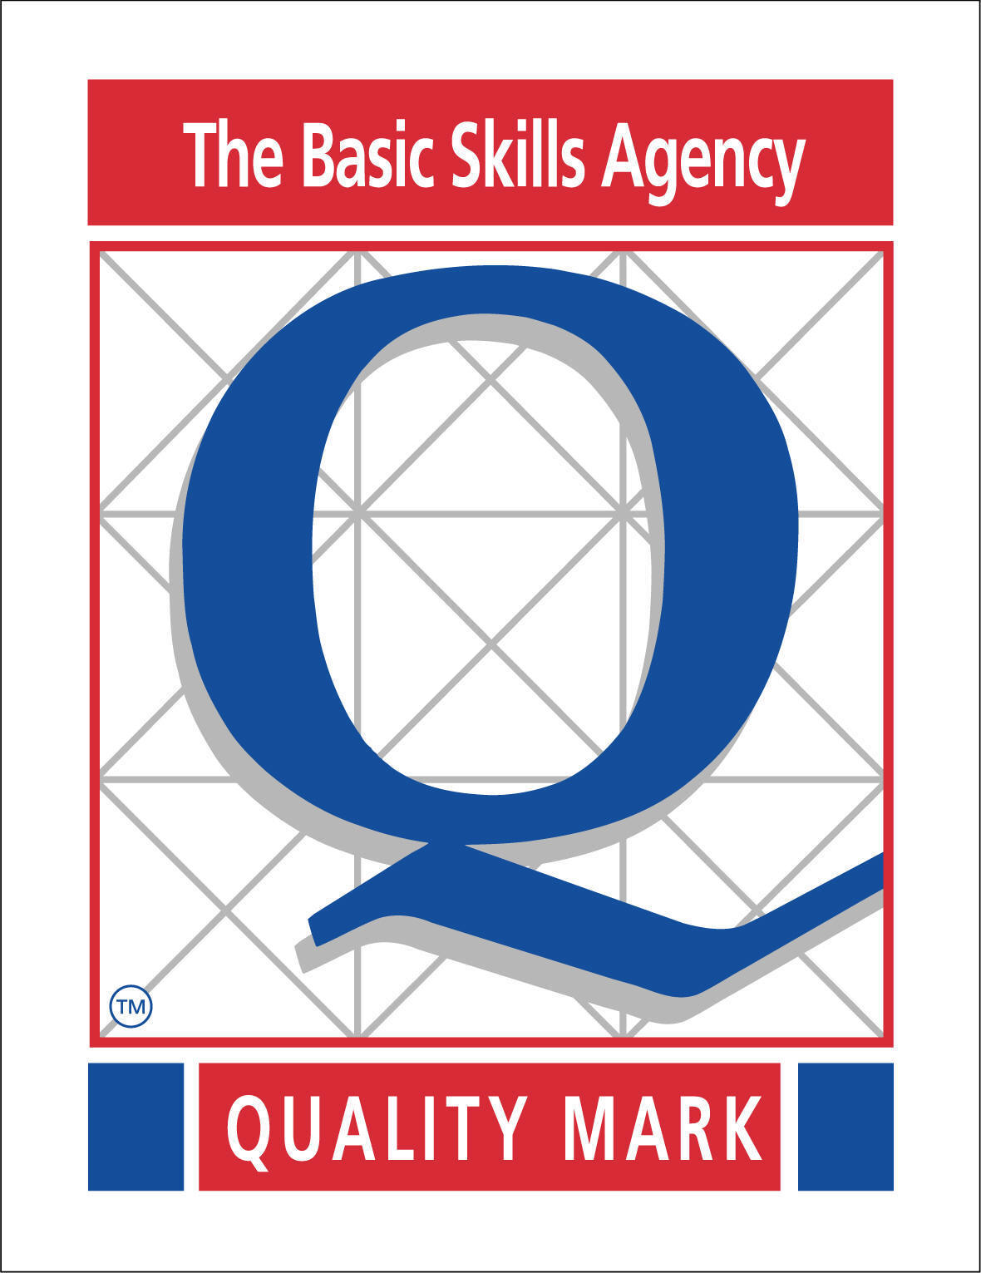
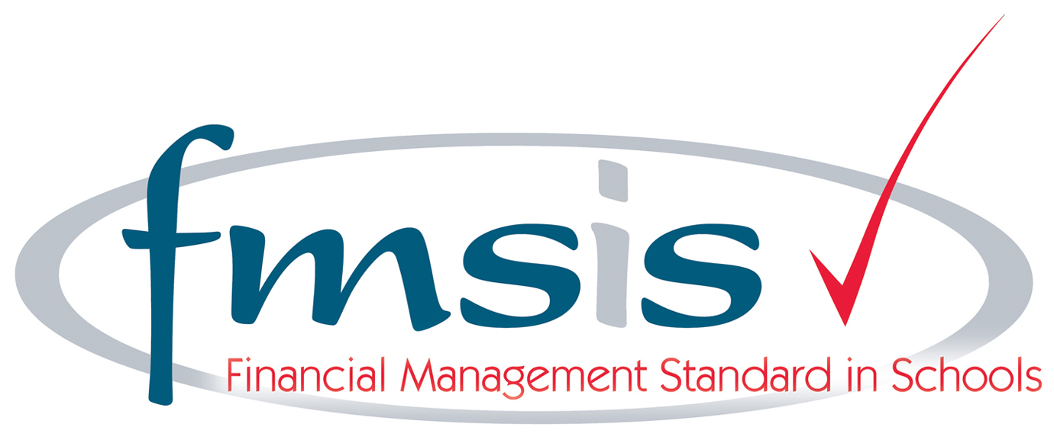
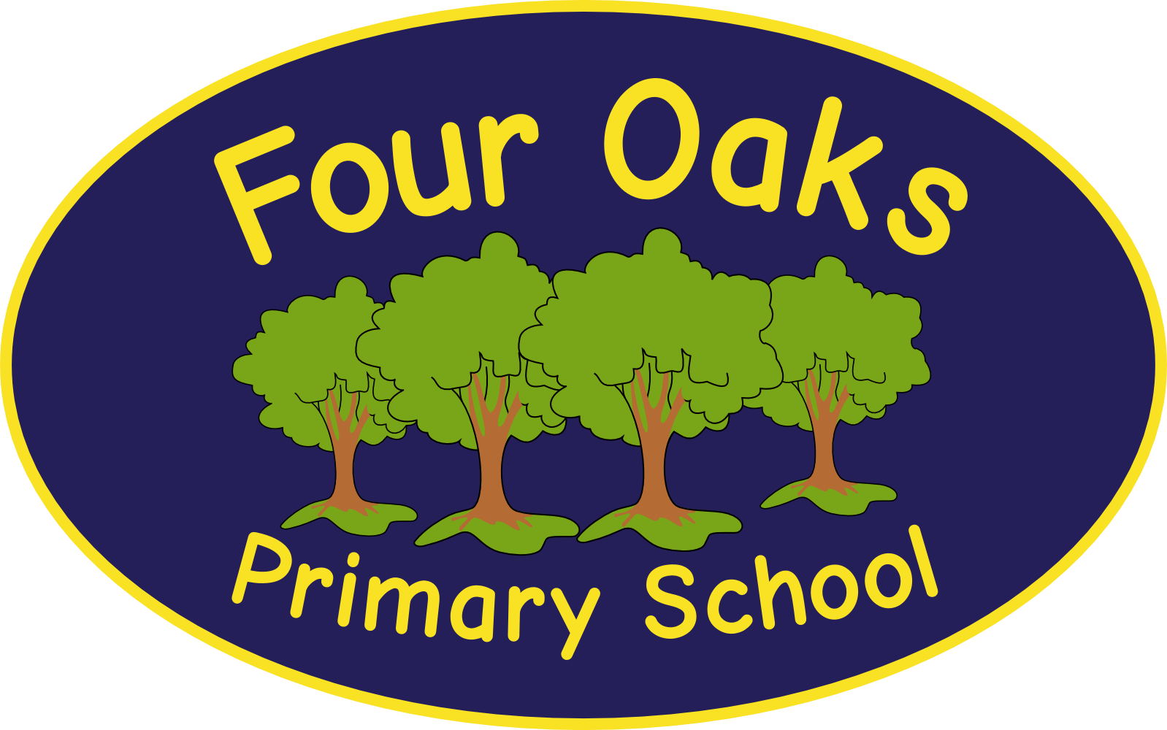

Headteacher: Mrs S Robinson B.A.(Ed) M.Ed. NPQH

39 Davy Street
Liverpool L5 1XP
Telephone: (0151) 263 4038
Fax: (0151) 260 7257
Email: office@fouroaksprimary.com
Website: www.fouroaksprimary.co.uk

20th November 2023
EYFS Teacher

Full-time, fixed term.
8th January 2024 to 31st August 2024

Four Oaks is an inclusive primary school, with high aspirations for all. We have happy, extremely well behaved children and supportive, dedicated staff and governors, catering for pupils from 1 to 11 years old.

Our school has received a prestigious SCALA architects’ award. It is a modern build with beautiful, well equipped classrooms and state of the art facilities including an interactive 4D classroom. It is surrounded by landscaped grounds with many facilities for the children. Visitors to our school always comment on the happy, enthusiastic children who demonstrate exemplary behaviour.

The Governors wish to appoint an EYFS teacher to join our team. The role will include working with our EYFS team across our 2-year old nursery, pre-school Nursery and Reception. You must have consistently strong feedback on your teaching. You will be joining an EYFS team who work well together and who are dedicated to providing the very best education to our children.

This post is fixed term to cover a Maternity leave.

Closing date: Wednesday 6th December 2023
Please email application forms to applications@fouroaksprimary.com
Please address any queries to office@fouroaksprimary.com

Four Oaks Primary School is committed to safeguarding the welfare of young people and expects all staff and volunteers to share this commitment. All appointments are subject to enhanced DBS checks and excellent references.

