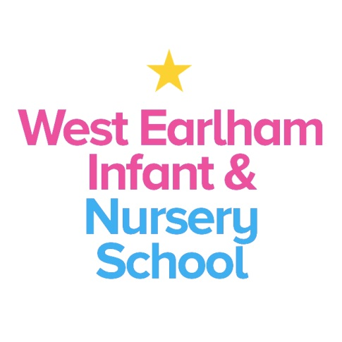
West Earlham Infant & Nursery School
Scarnell Road
Norwich
NR5 8HT
Tel 01603 451299
Email office@westearlhaminfant.norfolk.sch.uk
EYFS TEACHER IN RECEPTION Temporary – Maternity Cover
Required from April 2023 or September 2023
Governors are seeking to appoint an outstanding teacher to join our school set in the dynamic neighbourhood of West Earlham in Norwich. The post holder will join our existing EYFS team in the Reception class. We are looking for a teacher who:
- Understands how young children think, learn and develop
- Is passionate in providing high quality Early Years provision
- Can use a range of strategies to nurture and support children’s emotional well-being
- Has a current knowledge of the demands of the EYFS framework
- Will actively engage in shaping provision to promote outstanding practice and outcomes for all children
- Has high aspirations for all children and can demonstrate how to enable all children to make accelerated progress from their starting points, including children with SEND
- Has experience in using effective team management skills and has excellent inter-personal skills, energy, resilience, creativity
- Has the ability to build strong positive relationships with colleagues and families
- Can demonstrate how to plan to maximise speech and language development and early reading skills
- Has an enthusiasm and willingness to take part in the broader life of the school including subject leadership

You can expect:
- To be welcomed and supported by staff, governors, children and families
- To work in a dynamic and lively community where the value of EYFS is promoted and highly valued
- To work with a forward thinking and a highly committed team, in a class which is smaller than average
- To learn with us from our expert ‘resident’ speech and language therapist
- To work closely with our nursery team and KS1 colleagues
- To develop as a teacher and receive appropriate support and opportunities to enable you to do this
- To contribute to school improvement and development

How to Apply
Applicants should access more information about our school via our website www.weins.co.uk. We actively welcome applicants from out of Norfolk.
Visits to the school by appointment are warmly welcomed, though this would not prejudice against those applying from out of county.
For further details please don’t hesitate to get in touch, our number is 01603 451299. You can find an application form by clicking on the orange “Apply for Job” button.
Please return your application to us via email to office@westearlhaminfant.norfolk.sch.uk or by post to the school address.
Closing date: 12 noon Monday 13th March 2023
Interviews to be held on: Monday 21st March 2023
Our school is committed to safeguarding and promoting the welfare of children and young people and expects all staff and volunteers to share this commitment. An Enhanced DBS check will be carried out before the post begins.
This post comes under the requirements of the Childcare (Disqualification) 2009 Regulations and the successful applicant will be required to complete a declaration form to establish whether they are disqualified under these regulations

