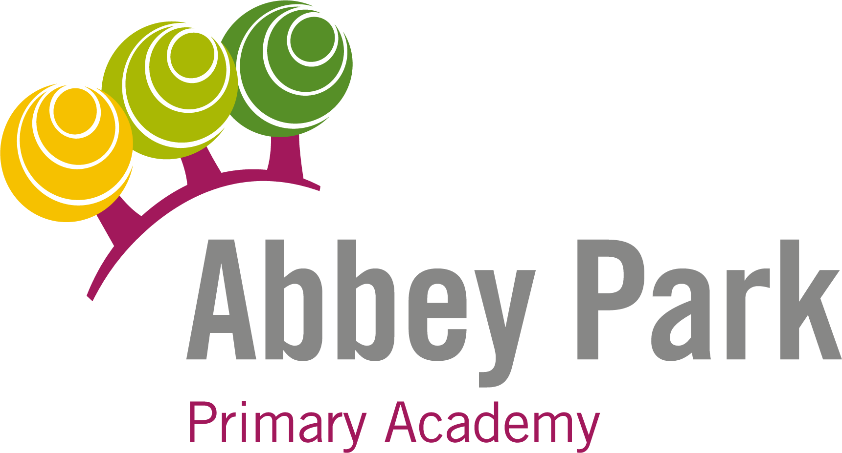

Outcomes Focused, Child Centred

EYFST TEACHER WITH NURSERY EXPERIENCE TO COVER MATERNITY
Contents

Welcome from the Chief Executive | 03
Welcome from the Principal | 04
Northern Education Trust | 05
The Application Process | 06
Where to Find Us | 07
Job Advert | 08
Job Description | 09
Person Specification | 12

Welcome from the Chief Executive

On behalf of the Northern Education Trust Board, welcome to the Northern Education Trust.

We are unswerving in our commitment to ensure that the outcomes our young people secure prepare them fully for life beyond school. Our Academies are happy and thriving communities where children both achieve and feel safe and cared for. As an inclusive Trust we strive to help young people overcome any barrier to learning.

We are a caring employer and invest heavily in professional development, allowing our staff opportunities to take the next steps in their career. We hope you find our website holds all the information you need to believe that whether you are a parent or prospective employee, your next steps should be taken with us.
Welcome from the Principal

Abbey Park is an academy that children, parents, staff and academy council members are proud of. We provide a warm and caring environment where all children, parents and staff feel welcomed and valued.
I am very honoured and privileged to lead the academy and will constantly strive alongside my dedicated team to ensure that children achieve the best possible outcomes no matter their starting point. Together every member of staff and academy council member at Abbey Park believes in giving our children the best possible education, a range of opportunities and experiences and the life-skills necessary to grow up to take their place in the world. We believe that building relationships and learning collaboratively is essential and therefore try to ensure that relationships across the school are built based on mutual respect.
I believe that all children are entitled to a well-balanced and engaging curriculum. The curriculum supports the fundamental learning of English and Maths but ensures children have a wide range of opportunities to learn skills and knowledge in all subject areas. It is further enriched by additional drama, sport and music opportunities but at the heart of this curriculum, we aim to make sure children are able to understand their place in the local and wider community.
Our main aims:
- To ensure the achievement, personal development and well-being of children and young people.
- To promote and support parent and carer engagement in the development of learning and educational experience of their children.
- To understand the community context within which the academy operates and to engage in appropriate activities with other agencies and community groups in order to promote community cohesion and economic regeneration.
- To have an aspiration to be the best.
- To provide learning and teaching which engages pupils and is active, collaborative and encourages independence.
- To foster pupil voice intended to empower and involve young people in the development and delivery of their own education and the life of their academy.
- To create and sustain a creative curriculum which meets the needs of all learners, is engaging and fun.
- To support the development of professional networks, within our group and beyond, providing and engaging in school to school support to improve opportunities for pupils and sharing professional development.
- To promote community involvement with our school and to lifelong community learning.

I hope you find the information provided useful and can get a sense of what it means to learn at Abbey Park.

Mr. Ben Normington
Principal at Abbey Park Primary
Northern Education Trust

Our Vision

We constantly focus on standards as we understand outcomes are paramount. Our decision making is driven entirely by what is best for children. By doing this we enhance the life chances of the children and young people in our care.

The 10 values which underpin our vision:

- We care passionately about the education and welfare of young people

- We believe that all young people, irrespective of background or ability will be successful in our Trust

- We are not and will never be selective. We believe that local schools are for all children

- We are always inclusive. Our mechanisms to support the most vulnerable child to succeed and overcome barriers to learning are a key aspect of our work

- Our approach to education recognises that outcomes are paramount and also allows children to gain experiences and values which prepare them fully for life in modern Britain. This includes workplace skills and appropriate advice for future progression

- We have high expectations of behaviour

- We adopt the local authority admissions protocol and work closely with them

- We would always wish to act in such a way that has a positive effect on a neighbouring school or community. We care passionately about children in all schools, not just our own

- That all employees act with integrity and embrace the value that ‘we are the Trust’

- We work regionally and nationally to develop approaches to MAT improvement that influence the wider school-led system

The Application Process

Closing date: 12 noon 07/05/2021

Interviews: w/c 10/05/2021

Job Description

This tells you the main responsibilities of the post and explains what we are looking for. It tells you about the personal and professional qualities you need for this post. These criteria will be used to make the appointment.

Person Specification

This specification sets out which criteria will be used to shortlist candidates for interview.

Applying
If you decide to apply for this post please complete the accompanying application form. Your formal letter of application (supporting statement) should be no longer than 3 sides of A4 and should address the selection criteria detailed in the Person Specification. Please return your completed application by email to l.brown@northerneducationtrust.org

Additional Information

If you would like any additional information about this post or would like an informal discussion, please contact Cat McCormack on 01422 246610 or email l.brown@northerneducationtrust.org

Where to Find Us
The full postal code address of Abbey Park is:

Abbey Park Primary Academy
26 Keighley Close
Halifax
HX2 9DG

Where to Find Us

Contact Details

Abbey Park Primary Academy
Keighley Close
Illingworth
HX2 9DG

Phone: 01422 246610
Email: abbeypark.enquiries@northerneducationtrust.org
Web: https://apa.northerneducationtrust.org
Job Advert
EYFS TEACHER WITH NURSERY EXPERIENCE REQUIRED TO COVER MATERNITY

SALARY: MPS 1 £25,714.00 – UPS 3 £41,604.00
REQUIRED FROM: September 2021
CONTRACT TYPE: Fixed Term
Northern Education Trust (NET) is a charitable education Trust with an improving track record for school improvement. The Trust sponsors 21 academies; 11 secondary and 10 primaries across the North of England in eleven Local Authority regions.

We are looking for a candidate to join our excellent Team who:
- Has enthusiasm, commitment and a positive outlook
- Is committed to providing challenge and opportunity for our children
- Who has the drive and interpersonal skills to work with staff, children, parents and other stakeholders successfully
- Is able to deliver exciting lessons aimed at children’s needs, allowing them to all make outstanding progress.
- Is inspiring, energetic and creative
- Who can contribute to the culture of excellence in our Academy
In return, we can offer:
- Collaborative working with a friendly, experienced, enthusiastic and committed team
- Happy, friendly children who are keen to learn
- Key opportunities for professional/personal development including 1-1 coaching and mentoring
- An academy that is committed to pupil and staff wellbeing
- A supportive Academy Council
- The chance to be part of our exciting journey towards outstanding

Abbey Park is part of Northern Education Trust group of Academies. It is a friendly, vibrant and lively place where our children are enthusiastic learners, well motivated and encouraged to think for themselves. They have the potential to be the best learners in the world, so we need a staff team who can provide them with the world class education they deserve.

The Trust is committed to safer recruitment practice and pre-employment checks will be undertaken before any appointment is confirmed. All posts are subject to enhanced disclosure and barring service checks. We expect all adults to share our commitment to safeguarding and the health and wellbeing of our pupils.

For further information please download the job description and person specification from www.northerneducationtrust.org. Alternatively, you can contact Lorraine Brown, Office Manager l.brown@northerneducationtrust.org. Please note completed applications must be returned to Lorraine by email.

Informal discussions are encouraged; please contact Ben Normington, Principal or Natasha Kirkland Vice Principal on 01422 246610.

Closing date: 12 noon on 07/05/2021
Shortlisting: W/C 10/05/2021
Interviews: W/C 17/05/2021

Job Description
Job Title: | Teacher
Base: | Academy
Reports to: | Principal | Grade: | MPS - UPS
Service responsibility: |  | Salary: | £25,714 - £41,604  (FTE, Salary to be pro rata)
Additional: | Some travel may be required across NET sites. | Term: | Whole Time, 32.5 Hours

JOB PURPOSE
- The generic teachers’ job description applies to all teachers regardless the stage of their career
- As a teachers’ career progresses they are expected to extend the depth and breadth of knowledge, skill and understanding as is judged to be appropriate to the role they are fulfilling and the context within which they are working

NET expects all teachers to demonstrate that their practice is consistent with the Teaching Standards.

Responsibilities
The duties outlined in this job description may be modified by the Principal or Governors, with your agreement, to reflect or anticipate changes in the job commensurate with the salary and will be reviewed annually as part of the Appraisal process

The appointment of a Teacher is subject to the current conditions of employment for teachers contained in:

- The School Teachers’ Pay and Conditions Document (STCPD)
- the required Standards for Qualified Teacher status
- other current and relevant legislation

Teachers Role
- Set High Expectations Which Inspire, Motivate and Challenge Pupils
- establish a safe and stimulating environment for pupils, rooted in mutual respect
- set goals that stretch and challenge pupils of all backgrounds, abilities and dispositions
- demonstrate consistently the positive attitudes, values and behaviour which are expected of pupils

2 Promote Good Progress and Outcomes by Pupils
- be accountable for pupils’ attainment, progress and outcomes
- be aware of pupils’ capabilities and their prior knowledge, and plan teaching to build on these
- guide pupils to reflect on the progress they have made and their emerging needs
- demonstrate knowledge and understanding of how pupils learn and how this impacts on teaching
- encourage pupils to take a responsible and conscientious attitude to their own work and study

3 Demonstrate Good Subject and Curriculum Knowledge
- have a secure knowledge of the relevant subject(s) and curriculum areas, foster and maintain pupils’ interest in the subject, and address misunderstandings
- demonstrate a critical understanding of developments in the subject and curriculum areas, and promote the value of scholarship
- demonstrate an understanding of and take responsibility for promoting high standards of literacy, articulacy and the correct use of standard English, whatever the teacher’s specialist subject
- if teaching early reading, demonstrate a clear understanding of systematic synthetic phonics
- if teaching early mathematics, demonstrate a clear understanding of appropriate teaching strategies

4 Plan and Teach Well-Structured Lessons
- impart knowledge and develop understanding through effective use of lesson time
- promote a love of learning and children’s intellectual curiosity
- set homework and plan other out-of-class activities to consolidate and extend the knowledge and understanding pupils have acquired
- reflect systematically on the effectiveness of lessons and approaches to teaching
- contribute to the design and provision of an engaging curriculum within the relevant subject area/s

5 Adapt Teaching to Respond to the Strengths and Needs of all Pupils
- know when and how to differentiate appropriately, using approaches which enable pupils to be taught effectively
- have a secure understanding of how a range of factors can inhibit pupils’ ability to learn, and how best to overcome these
- demonstrate an awareness of the physical, social and intellectual development of children, and know how to adapt teaching to support pupils’ education at different stages of development
- have a clear understanding of the needs of all pupils, including those with special educational needs; those of high ability; those with English as an additional language; those with disabilities; and be able to use and evaluate distinctive teaching approaches to engage and support them

6 Make Accurate and Productive use of Assessment
- know and understand how to assess the relevant subject and curriculum areas, including statutory assessment requirements
- make use of formative and summative assessment to secure pupils’ progress
- use relevant data to monitor progress, set targets, and plan subsequent lessons
- give pupils regular feedback, both orally and through accurate marking, and encourage pupils to respond to the feedback

7 Manage Behaviour Effectively to Ensure a Good and Safe Learning Environment
- have clear rules and routines for behaviour in classrooms, and take responsibility for promoting good and courteous behaviour both in classrooms and around the Academy, in accordance with the Academy’s behaviour policy
- have high expectations of behaviour, and establish a framework for discipline with a range of strategies, using praise, sanctions and rewards consistently and fairly
- manage classes effectively, using approaches which are appropriate to pupils’ needs in order to involve and motivate them
- maintain good relationships with pupils, exercise appropriate authority, and act decisively when necessary

8 Fulfil Wider Professional Responsibilities
- make a positive contribution to the wider life and ethos of the Academy
- develop effective professional relationships with colleagues, knowing how and when to draw on advice and specialist support
- deploy support staff effectively
- take responsibility for improving teaching through appropriate professional development, responding to advice and feedback from colleagues
- communicate effectively with parents/carers in regard to pupils’ achievements and well-being

Personal & Professional Conduct
A teacher is expected to demonstrate consistently high standards of personal and professional conduct. The following statements define the behaviour and attitudes which set the required standard for conduct throughout a teacher’s career. Teachers uphold public trust in the profession and maintain high standards of ethics and behaviour, within and outside the Academy, by:

- treating pupils with dignity, building relationships rooted in mutual respect, and at all times observing boundaries appropriate to a teacher’s professional position
- having regard for the need to safeguard pupils’ well-being, in accordance with statutory provisions
- showing tolerance of and respect for the rights of others
- not undermining fundamental British values, including democracy, the rule of law, individual liberty and mutual respect, and tolerance of those with different faiths and beliefs
- ensuring that personal beliefs are not expressed in ways which exploit pupils’ vulnerability or might lead them to break the law

Teachers must have appropriate and professional regard for the ethos, policies and practices of the Academy, maintain high standards in their own attendance and punctuality

Teachers must have an understanding of, and always act within, the statutory frameworks which set out their professional duties and responsibilities

NET expects that all teachers are role models to students and promote the professional image of the Academy at all times in their behaviour, conduct and dress code

GDPR
- To adhere to GDPR and Data Protection Regulations, whilst maintaining confidentiality

General
- To participate in wider Academy meetings and working groups as required

Whilst every effort has been made to explain the main duties and responsibilities of the post, each individual task undertaken may not be identified and the post holder may reasonably be expected to undertake other duties commensurate with the level of responsibility that may be allocated from time to time.

NET is committed to safeguarding and promoting the welfare of children and young people. We expect all staff to share this commitment and to undergo appropriate checks, including an enhanced DBS check.

Signed: …………………………………… Date: ……………………………….

Person Specification

 |  |  | Assessed by:
No | Categories | Essential / Desirable | App Form | Interview / Task
QUALIFICATIONS
1 | A honours degree | E
2 | A teaching qualification together with Qualified Teacher Status (QTS) | E
EXPERIENCE
3 | Experience of teaching, learning and assessment to at least KS2 | E
4 | A good understanding of curriculum developments in English | E
ABILITIES, SKILLS AND KNOWLEDGE
5 | Able to use a range of teaching and learning strategies | E
6 | Commitment to high standards in all aspects of the academy’s work | E
7 | An understanding of how Assessment for Learning can improve student performance and how to embed this within your department | E
8 | Confidence in the use of standard computer packages and how these can be used to enhance student learning | E
9 | Able to use student level data to raise standards | E
10 | Enthusiasm for your subject | E
11 | Creative problem solving together with willingness to take on and develop and try new approaches and ideas | E
12 | Ability to relate to students in a pleasant and sympathetic manner and to recognise potential safeguarding issues | E
13 | Able to communicate both orally and in writing to students and their parents | E
PERSONAL QUALITIES
14 | Pleasant and friendly manner | E
15 | Polite and punctual | E
16 | Reliable | E
17 | A commitment to working as part of the whole Academy team and supporting the vision and aims of the Academy. | E

NET is committed to safeguarding and promoting the welfare of children and young people. We expect all staff to share this commitment and to undergo appropriate checks, including an enhanced DBS check.

Additional Requirements

The following criteria must be judged as satisfactory when pre-employment checks are completed:

1 | Enhanced DBS Certificate
2 | Additional criminal record checks if applicant has lived outside the UK
3 | Medical clearance
4 | Qualifications essential to the post
5 | Two references from current and previous employers (or education establishment if applicant not in employment)

Chief Executive: Mr R Tarn
Northern Education Trust
c/o Thorp Academy
Main Road
Ryton
NE40 3AH

Phone: 0191 406 6383
Email: public.enquiries@northerneducationtrust.org
Web: www.northerneducationtrust.org

