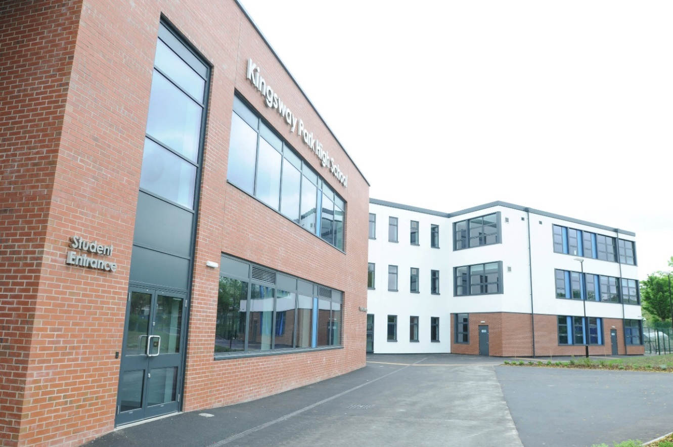

**Title:** Faculty Lead of English

**Application deadline:** 7th October 2024

**Interview:**  Week commencing 14th October 2024

Candidate Information Pack

Dear Applicant

We would like to extend a warm welcome to you in applying for the post of Faculty Lead of English at Kingsway Park High School.

Kingsway Park High School is proud to be a vibrant, inclusive, and diverse comprehensive school. We provide an individualised curriculum offer for all students regardless of their starting point, gender, ethnicity, faith or need. We seek to nurture and develop the whole child not just ensuring each students academic potential, but also preparing them as a socially responsible citizen who can flourish in society and give back to their local community. We seek to remove those barriers of inequity that prevent equality of opportunity so that all students can aspire and be inspired to realise their dreams. We also respect and recognise that success feels and looks different for each and every one of our students.

This school has soul and a true “family feel.” The staff here work relentlessly in the pursuit of excellence for this community and the students we serve.

Our challenge is to continue to develop the school’s culture and unique offer while improving aspirations, learning and achievement. This is not something that is possible for any one individual but requires a team of passionate, dedicated and committed staff, supported by a strong and principled senior leadership team. It is only through this collective responsibility and partnership working, that we can achieve a world-class learning experience for all.

If you are excited by what you have read and feel that you can support in elevating Kingsway Park High School, during its next stage of its journey, we look forward to receiving your application.

Yours sincerely



Mr Simon Ward – Headteacher

# Application

1. Complete the Altus Education Partnership application form
2. Provide a cover letter of no more than two sides of A4 paper Send your application by email to [recruitment@altusep.com](mailto:recruitment@altusep.com)

# Deadline

The deadline for the post is 7th October 2024 at 9am.

Interviews will be held on the week commencing 14th October 2024.

# Shortlisting

We will unfortunately be unable to notify candidates who are not on the shortlist, therefore, if you do not hear from us, your application has been unsuccessful on this occasion.

# For an Application Pack

1. Visit [www.kingswaypark.org](http://www.kingswaypark.org) or [www.altusep.com](http://www.altusep.com/)
2. Contact HR on: [recruitment@altusep.com](mailto:recruitment@altusep.com)

# Reward Package & Additional Benefits

We offer a comprehensive package, including membership of our outstanding Teachers’ Pension Scheme; our ‘Employee Benefits Programme’ which provides a range of options including:

* + Our Cycle to Work Salary Sacrifice Scheme
  + Free access to Employee Assistance Programme, offering guidance, support and counselling on a range of subjects.

# Background Information

# Kingsway Park High School

Kingsway Park High School was established in 2010 and joined the Altus Education Partnership in February 2022. We are now a very popular oversubscribed school (1350 students in years 7-11 and 190 staff) located in central Rochdale. We are very proud of the high-quality facilities, resources, and environment that we provide for both staff and students.

At Kingsway Park High School we strive to transform students’ lives. Through our relationships, we endeavour to instil both resilience and an intrinsic motivation to become confident, creative, and highly skilled students, capable of meeting tomorrow’s challenges head on. We strive to establish a culture rooted in achievement and progress that encourages our students to grow academically, personally, and socially, equipping them with the values of equality, fairness and openness. We pride ourselves on our relentless drive to achieve outstanding, high-quality teaching that provides a safe, supportive, and encouraging environment for all our students to be able to realise their academic potential in pursuit of educational excellence.

# Altus Education Partnership

The Altus Education Partnership is a Multi Academy Trust and was established in April 2017 by the Governing Body of Rochdale Sixth Form College, an outstanding A-Level provider founded in 2010. The college was awarded Outstanding status by Ofsted in 2013 and has developed a national reputation for excellence, having been used in Ofsted case studies for sharing best practice. The development of the Trust stemmed from a commitment to raising aspirations and improving the life chances of young people throughout the borough of Rochdale. In 2019 the Trust was successful in its application to open a new free school, the Edgar Wood Academy, which serves the local community in Middleton and Heywood.

We are committed to supporting all children in their academies to progress to a successful career, life and employment path of their choice.

All our academies will share a collective identity as providers of the highest quality teaching with high expectations of learners, coupled with effective assessment and intervention. Young people in our academies will engage with opportunities to develop their own skills and aptitudes to support their progression, while making valuable contributions to their communities. Leaders and teachers will take a collaborative approach, sharing best practice at a local, regional and national level, to continuously improve the performance and outcomes of all academies in the Trust.

# Altus Education Partnership Values

The values of the Altus Education Partnership will be embedded and visible throughout all the academies. Each will have its own unique identity built around the core Trust values. These are:

* Unrelenting commitment to improve the quality of our provision and enhance the lives of our students.
* Openness in the way we build trust and bring purpose to our work as a Multi Academy Trust.
* Accountability through the rigorous, transparent and forensic analysis of all aspects of our performance.
* Commitment to the principles of inclusion and equality.
* Dedication to the borough of Rochdale and its surrounds.
* Collective responsibility for one another and the results of all our students – ‘if one fails, we all fail’.

# The Ambition is that by the time students leave they will:

* Have achieved their personal academic potential giving them a greater choice in life.
* Have the highest aspirations and developed the self-esteem, confidence, and emotional resilience to exploit their potential.
* Be contributing members of the community and have compassion for others.
* Be able to celebrate their success and that of others.
* Have developed the confidence to overcome barriers to success.
* Be articulate, creative, and prepared for future growth and learning.
* Be happy!

# Shared Objective for all Staff

"To maximise students' achievements"

* At Altus Education Partnership we do this through engaging our students in their subjects and inspiring them to enjoy their studies in a totally positive atmosphere.
* Our students are challenged to achieve through a culture of high expectations and a belief in their ability.
* Above all, staff at Altus Education Partnership are committed to their students and demonstrate this through their daily conduct and interaction.

**Role Description:**

|  |  |
| --- | --- |
| **Job Title:** | Faculty Lead of English |
| **Reports to:** | Deputy Headteacher |
| **Staff Responsibility:** | Line manager of staff within subject area |
| **Additional:** | As Assigned |
| **Remuneration:** | Leadership pay scale L7-11 |
| **Contract:** | Permanent – Full Time |
| **Start Date:** | ASAP |

**Primary Purpose:**

We are looking to appoint a new faculty leader who has a real passion for their subject and is equipped with the skills to maximise outcomes for students within English at both KS3 and KS4. At KPHS we have introduced a range of faculties which share good practice, foster a sense of competition and work collaboratively to improve student outcomes whole school. The leadership of this faculty is vital to ensure consistency across all year groups. The faculty lead will line manage all TLR holders within the faculty and will monitor, evaluate, and strategically plan areas for improvement across the faculty. This is an exciting opportunity for an existing leader who has effectively demonstrated their ability to develop teaching and learning strategies across their department, engaged students both inside and outside the classroom and has consistently demonstrated improvements in student outcomes.

The new faculty lead will need to collaborate with existing TLR holders to initially evaluate the curriculum within the faculty and to further align the subject intents with the school’s overall intent - ‘We Cooperate, We Pioneer, We Belong.’ They will also look to increase both the outcomes of English by overseeing the mapping, sequencing, and execution of the existing KS3 curriculum model. The faculty leads will also work to ensure that all departments take an active role in the preparation of whole school assemblies, experiences, activities, and possible drop-down days.

**Leadership Responsibilities:**

* To effectively lead the staff within your faculty at KPHS by seeking to continuously maximise the outcomes of students at both KS3 and KS4.
* Lead the staff within your faculty to ensure they are planning and working in accordance with subject area course outlines and examination specifications. Ensure all internal and external deadlines are met.
* Display sound knowledge and understanding of each subject area within the faculty and communicate this effectively with staff, students, and stakeholders. Work collaboratively with existing TLR holders within the faculty to ensure leaders at all levels can articulate the intent, implementation, and impact of the English curriculum.
* Monitor and intervene effectively when leading staff to ensure consistency and high expectations across all classes within the faculty.
* Co-operate with other Faculty leaders and colleagues to ensure the achievement of the aims, values and visions of the school are demonstrated consistently across the subjects within the faculty.
* Assess academic performance in all subject areas within your faculty in light of previous achievement to enhance the value-added results of all students. Evaluate how well learning outcomes have been achieved and use them to improve specific aspects of learning and teaching.
* Assess and record students’ progress systematically and keep accurate records to check work is understood and completed consistently across the faculty. Ability to monitor strengths and weaknesses, inform planning and recognise the grade/level at which all classes and overall year groups are achieving.
* Ensure staff within your faculty set sufficient work for formal assessment, such that students understanding of skill and subject knowledge can be regularly checked and so that students can be fully prepared for the demands of public examinations and/or coursework.
* Ensure all teachers within the faculty attend parent’s evenings according to the school calendar to keep students’ families up to date with academic and personal progress. Ensure all departments within your faculty have regular contact with parents/ carers to ensure positive interaction between school and home.
* Promote positive student behaviour in line with school policies within your faculty area and across school. Have a thorough awareness of, and regard for, the confidential nature of many aspects of school information relating to individual students, groups of students and year group analysis.
* Work collaboratively with colleagues, parents/carers, educational psychologists, therapists, social services, and other outside agencies who may be involved with students for whom you have a responsibility.

**Teaching and Learning Responsibilities**

* Ensure the English faculty have a broad and balanced curriculum which is strategically mapped, sequenced, and implemented across KS3 and KS4.
* Work collaboratively with TLR holders and lead practitioners within the faculty to ensure students are engaged and sustained through provision of clear structure for lessons, maintaining pace, motivation, and challenges within the faculty.
* Plan and prepare lessons and schemes of work in accordance with school policy, ensuring a variety of learning opportunities for the development of key skills. Encourage the use of a variety of teaching strategies, which involve planned formative assessment and active learning strategies across the faculty.
* Ensure lessons across the department are effectively differentiated for the individual needs of students. Share effective strategies for individual students and groups both across the faculty and whole school.
* Self-evaluate teaching of self and others critically to improve effectiveness across the faculty. Develop a strategic understanding of the teaching profile across the faculty and be able to articulate strengths and development points to SLT/ external agencies.
* Maintain individual records of all student experiences and achievements within the department and use data to inform future planning.
* Mark, monitor and return work within a reasonable and agreed time span providing constructive oral and or written feedback that clearly indicates strategies for improvement. Ensure students are very clear as to how to move specifically to the next grade/level.
* Prepare, implement, and monitor Individual Learning Plans for students in accordance with school policy. Quality assure these plans whilst leading the team.
* Work actively to create an ethos that promotes equality, celebrates cultural and academic diversity, and ensures the inclusion of students of all abilities, including those with special educational needs.
* Establish good relationships with both staff and students that promote the achievement of learning, whilst maintaining a purposeful and positive atmosphere in the classroom

**Other Responsibilities**

* Lead regular Faculty meetings and attend both Curriculum Leader meetings and Faculty Lead meetings. Be prepared to also actively take part, as required, in meetings in relation to the curriculum and strategic organisation of the school.
* Participate in arrangements for professional development as outlined in the school development plan or identified through the appraisal process and take responsibility for own development.
* Encourage all staff within your faculty to actively engage in both pedagogical and leadership CPL to regularly improvement of existing practice.
* Ensure the activities in which students are engaged in both inside and outside the classroom are conducted in a disciplined, safe and healthy environment and in line with school policy

**General Responsibilities**

* To be an ambassador for the school and consistently embody the school intent of ‘We Cooperate. We Pioneer. We Belong.’
* To model the core values of the school in your professional life and to promote and develop the

school’s vision, ethos, aims and objectives.

* To establish a culture that promotes excellence, equality, and high expectations for all students. This should be replicated across all subject areas within your faculty.
* To respond professionally to unplanned situations, crises, and emergencies whenever they arise to ensure the safety and efficiency of staff and students of the school.
* To attend meetings with external agencies and organisations. Work with other faculty leads to share good practice and constancy across all curriculum areas at KPHS.
* To foster and support extra-curricular activities in the interest of the school community e.g. school productions, concerts, sports activities, trips, and excursions.
* To take on additional responsibilities as directed by the Headteacher and/or SLT link.

**Whole-School Organisation, Strategy and Development**

* Contribute to the development, implementation and evaluation of the school’s policies, practices and procedures to support the schools’ values and vision.
* Make a positive contribution to the wider life and ethos of the school.
* Actively participate in KPHS daily duty rota.
* Regularly contribute to internal CPL delivery, briefings, school newsletter and assembly rota.

**Health and Safety**

* Promote the safety and wellbeing of students and help to safeguard students’ well-being by following the requirements of Keeping Children Safe in Education and our school’s child protection policy.

**Professional Development**

* Keep your own knowledge and understanding relevant and up-to-date by reflecting on your own practice, liaising with school leaders, and identifying relevant professional development to improve personal effectiveness
* Take opportunities to build the appropriate skills, qualifications, and/or experience needed for the role, with support from the school.
* Take part in the school’s appraisal procedures.

**Personal and Professional Conduct**

* Uphold public trust in the education profession and maintain high standards of ethics and behaviour, within and outside school.
* Have professional regard for the ethos, policies and practices of the school, and maintain high standards of attendance and punctuality.
* Demonstrate positive attitudes, values and behaviours to develop and sustain effective relationships with the school community.
* Any other reasonable duties as requested by the Line Manager, Headteacher or member of the Senior Leadership Team that are not specified in this job description.
* Respect individual differences and cultural diversity.

**Person Specification**

|  |  |  |  |  |  |  |
| --- | --- | --- | --- | --- | --- | --- |
|  | | **Assessed by:** | | | | |
| **No.** | **CATEGORIES** | **App Form/**  **Letter** | **Interview** | **Lesson** | **Refs** | **Results Sheet** |
| **ESSENTIAL CRITERIA** | | | | | | |
| 1. | A high-quality degree with English (or similar) as a key focus | √ |  |  |  |  |
| 2. | PGCE with QTS/ QTLS and membership with DfE or IfL or willingness to work towards | √ |  |  |  |  |
| 3. | A passion for teaching the subject – History | √ | √ | √ | √ |  |
| 4. | Ability to engage with students, inspiring learning & promoting success | √ | √ | √ | √ |  |
| 5. | Exceptional classroom practitioner | √ | √ | √ | √ |  |
| 6. | Ability to devise, adapt and differentiate new resources for learning | √ | √ | √ | √ |  |
| 7. | Knowledge sand application of active learning and teaching styles | √ | √ | √ | √ |  |
| 8. | Evidence of dynamic and innovative practice | √ | √ | √ | √ |  |
| 9. | Either – successful teaching placement (*applicants currently in training) OR* successful record of teaching including quality KS4 results. | √ |  |  | √ | √ |
| 10. | Commitment to leading quality teaching and learning within department | √ | √ |  | √ |  |
| 11. | Competence in the use of ICT | √ | √ |  | √ |  |
| 12. | Ability to contribute positively to teams, share ideas & develop resources co- operatively | √ |  |  | √ |  |

|  |  |  |  |  |  |  |
| --- | --- | --- | --- | --- | --- | --- |
| 13. | Ability to be adaptable & flexible | √ | √ |  | √ |  |
| 14. | Effective inter-personal & communication skills | √ | √ | √ | √ |  |
| 15. | Commitment to valuing the individual and boosting their self-belief and worth | √ | √ |  | √ |  |
| 16. | Commitment to high standards & expectations – no accepting of second best in students and staff | √ | √ |  | √ |  |
| 17. | Commitment to professional learning & institutional improvement | √ | √ |  | √ |  |
| 18. | Commitment to high professional & personal standards of work & conduct | √ | √ |  | √ |  |
| 19. | Determination to promote equality of opportunity |  | √ |  | √ |  |
| 20. | Ability to offer enrichment & contribute to wider college life | √ | √ |  | √ |  |
| 21. | Commitment to professionalism, sharing, teamwork & collaboration | √ | √ |  | √ |  |
| **DESIRABLE CRITERIA** | | | | | | |
| 23. | GCSE experience in teaching English | √ | √ |  |  |  |
| 25 | Experience working for the exam board (Edexcel) | √ |  |  |  |  |
| 26. | Experience of contributing/ developing whole school experiences | √ |  |  |  |  |