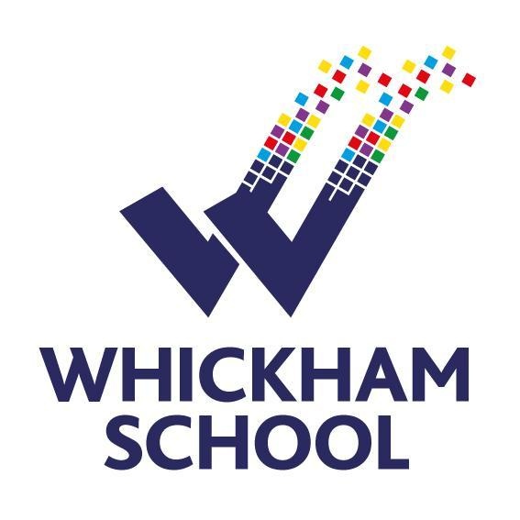
Faculty of English
February 2026

Leadership structure
Faculty Leader vacancy
Deputy Faculty Leader Mrs Claire Thirlwell
Assistant Faculty Leader Mr Robert Robinson
Assistant Subject Leader Mrs Sian Scott
Lead Practitioner Mrs Sophie Jalleh

Curriculum information

Stage | Course / teaching information
Key Stage 3 | Across Key Stage 3, pupils are immersed in a rich, varied and engaging literary curriculum designed to develop confident, thoughtful readers and writers, with literacy embedded throughout. In Year 7, Coraline introduces pupils to imaginative fiction that sharpens their analysis of character, atmosphere and themes of courage and identity, while in Year 8 The Book Thief deepens their understanding of narrative voice, historical context and the power of language to shape human experience and empathy. By Year 9, pupils extend their literary horizons through American literature, including To Kill a Mockingbird and Of Mice and Men, prompting mature, critical engagement with ideas of justice, prejudice, morality and the American Dream, alongside poetry that amplifies voices of injustice and explores language as a tool for challenge and resistance. Drama and Shakespeare are integral throughout KS3, with studies of Romeo and Juliet, A Midsummer Night’s Dream and a staged adaptation of Frankenstein enriching pupils’ appreciation of performance, theme and genre, while sustained exposure to poetry, plays, novels and non-fiction from diverse writers empowers pupils to celebrate varied voices and develop their own, both in writing and in oracy.
Key Stage 4 | AQA GCSE English Language & AQA GCSE English Literature:  At Key Stage 4, the curriculum builds on this foundation with a rigorous and purposeful focus on both English Language and English Literature, ensuring pupils are fully prepared for the demands of GCSE study and beyond. In AQA English Language, pupils follow a bespoke, carefully scaffolded approach to each assessment objective, explicitly teaching the reading and writing skills required for success while embedding clear exam strategies that support all learners to achieve with confidence. Pupils engage with a wide range of fiction and non-fiction texts in preparation for Paper 1 and Paper 2, developing their ability to analyse language and structure, compare viewpoints and perspectives, and craft increasingly sophisticated, accurate and purposeful writing for different audiences, purposes and forms. In English Literature, pupils study An Inspector Calls, Jekyll and Hyde, Macbeth and the Power and Conflict poetry anthology, texts chosen for their rich thematic complexity and enduring relevance. Together, these works enable pupils to explore ideas of power, responsibility, morality, identity and conflict, while deepening their understanding of historical and social context, authorial intent and critical interpretation, equipping them with the analytical depth, cultural capital and expressive confidence needed for success at GCSE and beyond.
Key Stage 5 | AQA A-level English Language, AQA A-level English Literature, EDUQAS A-Level Media:  At Key Stage 5, the curriculum offers a challenging and intellectually rich programme that encourages pupils to think independently, critically and creatively across Language, Literature and Media. In AQA English Language, pupils engage deeply with sociolinguistics, exploring how language is socially constructed and shaped by factors such as gender, region, occupation and power, as well as studying language change and the development of World Englishes. In AQA English Literature, pupils study Shakespearean comedy through Twelfth Night, alongside Oscar Wilde’s The Importance of Being Earnest, examining conventions of comedy, performance and subversion, before moving into crime writing, where they analyse narrative, genre and moral complexity across a range of texts. Complementing this, the Eduqas A Level Media Studies course introduces pupils to a dynamic and contemporary curriculum, combining theoretical frameworks with close textual analysis and practical production work. Pupils explore media language, representation, industry and audience across a range of platforms, developing both academic rigour and creative skills that prepare them for further study and careers in the cultural and creative industries.

Performance Summary

Key Stage 4 | 18/19 | 22/23 | 23/24 | 24/25
P8 English | -0.38 | 0.02 | 0.14 | n/a
A8 English | 5.17 | 5.38 | 5.45 | 5.60
English %4+ | 79% | 86% | 82% | 85%
English %5+ | 67% | 70% | 68% | 73%
English %7+ | 24% | 29% | 30% | 31%

Key Stage 5 | 18/19 | 23/24 | 24/25
VA English language | -0.15 | 0.23 | 0.37
VA English literature | -0.12 | 0.05 | -0.28
VA Media | -0.50 | -0.10 | 0.04

