Job Description Faculty Learning Support
Pay Range –B Range Linked to Role profile LSA Grade B- 2130
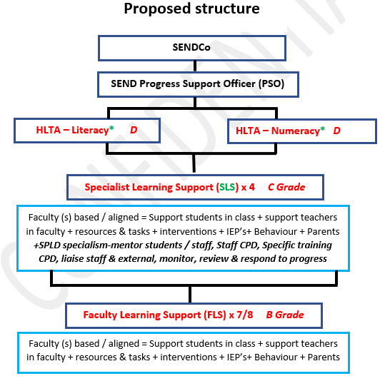

Role Purpose: | - To support SEND students in the classroom / faculty they are allocated to, to access and support learning and make expected progress.  - To complement and support the professional work of the Teachers in their faculty to support task learning activities.  - To support the progress of SEND students within the faculty and providing best practice resources and sharing ideas.  - To liaise with teacher within the allocated faculty with regards to curriculum and be prepared to support tasks and activities. This could include some pre-learning, responsive support in the classroom and additional interventions.  - To support SEND students in readiness and during formal assessments.  - Actively support and manage behaviour in conjunction with the teacher.  - The role includes dealing with individual pupils and/or groups with complex and demanding learning needs.  - The post holder’s working hours predominantly respond to students needs and will include provision outside of school hours.
Accountabilities | - Support for Students  Working with students, in the class, break times, interventions, managing behaviour. | 95%  28 lessons
 | - Support / Liaison with Teachers  Planning, resource prep, liaison with others. (students/ staff/parents) | 5%  2 lesson  +time pre  /post school
- Support for Curriculum
Review progress, resources, assist with assessment
Liaison  TS  1.8 parents | - Liaise regularly with faculty teachers and Hof / HoY regarding the progress and provision of SEND students they support.  - Liaise with parents with regards to the needs of SEND students, their progress and additional support needed (in consultation with SENDCo)  - Liaise with parents to report on/ review pupil progress following interventions.  and IEP’s.  - Liaise regularly (daily / weekly) with faculty teachers (including strategic groups e.g. RAG) to ascertain and create links with effective curriculum delivery. E.g., E/M interventions require liaison with regard to the E/M interventions.  - Liaise with other colleagues / stakeholders and the SEND faulty to share best practice and share pedagogy for effective dissemination.  - Liaise with the SLS and HLTA on effective support for students.
Support for student progress development and inclusion.  TS  1.3 SK  1.4 Lesson time  1.5 Differentiate  1.6 Assess /  feedback  1.7 Behaviour  1.8 Parents / staff | Student Progress  - In the presence of and in collaboration with the teacher, facilitate learning tasks in a strategic manner to support accessibility and progress. To work with identified students individually and collectively by contributing to decisions about the most appropriate learning goals and strategies, utilising information and training shared within the SEND faculty.  - Assess needs of pupils where appropriate and in discussion with SENDCo, identify specific needs and intervention.  - Provide feedback to students both orally and through written feedback  - Produce case studies (alongside the SENDCo) for students who they support who have High Needs.  - Co-ordinate and deliver specialist learning activities for SEND students (select  and prepare resources)  - Support with Access arrangement provision and liaise with exam boards.  - Oversee and deliver out of school learning activities to support SEND students, that consolidate class work. Providing regular follow up to class teachers on the interventions.  - Supervise and assist individual/small groups of pupils in activities and differentiate with teacher guidance.  - Build and maintain successful relationships with pupil, treat them consistently, with respect and consideration in line with the school vision and behaviour policy.  - Help reinforce and promote independent learning and social skills by supporting pupils.  - Help pupils record work in an appropriate way and to develop study and organisational skills without hindering independence.  - Support pupils to be on task and to build motivation by modelling good practice and utilising research and agreed pedagogy.  - Build the pupils’ confidence and enhance self-esteem and actively seek to promote the academic, social and emotional welfare of pupils  - Implement behaviour management policies in accordance with guidance provided by the teacher  - Attend formal and informal meetings with teachers (within working hours) to contribute to joint planning lessons/ activities  - Develop a secure knowledge of the relevant subject faculty areas they support and foster and maintain students’ interest in the subject.  - Prepare strategic materials and resources within faculty area (s) assigned to best support all SEND students within the assigned faculty to make expected progress.  - Help prepare pupils beforehand for a task in their faculty to ensure they can access learning content.  - Take every opportunity to develop pupils’ language, reading, mathematics and related skills as directed by subject specific teachers  - Assist the teacher and actively contribute to setting appropriate learning and behaviour expectations of pupils and supporting pupils appropriately to achieve these  - Supervise practical tasks  - Be pro-active in keeping records and evaluating identified pupils’ progress  - Support the use of ICT in the classroom and develop pupils’ competence and independence in its use  - Promote the inclusion and acceptance of children with Special Educational Needs within the classroom ensuring access to lessons and their contents through appropriate clarification, explanation and resources  - Be an active participant in planning and evaluation of learning activities with the teacher, providing feedback to the teacher on pupil progress and behaviour  - To supervise pupils for limited and specified periods including break-times  - To assist with escorting pupils on educational visits where deployed  Interventions  - Under supervision of the SENDCO / PSO develop and co-ordinate Individual Education Plans (IEP’s)  - Under supervision of the SENDCO / PSO deliver interventions to boost and develop progress areas of identified students.  - Provide accurate feedback and reports on SEND student attainment to SENDCo and teachers.  - Analyse the impact of interventions delivered and share accordingly.(to Staff + SENDCo / PSO)  - Undertake a commitment to developing own CPD to support effective delivery of interventions and faculty support.  Data  - Be aware of and make us of relevant SEND data in relation to the progress of students and possible actions to develop.  - Use relevant data to monitor progress and set targets and plan subsequent learning tasks.  - Review transition data and be aware of student needs to then plan strategies and interventions.  - Provide regular data and assessments in relation to interventions.  Professional  - Consistently model professional practices to support the development of all students  - Attend relevant school meetings as required  - To respect confidentiality at all times  - Share and support the school’s commitment to safeguarding and promoting the welfare of all young people  - Participate in the performance and development review process, taking personal responsibility for identification of learning, development, and training opportunities in discussion with line manager  - Carry out other roles and tasks as requested by the Headteacher that are commensurate with salary grade.
Skills needed | - Passion for working with young people and SEND students.  - Knowledge of the SEND code of practice. (training provided)  - Good standard of literacy of Numeracy.  - Approachable and professional manner to work alongside staff and vulnerable students.  - Current knowledge of education research and thirst for learning. (training provided)  - Excellent organisational and time management skills  - Excellent presentation skills including to a range of audiences.  - Excellent knowledge of office 365 and a willingness to develop skills, including data and monitoring.  - Ability to meet tight deadlines  - Successful Leadership experience at a range of levels.  - Ability to listen.  - Ability to work as part of a team and motivate others.  - High levels of motivation and to be work proactively.  - Some Experience at implementing and monitoring the Assess-Plan-Do-Review cycle. (training provided)  - Willingness and ability to collaborate and coach others.  - Problem solving skills and ability to work under pressure.  - Willingness and ability to promote the work and development of BHCS in a professional and collaborative manner.  - Excellent communication skills- written and verbal.
Undertake other reasonable tasks directed by the Headteacher and/or DHT.

