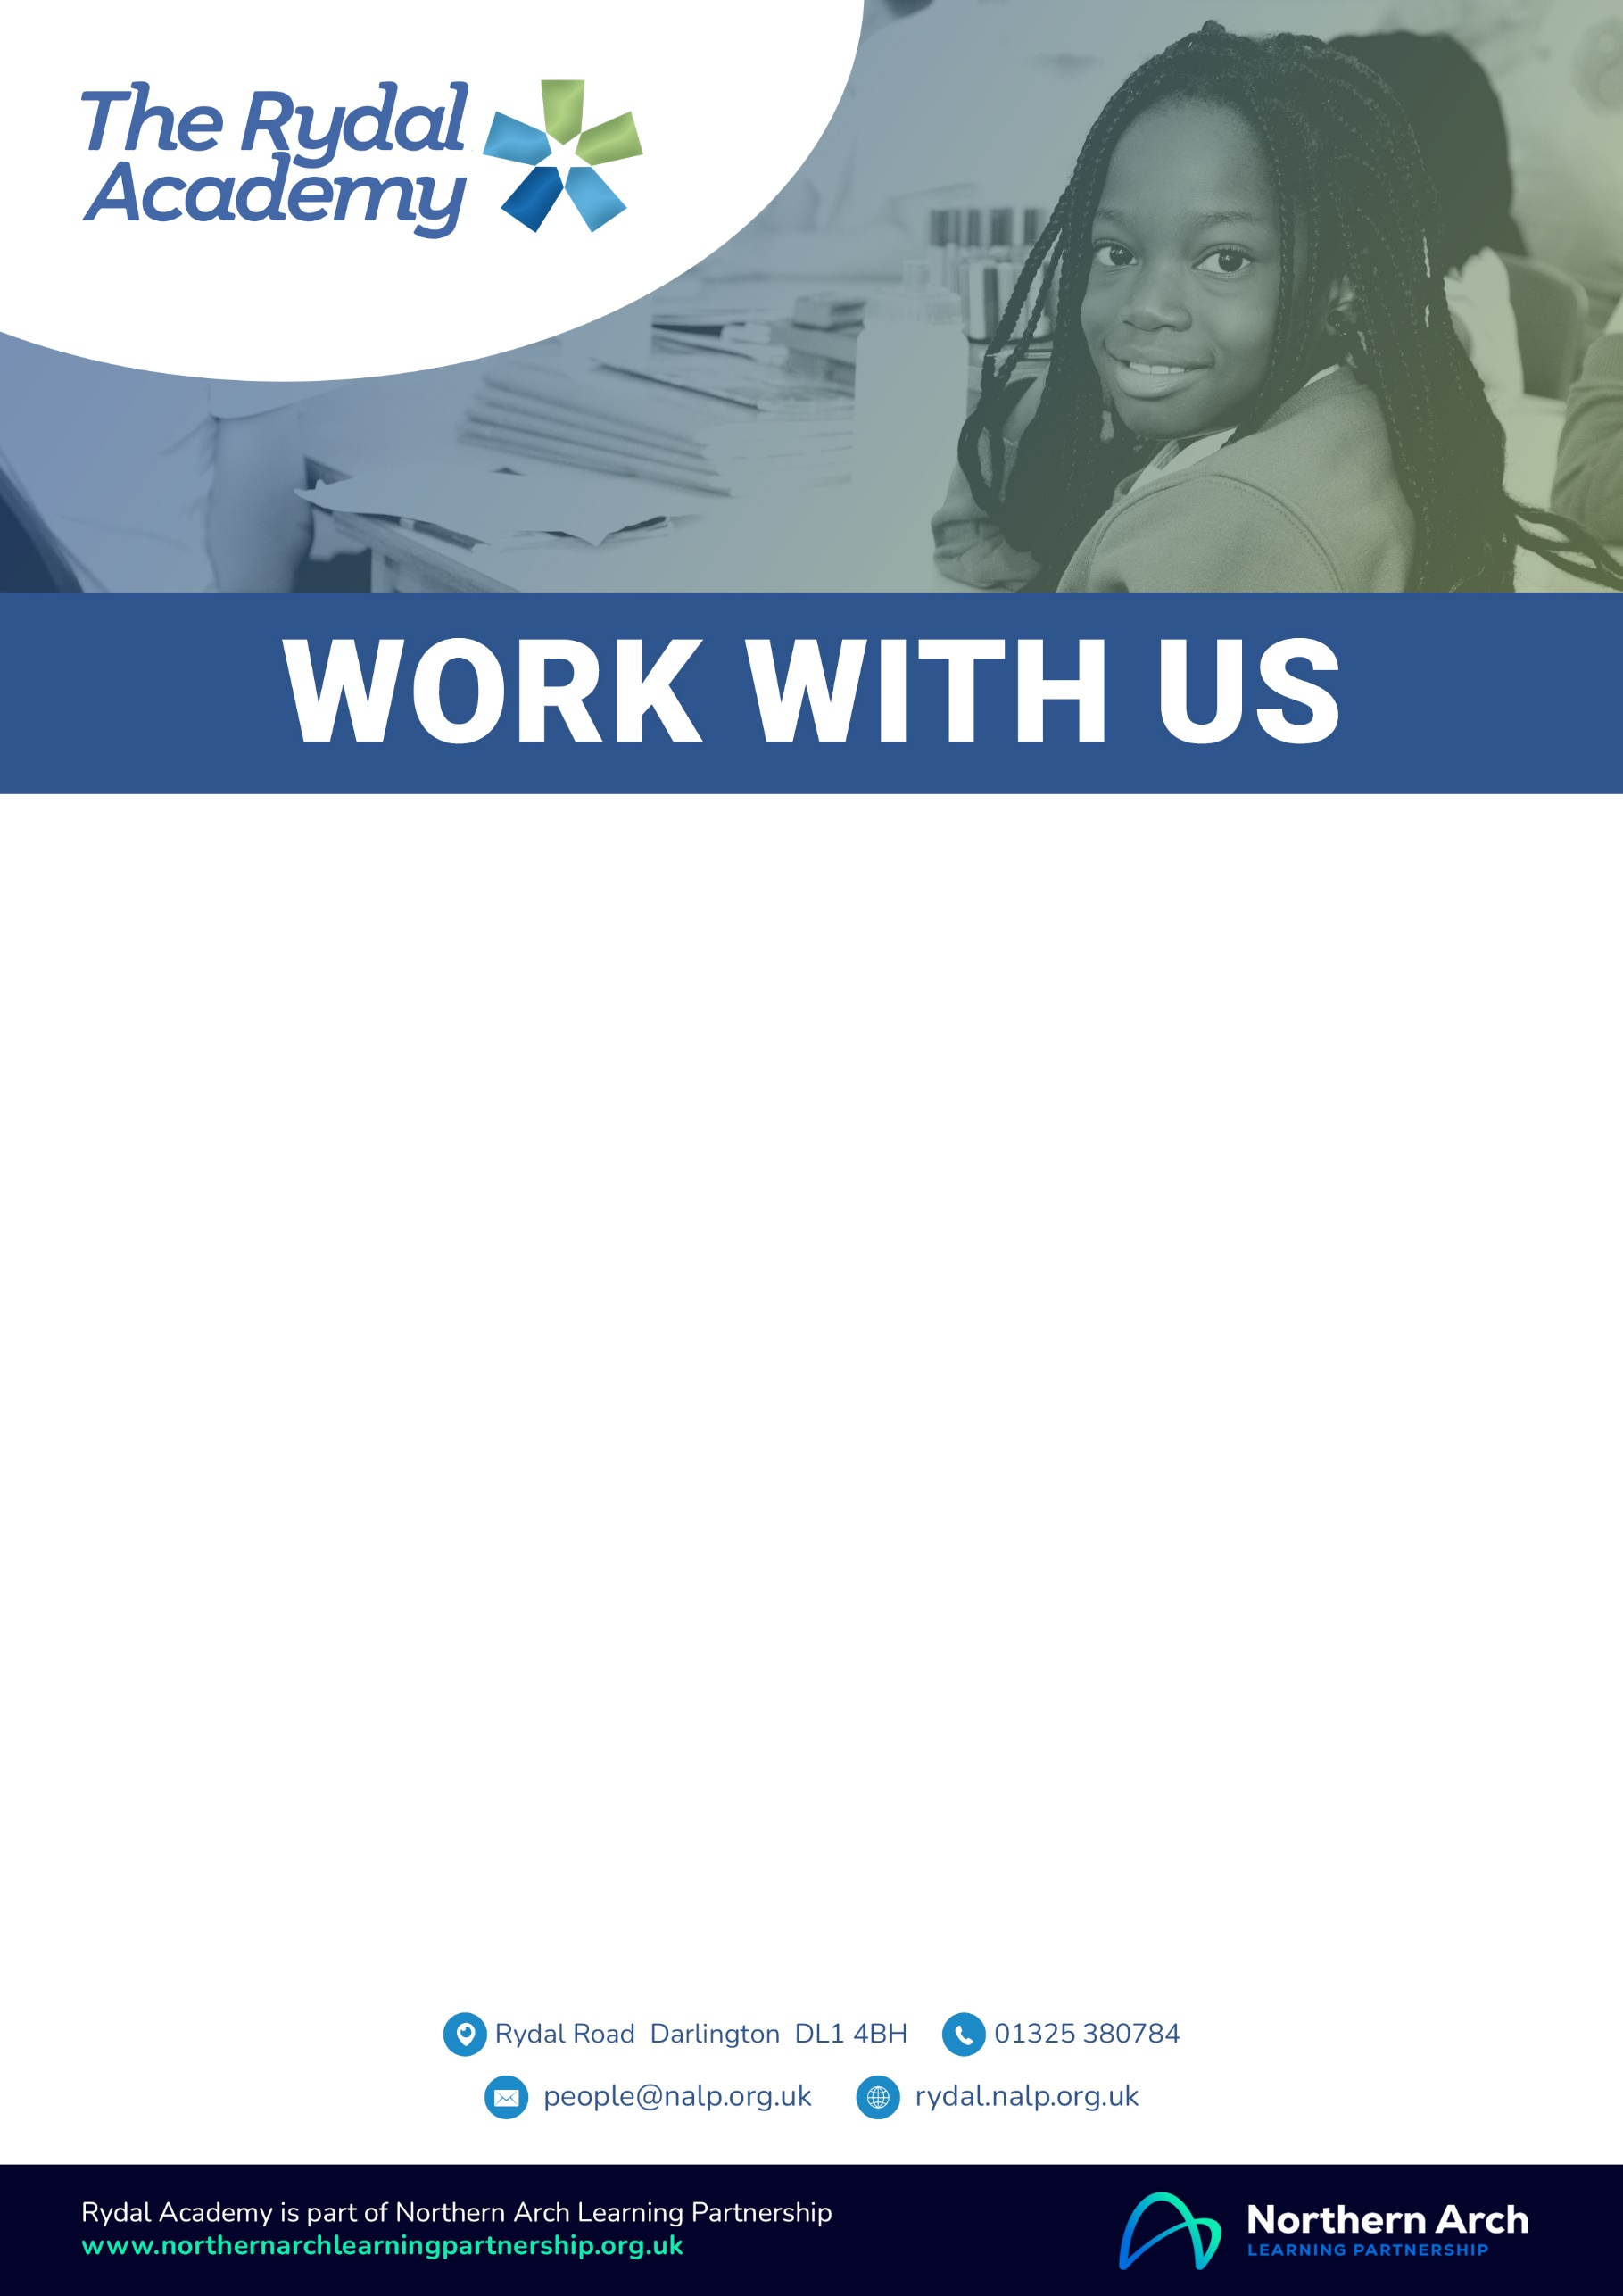

Family Partnership Assistant
Permanent, 30 hours per week, 39 working weeks,
(Term time plus 5 days, 47 paid weeks including holiday)
NJC Band 7, point 14-17, £21,589.04 – £22,672.16 (actual salary)
To start as soon as possible
We require an enthusiastic and skilled Family Partnership Assistant to join our team in a large, unique and diverse primary school and nursery which puts pupils and the school community at its heart. We are looking to appoint an enthusiastic and highly motivated individual to support our families through: triaging to pastoral, safeguarding, SEND and attendance services; supporting applications and action planning; sign- posting and liaising with external agencies.
In return we can offer: the opportunity to work in a supportive and inclusive work environment; access to a wide range of professional development opportunities; skilled, highly supportive and collaborative staff; a unique, rich, diverse community; strong moral leadership with our families at the centre of decision making.
For further information or to discuss the post please contact Mr John Armitage, Headteacher 01325 380784 or by e-mail to jarmitage@rydal.nalp.org.uk.
Information for applicants, including the job description and person specification for this role and an on-line application form, can be viewed at https://nalp.face-ed.co.uk/vacancies If you have any difficulties completing the on-line application form, please contact Sam Recruit on 01924 907319 or the People Team on people@nalp.org.uk.
Closing date: Tuesday 9th June 2026 (12pm) Interviews: Wednesday 24th June 2026

Northern Arch Learning Partnership and its partner schools are passionate about safeguarding the welfare of pupils and maximising their life chances. We expect all staff and volunteers to share this commitment. This post is subject to a satisfactory enhanced Disclosure and Barring Service criminal records check for work

