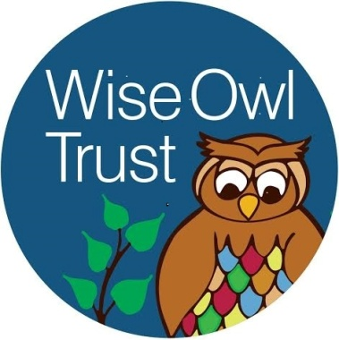

Wise Owl Trust

Person Specification
Family Worker Co-ordinator– Grade 6

The post holder will report to the Chief Executive Principal and Principal.

For this job we are looking for someone who:
- Has knowledge of legislation and National guidelines relating to the Children’s Act and Child Protection.
- Knowledge of the responsibilities of agencies towards vulnerable children.
- Has high quality written, oral and listening communication skills for effective interaction with internal and external contacts including members of the public, elected members and staff at all levels.
- Has the ability to manage and prioritise workloads.
- Has the ability to reflect on and develop own practices.
- Good IT skills including spreadsheets, databases, word processing and internet/ email.
- Has significant experience of working with children and families.
- An understanding of the ‘Early Help’ process.
- Knowledge of Schools Information Systems (Arbor).
Personal Style and Behaviour: You should:
- Be willing to comply with all Wise Owl Trust and Local Authority Policies and Codes of Conduct
- Have drive, tenacity and an ability to maintain focus, objectivity and sound judgement under complex conditions to achieve desired outcomes.
- Have the ability to work and co-operate as part of a team.
- Be flexible to adapt to changing workload demands and new organisational challenges.
- Have the ability to adapt to challenging situations and people and respond appropriately using negotiation and influencing skills to achieve objectives
- Have the ability to work as part of a team openly and collaboratively whilst applying the principles of confidentiality
- Have a desire to pursue own personal development and take full advantage of training provided
- Have a personal Commitment to continuous service improvements.
- Have a personal commitment to the school’s professional standards, including dress code and code of conduct at all times
Other Requirements:
- Ability to work flexibly.
- Self-motivated and able to prioritise a demanding workload.
- To be professionally assertive, clear thinking and able to negotiate.
- To be able to operate as part of a team.
- A full valid driving licence and the use of a car.

The Wise Owl Trust, Trustees and Governors are committed to safeguarding and promoting the welfare of young people, and expects all staff and volunteers to share this commitment. All staff and volunteers will be expected to complete a DBS (disclosure and barring service) check and also complete any other safeguarding documentation as and when requested.

All employees have a responsibility to co-operate in promoting and maintaining a safe and healthy working environment, and to take reasonable care of their own health and safety at work and that of all team members for which they have general management responsibility.

