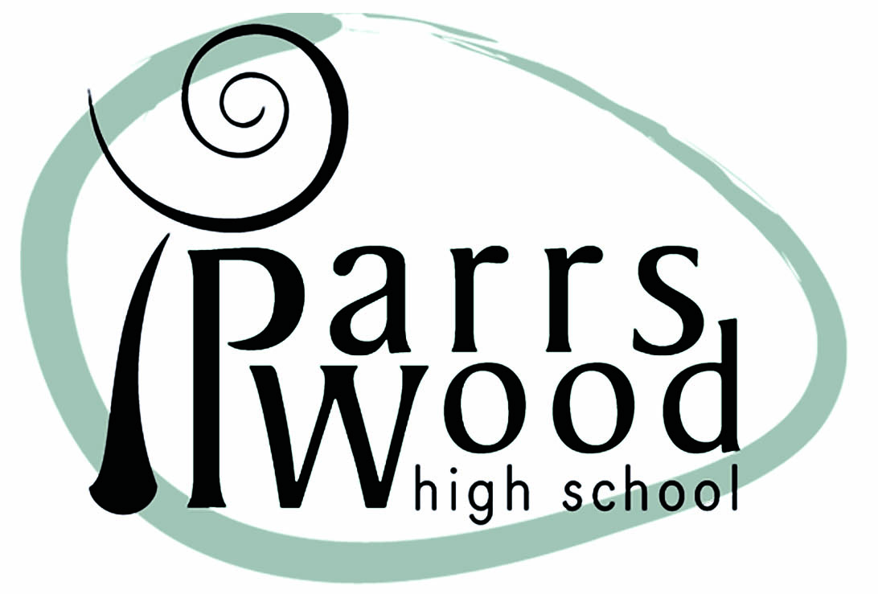
PARRS WOOD HIGH SCHOOL

Job Description
Female PE Teacher (MPS)

Relationships
The Postholder is responsible to the Headteacher in all matters, to the Head of Department/Faculty in respect of delivery of the curriculum and the Heads of Learning for issues of a curriculum and pastoral nature. The Postholder is expected to develop strong and professional working relationships with teaching and support staff, parents, carers, families and the community to improve standards and achievement for all students.

Purpose of the Job
To teach and facilitate learning for all students within the school and to carry out such other associated duties as are reasonably assigned by the Headteacher. Subject to the generality of the foregoing, particular responsibilities attached to the post are as follows.

Particular Responsibilities

- To plan and deliver lessons that inspires and challenges students to maximize progress in their learning.
- To create an environment that encourages students to be independent and reflective learners.
- To plan timely formative and summative assessments, and to provide feedback to students that highlight what they are able to do and what they have to do to further develop their learning.
- To promote high standards of behaviour in accordance with the rules and disciplinary systems of the faculty and school.
- The supervision of the female changing rooms.
- To plan and deliver lessons that develops literacy and meets the specific learning needs of all students within the classes they teach.
- To monitor and assess students' achievements and progress in accordance with arrangements agreed within the faculty and school.
- To have high expectations of every student, giving them the confidence and skills to succeed.
- To work collaboratively with support assistants.
- To take attendance registers for all classes according to school expectations and protocols.
- To monitor and report to the SEN coordinator on the progress of students with Special Needs.
- To monitor and report to the Gifted and Talented coordinator on the progress of Gifted and Talented students.
- To attend parent information evenings.
- To use student data to inform learning and teaching, to make accurate projections of performance and to plan appropriate interventions to overcome any barriers to success.
- To develop a wide range of teaching strategies.
- Working with other colleagues create an effective and stimulating environment for teaching and learning within the faculty.
- To control and oversee the use and storage of books and other teaching materials provided for class usage.
- To contribute to Department/Faculty and Pastoral meetings.
- To monitor and report to parents/guardians on the progress of pupils in allocated classes, groups or forms.
- When required contact parents/guardians to discuss student concerns/issues.
- To contribute to the pastoral life of the school as a form tutor.
- To promote equal opportunities within the school and to seek to ensure the implementation of the school's equal opportunities policy.
- To report all incidents of a Safeguarding nature to the school’s Child Protection team.
Person Specification

Minimum Requirements
Attribute | Essential | Measured by
Qualifications | - Degree or equivalent  - Qualified Teacher Status | Application form  Certificates
Knowledge | - Excellent subject knowledge  - Knowledge and understanding of the learning process and the needs of children  - Knowledge of the National Curriculum and of public examination requirements.  - Knowledge of how their specialism relates  to other areas of the curriculum and how it delivers cross-curricular skills.  - Knowledge of what constitutes good teaching.  - To know how pastoral structures support the learning process. | Application form  Interview  References
Skills | - The ability to work effectively as part of a team  - The ability to take the initiative when needed  - Excellent communication skills  - Good ICT skills  - The ability to plan, organise and deliver lessons which cater for all abilities  - Good organisational skills  - The ability to employ a range of strategies to promote good behaviour. | Application form  Interview  References
Personal Qualities | - A commitment to providing high quality learning and teaching.  - A commitment to providing an holistic education  - A commitment to working collaboratively with parents/carers and with other staff  - A commitment to professional development.  - A commitment to promoting positive attitudes and values.  - A commitment to equality of opportunity  - The ability to enthuse and inspire students  - A willingness to respond positively to change | Application form  Interview  References
 | Desirable not essential
Experience | - Experience teaching vocational PE courses BTEC, Cambridge National or VCert  - Experience teaching PE qualifications GCSE and /or A level PE  - leading groups/teams to sporting fixtures | Application form  Interview  References
Qualifications | - Additional qualifications such as Trampolining level 1  - Approval to drive minibus | Certificates

