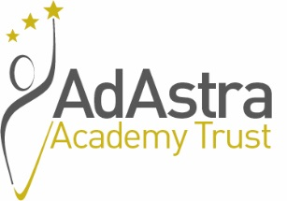

Ad Astra Academy Trust

Finance & Administration Assistant, full time, whole time (37 hours per week), permanent, Band 7, £20,493 to £21,748 per annum.

Following the promotion of one of the current postholders, Ad Astra Academy Trust is seeking to appoint a new Finance & Administration Assistant to join our innovative and forward thinking organisation.

The successful candidate will work with the Finance Manager and Chief Operating Officer to provide the full range of financial and administrative support to the central team and academies within the Academy Trust.
This role will include undertaking a range of financial procedures such as processing orders and invoices, making payments to suppliers, handling financial queries and payroll checking. In addition, the successful candidate will be required to undertake a range of general office administrative tasks including taking and producing minutes of meetings for the Trust as well as its schools.

The successful candidate will have a minimum of 12 months experience working in a finance environment, with good organisational skills and ability to work to tight deadlines and be able to meet the criteria as set out in the Person Specification.
The position will be based at the Trust head office located at the Innovation Centre, Queens Meadow in Hartlepool. There may also be an opportunity to have a hybrid working arrangement.

The successful candidate will:
• Join a Trust with a highly supportive, warm, friendly and respectful ethos, and the drive and ambition to ensure that all employees and children achieve their full potential.
• Be given opportunities to further develop their skills through a variety of professional development available through working for Ad Astra Academy Trust.

Please see our promotional Trust video via https://youtu.be/Apps8_Q1W5I
Ad Astra Academy Trust is committed to safeguarding and promoting the welfare of children and young people and expects all staff and volunteers to share this commitment. As such the successful candidate will be required to undergo an enhanced DBS check.

For a confidential, informal conversation about this exciting role, please contact Sue Lister, Chief Operating Officer via sue.lister@adastraacademytrust.com.

An Application Form, Job Description and Person Specification are available via the Ad Astra website site:
http://www.adastraacademytrust.com/careers/

Closing date for receipt of applications – 9am, Friday 26th November 2021.

