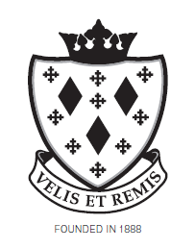
STOCKPORT SCHOOL

Finance Assistant

Person Specification

Attributes | Essential | Desirable | IDENTIFIED
Relevant Experience | - Experience in a clerical context  - Good ICT skills  - Ability to work with a range of ICT Software | - Experience of working in an educational context  - Experience in a finance role  - Knowledge of the SIMs system  - Knowledge of the SIMS FMS accounts | Application form and interview
Education and Training | - GCSE English & Maths – Grade 4 (C) or above or equivalent  - Willingness to undertake continuing professional development | - A Level or degree level qualifications | Application form, interview and assessment exercise
Special Knowledge and Skills | - Good communication skills both oral & written  - Financial/accounts experience  - Good ICT skills  - Ability to use the internet effectively  - Ability to maintain confidentiality at all times  - Ability to act on own initiative and to prioritise own workload  - Ability to provide support to students and staff  - Excellent telephone manner | - Knowledge of Data Protection  - Knowledge of school practices, policies and procedures  - Cash handling experience | Application form, interview and assessment exercise
Other Features | - Ability to meet deadlines & handle workload  - Flexibility, Adaptability and the ability to manage change  - Good organisations skills  - Excellent interpersonal skills  - Approachable, with positive friendly manner  - Ability to work as a team member  - Excellent attendance & punctuality  - Enthusiasm & commitment to hard work  - Good sense of humour  - Smart appearance, promoting positive image | - Basic appreciation of current issues in education  - Able to work in a diverse environment and able to demonstrate an understanding of the issues relating to young people in a learning environment | Application form and interview

