

**Finance & Data Manager**

**Candidate Information Pack**

**February 2025**

**Welcome from the Headteacher**

Dear Prospective Candidate,

Thank you for your interest in joining our dedicated and compassionate team at Cann Bridge School as our new Finance & Data Manager. I am delighted to introduce you to our school and the exciting opportunities that await you here.

Located in Estover, Plymouth, Cann Bridge School is a local authority-maintained special school serving children and young people aged 3 to 19 years from Plymouth, Devon, and Cornwall. With a capacity for 108 pupils, we are an oversubscribed school, currently educating 118 learners. Our students have complex cognition and learning needs, with many having additional specific learning difficulties or complex medical conditions. To learn more about our school, please visit:

* Website: [www.cannbridgeschool.co.uk](http://www.cannbridgeschool.co.uk)
* Facebook: [www.facebook.com/cannbridgeschool](http://www.facebook.com/cannbridgeschool)
* School Newsletters: [www.cannbridgeschool.co.uk/families/newsletters-forms](http://www.cannbridgeschool.co.uk/families/newsletters-forms)

We are seeking an outstanding individual to join our collaborative and progressive team, where every learner thrives. As the Finance & Data Manager, you will play a pivotal role in ensuring the smooth operation of our school by managing financial operations and maintaining accurate data. Your expertise will contribute to budgetary advice for the Headteacher and Governors, overseeing financial transactions, securing and managing grants, and handling external funding.

Your responsibilities will also encompass managing payroll services, the school fund, and cultivating relationships with charitable organisations. Extending beyond finance, you will oversee site management, maintain compliance with health and safety regulations, and coordinate inspections and maintenance. Additionally, you will manage our Finance Management System (Bromcom), submit statutory data returns, and facilitate the transition into the New Year within the system.

Collaboration is a key aspect of our school culture, and as the Finance & Data Manager, you'll work closely with our HR and Office Manager and Headteacher, and report to Governors regularly.

Join us in our mission to preparing our learners for their best possible futures and create an outstanding learning environment. We welcome applicants to visit the school prior to applying and look forward to receiving your application.

Warm regards,



Shane Baker

Headteacher

**Our Vision & Values**



**The Role**

* Financial Management - Develop and oversee budgets. Provide financial analysis, benchmarking data, obtain best value quotes for contracts, and budgetary advice to the Headteacher and Governors. Manage payroll services, process teacher salary statements annually, school funds, and financial audits. Process time sheets and acting up claims, monthly salary checks. Process financial transactions, including invoices, petty cash, VAT documentation, monthly returns, review and approve BSM entries and reconcile. Secure and manage grants and external funding. Respond to any finance and pay queries. Financial close down procedures, capital lease returns, CFR reports, termly reports to LA.
* School Fund – Complete charity return, manage and report on accounts to Headteacher, Governors and Friends of Cann Bridge. Prepare accounts for audit.
* Site & Premises Management - Oversee capital projects, health and safety compliance, and site maintenance (maintaining the school PiC folder). Manage service contracts and tenders for site-related services ensuring best value. Ensure environmental sustainability initiatives are implemented. Arrange minibus inspections and MOTs.
* Data Management - Maintain and update MIS/FMS and other management information systems. Complete statutory data returns (e.g., DfE census, workforce census, School Audit), monthly bursary returns. Promote the New Year in the FMS.
* Fundraising - Identify funding opportunities and manage external donations. Maintain a database of charitable organisations and complete financial reports for funders. Write and submit applications and bids for fundraising. Attend Friends of Cann Bridge meetings. Collecting in money from teaching and learning fundraising events – including banking, receipts and cheques.
* Process and administer Pupil Premium, Sports Premium, Free School Meals, Pupil Premium Plus and any grants.
* Professional Development & Compliance - Provide staff training on financial and data management systems.

Work closely with the HR and Office Manager and Headteacher.

Report termly on areas of responsibility in Headteacher Report to Governors. Attending Governor Meeting Regularly.

Contribute to sharing school news on website, social media, newsletters and local media

**Organisation Structure**

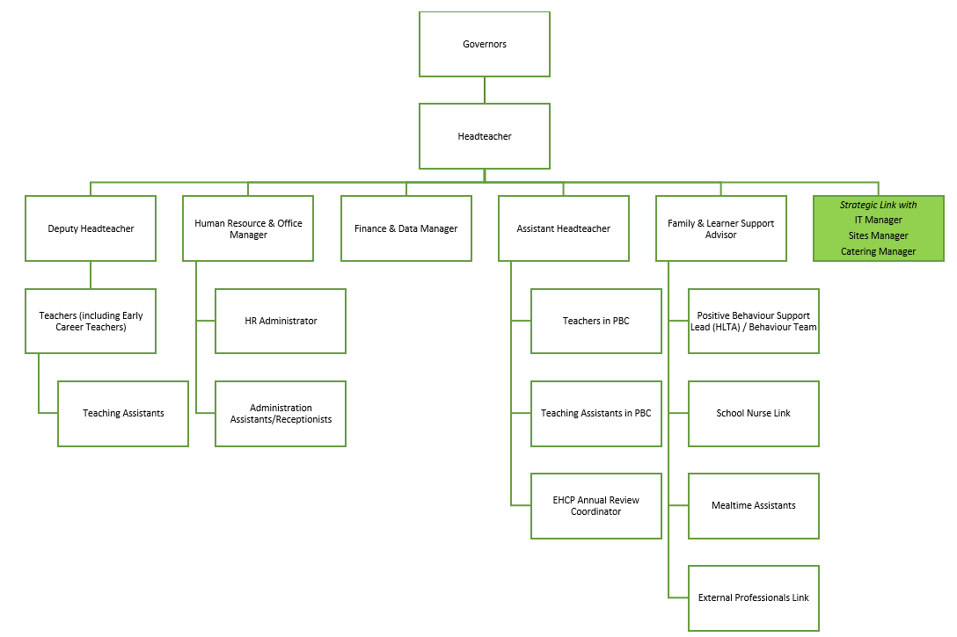

**Why Work for Us?**

At Cann Bridge School, we cultivate an environment where both learners and staff can thrive. Our learners benefit from a well-structured curriculum, a supportive staff team, and a purposeful learning environment, all designed to help them grow into confident, well-rounded, and independent young adults. This success is made possible by our talented and dedicated team, who work together to ensure that every child has the opportunity to succeed both academically and personally.

When you join Cann Bridge School, you’ll become part of a committed team that values your professional growth.

We offer:

* Bespoke Continuing Professional Development (CPD) tailored to your individual needs and career goals
* Access to the Local Government Pension Scheme for future financial security
* An excellent Employee Assistance Programme, offering physiotherapy, counselling, wellbeing services, and private healthcare options (where applicable) through Education Mutual
* Staff Discounts on a wide range of products and services through the Blue Card professional student discount scheme
* The opportunity to work with incredible children, young people, and a dedicated staff team

**Recruitment Timeline**

* Opportunities to visit Cann Bridge School: Please contact the school to arrange your visit 01752 207909 or [HR@cannbridge.co.uk](mailto:HR@cannbridge.co.uk)
* Application closing date: 9am 28th February 2025
* Candidate shortlisting: Afternoon 28th February 2025
* Interviews: Tuesday 4th March 2025

Complete applications should be sent to: HR@cannbridge.co.uk



**Job Description: Finance & Data Manager**

Cann Bridge School is committed to creating a diverse workforce. We’ll consider all qualified applicants for employment without regard to sex, race, religion, belief, sexual orientation, gender reassignment, pregnancy, maternity, age, disability, marriage, or civil partnership.

**Job details**

**Position:** Finance & Data Manager

**Location:** Cann Bridge School, Estover, Plymouth

**Grade:** H

**Job Type:** School Management Role

**Salary:** **£39,513 - £43,693 FTE £27,436 - £30,338 Pro Rata**

**Contract type:** 30 hours per week, term-time, permanent

**Reporting to:** Headteacher

**Start Date:** As soon as possible

**Main purpose**

The primary purpose of the Finance & Data Manager role is to oversee and manage the School's financial, MIS data, and site and premises functions, ensuring compliance with relevant policies and standards. This role includes assisting the Headteacher in budgeting and financial planning, maintaining robust financial systems, advising on budgetary implications, and ensuring accurate financial reporting and compliance with Devon Audit standards. Additionally, the Finance & Data Manager is responsible for payroll services, insurance management, preparation of final accounts, and overseeing School Fund accounts. They manage capital works projects, health and safety compliance, and service contracts for site maintenance. This role also involves managing SIMS data, completing statutory returns, and liaising with ICT for smooth system operations. The Finance & Data Manager supports fundraising efforts by securing additional funding, managing charitable databases, and ensuring compliance with audit regulations. They attend relevant committee meetings, provide benchmarking data, and ensure sustainable and eco-friendly financial management practices.

**Duties and responsibilities**

**School Financial Management**

* Assist the Headteacher in detailed budget planning and input new budget details into Financial Management System (FMS) for Governor approval.
* Ensure appropriate financial systems are managed in accordance with policies and timetable.
* Advise the Headteacher & Governors on budgetary implications of proposals and developments.
* Complete finance returns for Governor review and upload to the Local Authority.
* Complete year-end returns for school budget share and capital funds, and perform financial system close down annually.
* Ensure compliance with Financial Management Standards in Schools as required by Devon Audit.
* Provide benchmarking data and analysis for Governors.
* Provide budgetary advice to the Headteacher & Governors to ensure best value.
* Maintain and monitor development/management plans for financial matters.
* Monitor budget expenditure and financial targets, producing regular reports for the Headteacher, Governors, and staff budget holders.
* Attend Governor meetings.
* Manage payroll services for all school staff, including processing claims for overtime, supply, travel, and subsistence.
* Complete the School Workforce Census and maintain the schools MIS system (Bromcom)
* Seek professional advice on insurance, advise Governors, implement approved insurances, and handle claims.
* Prepare final accounts and liaise with auditors.
* Oversee the operation of all school funds, ensure regulatory compliance, complete school fund accounts for audit, produce annual trustee reports, and submit online charity commission returns.
* Maintain accurate financial records and submit mandatory returns to the Plymouth City Council Finance Team.
* Ensure financial policies and procedures adhere to Plymouth City Council financial regulations.
* Liaise with local authority officers as needed.
* Process orders, requisitions, and invoices.
* Process all BSM entries, ensure correct VAT documentation, approve transactions, and reconcile monthly statements.
* Process all petty cash entries, ensuring correct VAT documentation and reconciling monthly statements.
* Conduct regular financial audits to ensure accuracy and compliance.
* Provide training to staff on financial procedures and systems.
* Manage and report on all grants and external funding received by the school.
* Ensure all financial activities align with the school’s strategic objectives.

**School Site & Premises Management**

* Manage school capital works projects and liaise with outside agencies when relevant.
* Manage health and safety in accordance with Plymouth City Council and School policies.
* Ensure necessary service contracts are in place annually for building and equipment safety and maintenance.
* Coordinate tenders for contracted services.
* Assist the Headteacher in maintaining and monitoring site and building development/management plans, providing updates to relevant Governors meetings.
* Oversee standards of service for utilities and conservation issues.
* Manage the Display Energy Certificate Scheme.
* Maintain regular contact with the Sites Team to ensure proper maintenance and repair of the school.
* Respond to emergency repair needs in the absence of the Sites Team.
* Administer charges for all school lettings regularly.
* Ensure school grounds are maintained and secure, in conjunction with the Headteacher.
* Liaise with the Tor Bridge High Campus Business Manager on joint services contracts and service level agreements.
* Manage site recharges, update and monitor annual costings, and inform Governors of changes and cost implications.
* Conduct regular site inspections to ensure compliance with health and safety regulations.
* Develop and implement a long-term maintenance plan for school facilities.
* Manage environmental sustainability initiatives related to the school premises.

**Data Management**

* Liaise with the HR & Office Manager to ensure MIS information is up-todate for school integration needs.
* Complete and upload Key Stage and Phonics returns to DfE.
* Complete the census and workforce census returns to DfE.
* Complete the annual year-end promotion of pupil information in MIS.
* Liaise with the IT Team to ensure smooth operation of office and school ICT systems.
* Ensure annual maintenance of equipment inventories and completion of statistical returns as appropriate (Asset Record).
* Analyse and report on school performance data to inform strategic decisions.
* Maintain data security and confidentiality in accordance with GDPR regulations.
* Implement data management best practices and train staff as needed.

**Continuous Professional Development Management**

* Organise attendance at external training courses and keep records of associated costs.
* Raise internal charges and invoice requests for delegates attending school-organised on-site training.

**Fundraising**

* Secure additional funding for school projects, activities, and equipment through fundraising bids and donations.
* Set up, maintain, and manage the database of charitable organisations.
* Complete annual accounts and returns to the Charity Commission, School Fund Trustees, and School Governors.
* Identify new funding sources.
* Manage and monitor all income and expenditure, identifying restricted funds for specific projects to comply with audit regulations.
* Handle banking and reconciliation of income in line with school financial policies and procedures.
* Complete complex online bids for funding.
* Manage the school fund account in line with school audit regulations.
* Develop and implement a fundraising strategy aligned with the school’s goals.
* Build and maintain relationships with donors and sponsors.
* Attend Friends of Cann Bridge meetings.

**General**

* Manage all aspects of school financial management sustainably and eco-friendly.
* Undertake additional duties and work hours as agreed with the Headteacher.
* Stay updated with changes in education finance regulations and best practices.
* Collaborate with other school staff to support overall school administration and operations.

Please note that this is illustrative of the general nature and level of responsibility of the role. It is not a comprehensive list of all tasks that the Finance Data Manager will carry out. The postholder may be required to do other duties appropriate to the level of the role, as directed by the headteacher or line manager.



**Person Specification: Finance & Data Manager**

|  |  |  |  |
| --- | --- | --- | --- |
| **Criteria** | **Qualities**  **Essential** | **Qualities**  **Desirable** | **Method of Assessment** |
| **Qualifications and knowledge** | * Relevant Level 4 professional qualifications in finance, accounting, or business administration (e.g., AAT, ACCA, CIMA). * GCSE Grade C or 4 in English and Maths * In-depth knowledge of financial management systems (e.g., FMS). * Understanding of school financial regulations and compliance requirements. * Knowledge of Financial Management Standards in Schools. * Familiarity with data protection regulations, including GDPR. * Strong understanding of budgeting, financial planning, and monitoring. | * Degree in finance, business administration, or a related field. * Knowledge of health and safety regulations and site management. * Understanding of environmental sustainability initiatives. * Familiarity with fundraising strategies and grant application processes. * Proficiency in using Bromcom and other school management information systems. | Application form |
| **Experience** | * Proven experience in financial management. * Experience in budget planning, data analysis, monitoring, and reporting. * Handling payroll services and completing financial audits. * Conducting financial and compliance audits. * Experience in data management. * Coordinating capital works projects and managing service contracts. * Advising on insurance matters and handling claims. | * Proven experience in financial management within an educational setting. * Experience in fundraising and managing charitable donations. * Project management experience, particularly in school capital works. * Experience in data management, including completing statutory returns to DfE. * Liaising with external agencies and local authorities. * Experience in managing environmental sustainability projects. * Managing school funds, including grant and external funding administration. * Experience of securing external funding and writing grant proposals. | Application form  Interview process |
| **Skills** | * Strong financial and analytical skills. * Excellent organisational and time-management abilities. * Ability to communicate effectively with a range of stakeholders, including Governors, staff, and external agencies. * Proficiency in financial software (e.g., Bromcom, FMS). * Strong attention to detail and accuracy in financial record-keeping. * Ability to face new demands, manage conflicting deadlines, and frequently switch attention to cover a wide range of unanticipated tasks daily. * Strong problem-solving skills and the ability to meet deadlines. * High level of integrity and confidentiality. * Ability to build and maintain effective working relationships with all members of the school community. * Strong project management skills. * Proficient in Microsoft Office Suite (Word, Excel, PowerPoint, Outlook, Sharepoint, Forms, Teams). * Ability to interpret advice/statutes and devise policies/practices accordingly. * Ability to work on own initiative. * A commitment to continuous professional development and improving working practices. | | Application form  Interview process |

This job description may be amended at any time in consultation with the postholder.

**Last review date:** February 2025

**Line manager’s signature:** _______________________________________

**Date:** _______________________________________

**Postholder’s signature:** _______________________________________

**Date:**  _______________________________________