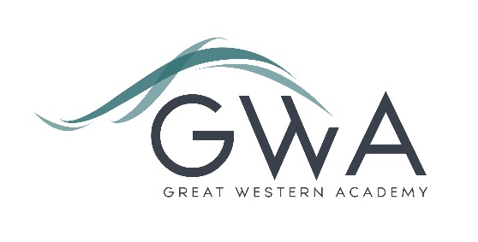

# Information for Applicants

**Finance Officer**

As stated in the main advert, this role is now available following the internal promotion of the current role holder.

We are looking for a candidate who can enthusiastically support our financial processes, from supporting departmental budgeting, raising purchase orders, ordering, processing invoices, producing reports and generating VAT reports. The successful candidate would work with our Finance Manager who has been with GWA since it opened in 2018. It is a well run and efficient finance department with five years of successful audits.

The role will involve working closely with the Finance Manager as well as being part of our friendly and supportive Admin team whilst also liaising with the wider staff team. The Finance office is located in the main Admin office. Within that office there are two Receptionists, an HR Assistant, an Events and Trips Co-Ordinator, a PA to the SLT, an Assistant Business Manager and a Business Manager.

The hours for this role are 36.5 hours per week, 8.30 - 4.30pm (3.30pm Friday) with 30 minutes for lunch. This is a term-time only role, to include all TD days and with one additional week to be worked in the school holidays in agreement with the Finance Manager.

Great Western Academy aims to radically improve the life chances of every student who attends. Our new building and state-of-the-art facilities help us to achieve this, but it is the fantastic team of staff who turn our vision into reality. If you have the drive and ability to support the successful running of this school then this provides you with an exciting opportunity to shape and develop your career.

Additional benefits of working at GWA include:

* Excellent CPD opportunities
* State of the art facilities
* Free Health and Wellbeing Support Service
* Staff wellbeing activities and events
* Cycle to work scheme through Cyclescheme
* Electric Vehicle Salary Sacrifice scheme through OctopusEV
* Easy access to the A419, and free parking

Further details are available on the Academy website [www.gwacademy.co.uk](http://www.gwacademy.co.uk/) and in the information documents attached.

**Application process**

Please complete the application and equalities forms supplied and enclose a supporting letter, either in the space provided on the application form or as a separate document. The application form should be completed in full in black ink or type. A CV is not requiredand should not be submitted as part of the application.

Your supporting letter should be no more than 2 sides of A4 (with a font size no smaller than 11) and should enhance your application by providing further information, matched to the person specification, about your suitability for the post.

Applications should be submitted electronically to [recruitment@gwacademy.co.uk](mailto:recruitment@gwacademy.co.uk) by 9am **on Monday 4th November 2024**. Interviews will take place as soon as possible after this date.

*Great Western Academy is committed to safeguarding and promoting the welfare of children, young people and vulnerable adults and we expect all staff to share this commitment and undergo appropriate checks. All posts within the Trust are therefore subject to an Enhanced DBS and barred list check.*

**References:** References will be taken up prior to interview.