

*Our Vision:*

*To develop aspirational learners who strive for excellence academically, creatively and culturally, benefitting from a wide range of opportunities led by inspirational educators.*

**Shirley High School**

**Performing Arts College**

***“Striving for Excellence”***

**Job Description:**

**Post:**  First-Aid, Reprographics, Marketing

**Line Manager:** Office Manager

To provide an effective and efficient administrative support service to the school with particular responsibility for reprographics and marketing.

**Areas of responsibility and guidance:**

**Reprographics:**

* Responsibility for photocopier machines within the school; duplicating and collating for all staff members on a daily basis.
* Overseeing copying machines to ensure that they are stacked with paper and in good working order. Stacking paper first thing in the morning and last thing at night.
* Checking all form trays in the staff room are replenished daily.
* Ordering all supplies for reprographics.
* Maintaining a monthly log on an Excel spreadsheet of the number of copies used, each month, on staffroom and reprographic machines and passing these figures to the Finance Assistant. Reports to be completed on the first day of the month.
* Organising the servicing and ongoing repair of equipment.
* Maintaining an up-to-date filing system of all work reproduced from teachers and admin staff on a daily basis.

**Marketing:**

* Assisting all departments with their marketing requirements ensuring delivery of key messages in line with the academy’s brand, strategy and mission
* Support the production of the parent communications, ensuring that articles convey the school’s brand, ethos and key messages. This will include liaison with staff to source articles and images
* Maintaining the school’s social media to promote the school, ensuring that the school maintains a continuous stream of news.

**Publicising events on the academy’s sites aimed at pupils, parents and teachers in order to enhance recruitment:**

* Organising a photo library of academy activities.
* Producing materials for ad hoc events
* Photography/Video
* To keep all imagery updated for use in marketing campaigns as required.
* Reviewing current marketing strategies and suggesting improvements.
* Keeping up-to-date with the newest channels of communication and marketing.
* Ensure compliance with the UK GDPR, including ensuring that social media, photography, website and collateral are in line with legislation

**First Aid:**

* Dealing with all sick students reporting to the medical room, keeping a log of name, form tutor, reason for attending medical and what time student went back to lesson or was sent home.
* Dealing with accidents for both staff and students and keep Line Manager informed.
* Completing an accident form when needed and maintain a current First Aid Certificate.
* Maintaining supplies for first aid.
* Ensuring the student Medical Register is kept up to date.
* Liaising with parents/carers on all accidents and when necessary for sickness.
* Supporting students with more complex medical needs, e.g. epilepsy, diabetes.

**Other Duties:**

* Opening the daily post and distributing to staff via pigeonholes.
* Distributing internal post between Reception / Staffroom and General Office at regular intervals during the day.
* Making sure all the trays are clear before leaving the building.
* Assisting with administration work in the General Office as appropriate.
* Participate in development and training opportunities.
* Covering Reception daily for break / lunch and for staff absences and where necessary.

**Support for the School:**

* Being aware of and complying with policies and procedures relating to child protection, health and safety, security and confidentiality, reporting all concerns to an appropriate person;
* Being aware of and supporting inclusivity and ensuring all pupils have equal access to opportunities to learn and develop;
* Contributing to the overall ethos/work/aims of the school;
* Appreciating and supporting the role of other professionals;
* Attending relevant meetings as required;
* Participating in training and other learning activities and performance development as required;

**Personal Qualities:**

* Reliable and conscientious pastoral leader with high expectations in line with the school;
* Demonstrate great communication skills with all within the school community;
* Neat appearance in line with the school policy;
* Ability to work as part of a successful team and work effectively under pressure;
* Have the determination and resilience to ensure that all students are challenged in all aspects of school life.

**Think Green:**

* Support the school in demonstrating good environmental practices (such as energy efficiency, use of sustainable materials, recycling and waste reduction) wherever possible in day-to-day work.

**Safeguarding and Child Protection:**

* To reinforce and enforce the school’s commitment to safeguarding and promoting the welfare of children and young people.
* Uphold the duty of care to ensure that if there are any concerns relating to the welfare or safety of a child they are immediately relayed to the Designated Person(s) with responsibility for safeguarding children.

|  |  |
| --- | --- |
| Essential | Desirable |
| Experience with relevant technology e.g. photocopiers and social media | Awareness of GDPR / safeguarding |
| Ability to relate well to children and adults | Experience working in a school |
| Good numeracy and literacy skills | Ability to work constructively as part of a team, understanding school roles and responsibilities and your own position within these |
| Good ICT and Social Media skills | Ability to self-evaluate learning needs and actively seek learning opportunities |
| Ability to conduct basic admin tasks e.g. filing | Willingness to undertake training as required |
| Very good organisational skills | Current First Aid certificate |
|  |  |

We want all at SHS to believe in and maintain the values of our school:

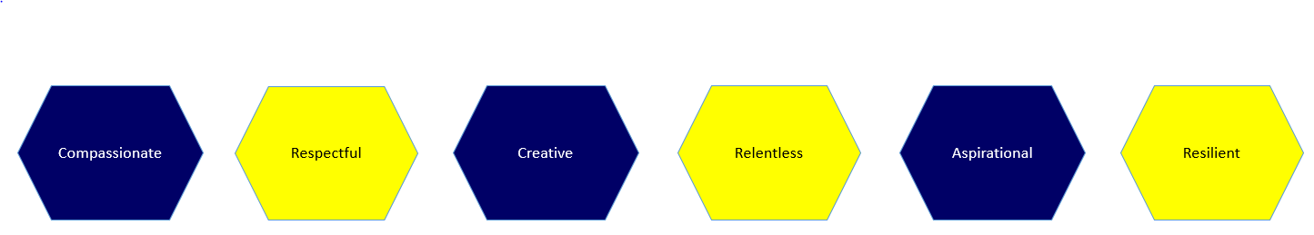

Signed: ………………………………………………………………………………………… Dated: …………….……………………………