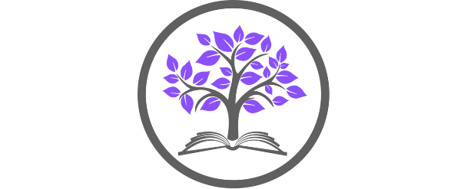

Meadow Park School
Haswell Drive, Stockbridge Village, Knowsley, L28 1RX

KS3 & 4 Food (80%)
& KS3 Art Teacher (20%)
Required to start as soon as possible
Permanent / Full time
Main Pay Scale 1-6 / £30,000 - £41,333 per annum
Upper Pay Scale 1-3 £43,266 - £46,525 per annum (dependent upon experience)
plus an SEN allowance of £5,009 per annum

Meadow Park School is a pupil referral unit situated in the borough of Knowsley on Merseyside. We provide a quality educational experience for students who have or are experiencing difficulties in a mainstream setting due to medical, social, emotional, or behavioural needs.

We support young people from Years 1-11, to develop strategies to improve their resilience and confidence through a personalised curriculum, delivered by dedicated, experienced and qualified staff.

We seek to recruit a dedicated Teacher with a specialism in Food, and the ability to deliver KS3 Art. The applicant should be a suitably qualified, enthusiastic, and inspirational teacher with the ability to work in a team. They will be passionate about the subject and demonstrate flair whilst maintaining the very highest of standards. An ability to establish and maintain appropriate relationships and personal boundaries with students is essential.

The successful candidate will:
- Inspire disengaged students and help them to make accelerated progress from their starting points by delivering personalised and interesting lessons
- Guide and support their classes to ensure best outcomes
- Establish good working relationships with students acting as a role model and setting high expectations
- Promote inclusion and acceptance of all
- Provide pastoral care, support, and guidance as a form tutor
- Establish and maintain an appropriate learning environment
- Deliver and assess relevant KS4 qualifications

For an informal and confidential discussion, or to arrange a tour of the School, please contact Jackie Cleary, Headteacher. Applicants should apply on the School website by clicking on the following link Meadow Park School (meadowparkknowsley.co.uk). Applications must be made using the Knowsley Council application form. CVs will not be accepted for this post.
Applications to be submitted to Jackie.cleary@meadowparkknowsley.co.uk

Closing date: Sunday, 8 September 2024 by 12am
Interviews: Monday, 16 September 2024

Meadow Park School is committed to safeguarding and promoting the welfare of children. All posts within our school are subject to satisfactory references, DBS and health clearances and proof of legal working in accordance with the Asylum and Immigration Act 1996.

By engaging in this recruitment process, shortlisted candidates consent to an online search in line with the Keeping Children Safe in Education Guidance 2022

