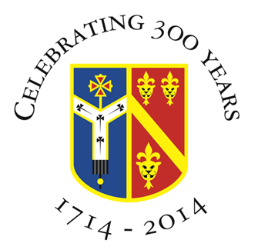

Archbishop Tenison’s C.E. High School,
Selborne Road, Croydon, CR0 5JQ
Tel: 020 8688 4014
www.archten.croydon.sch.uk

APPOINTMENT OF FOOD TECHNICIAN (part-time)

Location: Croydon, Surrey
Required for: As soon as possible
Contract: Fixed Term until 18th July 2025 (term-time only plus Staff Development Days)
Hours: 17 ½ hours per week 9am – 12.30pm Monday to Friday
Salary: Food Technician - Grade 3 point 5 to 7 (£27,030.00 - £27,885.00 pro rata)
Closing Date: Friday, 22nd November 2024
Interviews: tbc

The Governors wish to appoint a Food Technician to support the Food and Nutrition classroom teacher. For this joint role, candidates must have good organisational and communication skills. Experience of working in a school and or kitchen environment would be an advantage but not essential.

The successful candidate must have:
- strong organisational and communication skills
- the ability to relate well with pupils and students
- good attention to detail

We can offer you:
- a rewarding and challenging working environment
- the opportunity to work closely with staff, pupils and students
- be part of a school with strong traditions
- develop professionally and personally in a secure, but lively atmosphere
- contribute to our pastoral care and our Christian ethos

Archbishop Tenison’s is a 310 year old Church of England, mixed 11-18 comprehensive school with an excellent track record at both GCSE and A Level. Most importantly, it is a community where the people who work believe they can make a difference to the young people they teach. Our school motto is “Academic excellence for each person in a Christian community”.

Total number of pupils - 793 pupils (Sixth Form 76)

The school is situated near East Croydon Station which has excellent fast rail links to London and the South Coast. There is some staff parking on the school site and parking bays in and around the local area (approx £12per day)

How to apply

If you would like to apply, please submit your application and a covering letter to Mr Parrish, Headteacher detailing your suitability for the role by Friday, 22nd November. Please visit the staff recruitment page via the school website https://www.archten.croydon.sch.uk/staffrecruitment.

Archbishop Tenison's is an equal opportunities employer and committed to safeguarding and promoting the welfare of children. Successful candidates will be required to undertake an enhanced Disclosure check by the Criminal Records Bureau; online checks will be carried out.

