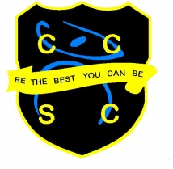

Food Technician

Chesterton Community Sports College is an exciting school to work in with a dynamic, enthusiastic team. We are the lead school of the Collective Vision Trust and have an excellent reputation in the area.

We are an oversubscribed school with a record of excellent progress and results. We have a warm and friendly learning environment with a hard-working ethos and both staff and pupils strive, ‘To be the best they can be.’

We are looking for a Food Technician to join our Technology department team at Chesterton Community Sports College. The candidate should have a good general knowledge of food and enjoy cooking.
Main Roles and Responsibilities
- To work under the guidance of the class teacher
- Health and safety checks throughout the food room
- Monitoring of equipment and stock
- Ensure the department is kept clean and tidy
- Support in food practical lessons

The post will be advertised on our website http://www.ccsc.staffs.sch.uk
with the closing date Monday 4th July and interview date on Thursday 7th July.

You are welcome to come and visit, prior to interview, to see our wonderful school.

We look forward to hearing from you and hope you are excited by this fantastic opportunity to join our staff team.

This position is subject to an Enhanced Disclosure check under the Rehabilitation of Offenders Act 1974. Further details regarding this check are available from the school or by visiting www.dbs.gov.uk

This school is committed to safeguarding and promoting the welfare of children and young people/vulnerable adults and expect all staff and volunteers to share this commitment.

