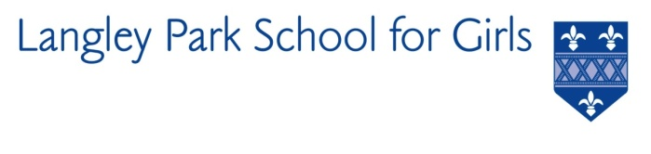

Langley Park School for Girls

Hawksbrook Lane

Beckenham

Kent BR3 3BE

Headteacher: Ms Katie Scott

FOOD TECHNICIAN

REQUIRED FOR SEPTEMBER 2021

Salary: NJC Scale 3 FTE £22,185 to £22,585 per annum

(Pro rata £18,911- £19,252)

36 hours per week, 39 weeks per year

Langley Park School for Girls is seeking a Food Technician to support the Food Technology Department of this high achieving school. We are ideally looking for someone with previous school experience.

The purpose of the role is to work closely with teaching staff to support, develop and further extend the work of the department and the experiences of the students and to provide technical support to the department, by the preparation of tools, equipment and materials for lessons.

The successful candidate will be a strong team player with a positive attitude to working with both students and staff.

LPGS is a calm, friendly and collaborative environment which offers strong staff support. Our CPD programme gives all teachers time to pursue their own priorities. This results in a two week October half term. Please see application details on our website www.lpgs.bromley.sch.uk. Completed application forms should be emailed to Helen Partridge, hpa@lpgs.bromley.sch.uk.
Please note that whilst you are also welcome to submit a CV, shortlisting will be based solely on our application form and covering letter. All applicants must complete the LPGS Application Form.

The closing date for applications is 12 noon on Thursday 9th September 2021 with interviews likely to be scheduled for week commencing 13th September 2021. You are encouraged to submit your application as soon as possible. Please note the school reserves the right to appoint prior to 13th September.

This school is committed to safeguarding and promoting the welfare of children and young people and expects all staff and volunteers to share this commitment. The successful applicant will be subject to an Enhanced Disclosure & Barring Service check.

