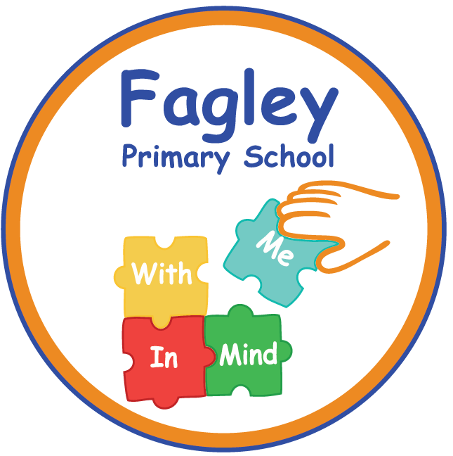

**Forest School Leader**

Hours : 32 hours per week, Term time only

Pay scale : Unqualified Teacher 2 – annual salary £24,224

Closing date : 6th January 2025

Interview date : 9th January 2025

Start : ASAP

Fagley Primary is an outstanding primary school situated in Bradford close to Ravenscliffe Wood. We are dedicated to inspiring children through nature-based learning and outdoor exploration. Supporting children’s emotional, social, and physical development through activities that promote teamwork, problem-solving, and independence.

We are currently looking to appoint an energetic and enthusiastic Forest School Leader to develop our outdoor curriculum. The successful candidate will have a passion for outdoor education and engaging children with the natural world. Your primary responsibility will be running forest school activities with groups of children both on and off site.

Our Forest Schools Leader would be responsible for planning and delivering outdoor learning experiences that promote children's development through engagement with nature. It is essential that you hold a Forest School Level 3 certification and you have previous experience in leading outdoor education sessions.

**In return we can offer the successful candidate:**

* A positive, safe and caring environment with a learning culture for all
* A commitment to your professional development
* A committed and dedicated staff team who are working together to develop excellence and enjoyment and a curriculum where every child matters
* A positive school ethos that celebrates success and is committed to inclusion

Visits to the school are encouraged and welcomed and should be made by contacting Catherine Boddy, School Business Manager, in the office on 01274 771124

Closing Date: 6th January 2025

Interviews: 9th January 2025

***At Fagley Primary School we are committed to the safeguarding and welfare of***

***our children and therefore this post is subject to an enhanced DBS check.***